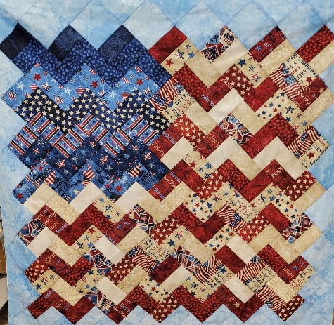
Yankee Doodle Zig Zag Flag Quilting Class
Quilt Lizzy Wake Forest
The purpose of this class is to reinforce the basics of quilting and add more advanced skills. Students will set strip blocks on point and master set in triangles to form the outer border of this patriotic quilt.
Class Level: Confident beginner
Cost: $99 (kit included)
Location/time: Quilt Lizzy Wake Forest, November 5, 2022, 9:30-4:30 pm

Standard Sewing Class Supply List
- Sewing machine (in good working order) | - Thread and bobbins
- 18 x 24 Cutting mat (optional) | - Flat flower pins and magnetic pin cushion
- Standard 6.5 x 24-inch ruler (or larger) | - Fabric marker/pen/chalk
- Smaller ruler for trimming at least 4.5” square | - Scissors/snips
- Self-closing/Ergonomic rotary cutter
- Seam Ripper
- Machine Needles

