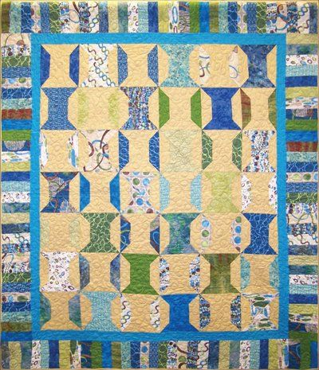
Spool Box Quilting Class
The purpose of this class is to teach the basics of quilting. During this class, the tools and fabric will be discussed, and students will complete the top of their quilt. Using the Creative Grids 90° Double Strip Ruler, students will seam blocks on the bias.
Class Level: Confident beginner
Teachers: Laura Clark and Elizabeth Weidner
Cost: $99
Location/time: Quilt Lizzy Ayden, October 22, 2022, 9-4:30 pm
Class One: Safety use of tools and a brief discussion of reading the pattern. There will be a demonstration on using the required ruler and making the blocks. Students will then begin cutting their fabric as per the pattern for the remaining class. Students will complete the Spools and sew their tops together. Instructors will be guiding the process along.
KIT and Class specific supplies

- 21 Fat quarters for spools and piano key border (high contrast colors)
- 1¾ yard background and spool blocks
- 5/8 yard inner border
- Creative grids 90 Degree Double Strip Ruler
- Spool Box Pattern

Standard Sewing Class Supply List
- Sewing machine (in good working order) | - Thread and bobbins
- 18 x 24 Cutting mat (or larger) | - Flat flower pins and magnetic pin cushion
- Standard 6.5 x 24-inch ruler (or larger) | - Fabric marker/pen/chalk
- Smaller ruler for trimming | - Scissors/snips
- Self-closing/Ergonomic rotary cutter | - Seam ripper
- Iron | - Measuring tape
- Portable ironing board/mat | - Machine and hand sewing needles
- Optional: Extension cord, Best press/sizing, Thimble, spare rotary blades

