Orchard Pictures and Okay Goodnight Present
A Co-Production With Independent Television Service

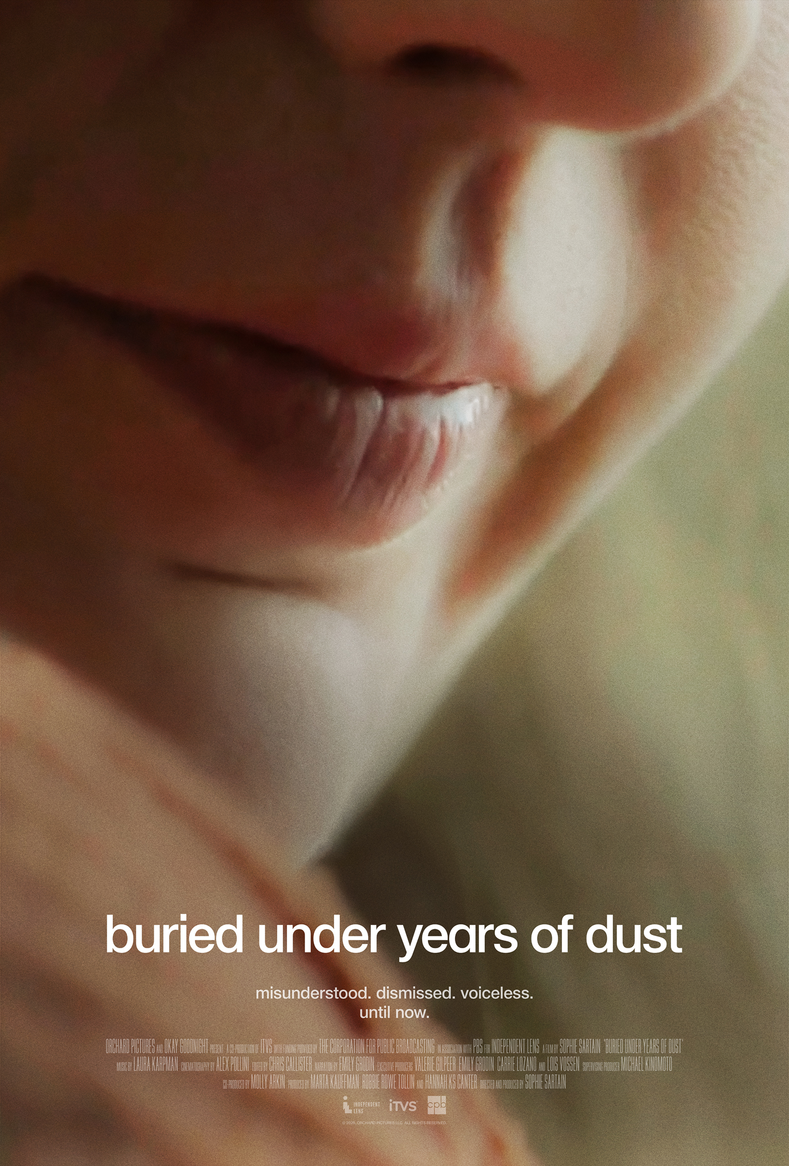

Contact:
Sophie Sartain
Orchard Pictures LLC
sophiesartain@gmail.com

US • 2026 • 29 minutes • 16:9 • 5.1 Stereo • NR • English
THE FILMMAKERS

Directed and Produced by..........................................................................SOPHIE SARTAIN

Produced by..........................................................................................MARTA KAUFFMAN
ROBBIE ROWE TOLLIN
HANNAH KS CANTER

Narration by……………………………………………………………………………………………..EMILY GRODIN

Edited by....................................................................................................CHRIS CALLISTER

Cinematography by..........................................................……………..................ALEX POLLINI

Music by….…………….…………………………………….……………………………………...LAURA KARPMAN

Executive Produced by..................................................................................EMILY GRODIN
VALERIE GILPEER
CARRIE LOZANO
LOIS VOSSEN

Supervising Producer…………………………………………………………..…………MICHAEL KINOMOTO

Co-Producer………………………………………………………………………………………….……MOLLY ARKIN

BASED ON THE BOOK
“I HAVE BEEN BURIED UNDER YEARS OF DUST:
A MEMOIR OF AUTISM AND HOPE”
by VALERIE GILPEER & EMILY GRODIN

FEATURING
EMILY GRODIN
VALERIE GILPEER
TOM GRODIN
MARTA AMAYA
STEPHANIE ELBAUM
LINDSEY GOODRICH
DARLENE HANSON
EMMA CLADIS
BELLA SANTOYO
NICOLE VOISARD

BURIED UNDER YEARS OF DUST
Synopsis

How does someone go from not communicating for 25 years to narrating her life story? Buried Under Years of Dust traces the remarkable journey of Emily Grodin, a woman silenced by autism, finally finding her voice. Despite Emily’s increasing frustration, physical outbursts, and violent meltdowns, Emily’s parents never abandoned hope that their daughter would one day share her thoughts, feelings, and deep intelligence. Then, using a controversial assisted-typing technique, Emily had an extraordinary breakthrough. One of her first sentences was “I have been buried under years of dust.” In a time when American health officials call into question the value and contributions of people with autism, Emily has the mic, and she’s got a lot to say.

BURIED UNDER YEARS OF DUST
Director’s Statement

In 2015, I completed a documentary about autism titled Mimi and Dona. A deeply personal film that The New York Times described as “heart-wrenching” and “as unflinching as it is beautiful,” Mimi and Dona chronicled the process of finding a home for my 64-year-old aunt with intellectual disability and undiagnosed autism when her 92-year-old mother, my grandmother Mimi, could no longer care for her. That film coincided with my son’s autism diagnosis as a child, and with my non-speaking autistic nephew’s aging out of his public school system at age 22. Needless to say, autism has affected my family for generations.
For this reason, it’s obvious that I would be drawn to a story like Emily’s. But affinity for the subject matter only got me to read I Have Been Buried Under Years of Dust, the memoir Emily and her mother Valerie wrote about Emily’s communication breakthrough at age 25. Once I started the book, I was stunned not only by Emily’s breakthrough, but also by her insights and observations. These ranged from explaining the noises she makes to admitting the sadness she felt as a little girl disappointing her parents – “I knew I was not living up to their expectations for me. They expected me to speak. My frustration was huge.”
When Emily’s parents shared their dramatic home movie footage with me, I knew there was a film. I reached out to my previous collaborators, producers Marta Kauffman, Robbie Rowe Tollin, Hannah KS Canter and Molly Arkin, editor Chris Callister, and cinematographer Alex Pollini, and we set about to tell Emily’s story. Following the disability maxim “nothing about us without us,” we knew that Emily’s voice needed to drive the narrative. She agreed to tell her life story with the AI voice she prefers, with the pictures and footage illuminating her words on the page. She also jumped in to play herself in key parts of her story.
Clearly Emily has much to teach us. And this is my foremost hope for the film – that she guides us inside a world few of us know or understand. Her astonishing voice has already touched readers around the world. Her memoir has been translated into Russian and Chinese. Our aim is to amplify her voice even more and spotlight the lives of non-speaking and minimally speaking individuals with autism through the powerful medium of film.

BURIED UNDER YEARS OF DUST

SOPHIE SARTAIN (Director and Producer)

Sophie Sartian is the co-director and producer of the Netflix documentary Seeing Allred, which premiered at Sundance and was described as “remarkably engaging” (The New York Times) and “an ideal companion to the #MeToo movement” (Variety). Among Sartain’s credits is her film Mimi and Dona, which aired on Independent Lens and was named one of the top ten TV shows of the year by The New York Times. She is a member of the Academy of Motion Picture Arts & Sciences and New Day Films.

MARTA KAUFFMAN (Producer)

Marta Kauffman is an Emmy and Golden Globe-winning television writer, producer and showrunner best known for co-creating the hit show Friends. The iconic series, which ran for ten seasons, earned 63 Emmy nominations, winning Outstanding Comedy Series in 2002. Kauffman also co-created Dream On and Grace and Frankie, Netflix’s longest-running series. In addition, she produced Seeing Allred for Netflix. Kauffman has received the Paddy Chayefsky Laurel Award for Lifetime Achievement in Television Writing, the Norman Lear Achievement Award in Television, and the Humanitas Kaiser Award.

ROBBIE ROWE TOLLIN (Producer)

Robbie Rowe Tollin is an Emmy Award-winning TV and film producer, currently the producing partner of Marta Kauffman at Okay Goodnight. The company has produced Netflix’s Grace and Frankie, and Seeing Allred, about attorney Gloria Allred. The company has several TV and film projects in development for streamers and networks.

HANNAH KS CANTER (Producer)

After joining Okay Goodnight, Hannah KS Canter developed Grace and Frankie and produced Seeing Allred. She and Marta Kauffman have also co-written a feature and pilots, including the comedy DINKS for Amazon, on which she serves as co-creator and co-showrunner. Canter has held posts at StudioCanal, Katahdin Productions, and Tollin Productions.

MOLLY ARKIN (Co-Producer)

Molly Arkin joined Okay Goodnight in 2017. She was an associate producer on Grace and Frankie and worked with the team on the feature documentary Seeing Allred for Netflix. Arkin covers Okay Goodnight’s slate of passion-driven development projects, including the improv-comedy pilot DINKS for Amazon, on which she is a co-producer.

CHRIS CALLISTER (Editor)

Chris Callister was the editor and post-production supervisor of Seeing Allred. Callister also served as an editor on the Netflix series Evil Genius. Other credits include Mimi and Dona (2015), Above and Beyond (2014) and Hava Nagila (The Movie) (2012). He was assistant editor on Blessed Is the Match: The Life and Death of Hannah Senesh (2008).

ALEX POLLINI (Director of Photography)

Alex Polini shot the 2018 documentary Seeing Allred. His films as director of
photography have premiered at Sundance, SXSW, and Tribeca. Feature-length documentaries include Not Going Quietly, the documentary series Home Game for Netflix and Power Trip for Hulu. Accolades include a Primetime Emmy Nomination for HBO’s Olive Kitteridge title sequence.

