Transportation Learning Network
A partnership with MDT ● NDDOT ● SDDOT ● WYDOT
and the Mountain-Plains Consortium Universities

Presentation Series: 2022 - 2023

TLN Helpdesk: 701-552-0672

www.translearning.org

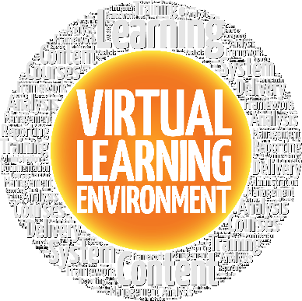

MPC Removal of Escherichia coli from stormwater

DATE: Thursday, September 29, 2022 | TIME: 9:30 AM – 10:30 AM CST (8:30 AM – 9:30 AM MT)
Register in advance for this meeting (Delivery via Zoom): https://ndsu.zoom.us/meeting/register/tJcrceqhpzotGNOaaMzazExLeQAutt-IL5hF

DESCRIPTION: The MPC project of Removal of Escherichia coli from stormwater using recycled steel byproduct filtration: Laboratory to field scale demonstration covers the fact that stormwater runoff is the one of the most common forms of non-point source pollution, which can degrade surface water quality. Fecal indicator bacteria such as Escherichia coli (E. coli) have been recognized as major contaminants that prevent the potable and non-potable reuse of stormwater runoff. This project aims at developing a low-cost media filtration technology using recycled steel byproducts to remove E. coli from stormwater. Recycled steel byproducts including steel chips and steel slag were evaluated in this study.

PRESENTER:

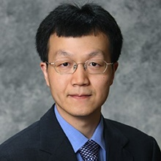
Dr. Guanghui Hua is currently an associate professor in the Department of Civil and Environmental Engineering at South Dakota State University. He received his PhD degree in civil engineering from the University of Massachusetts at Amherst. Prior to joining SDSU, he had six years of consulting experience in water and wastewater treatment. His current research interests include drinking water treatment, disinfection byproducts, and stormwater treatment.

