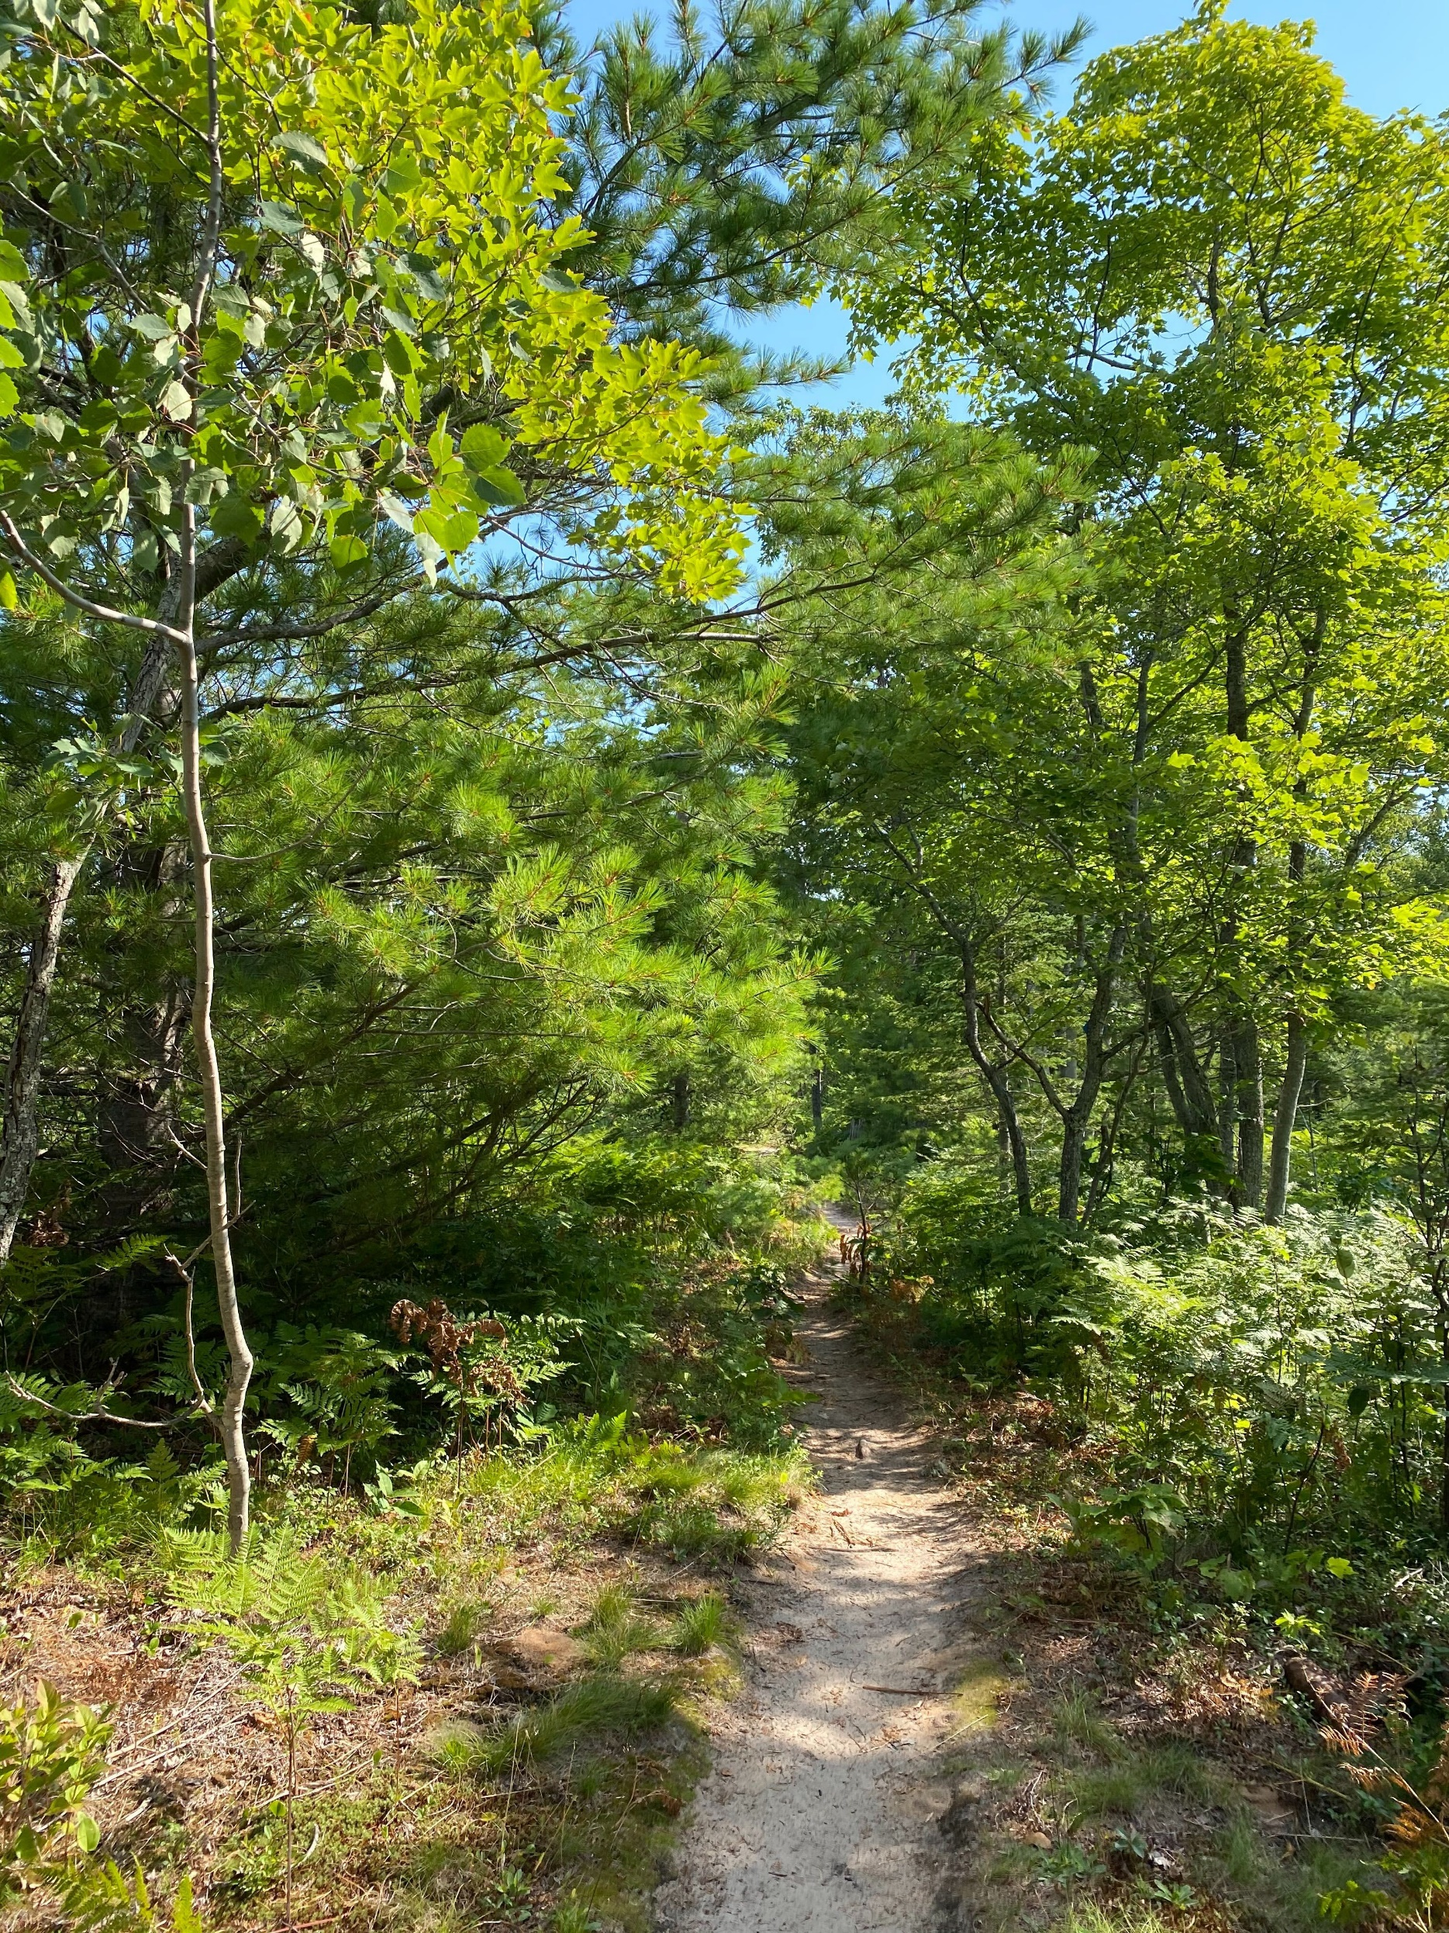
A quick start guide
to adaptation planning for
land trusts.




2020

About this document
This document was created by the Northern Institute of Applied Climate Science in collaboration with the Land Trust Alliance. This Quick Start Guide was developed specifically to support Land Trusts and serve as a stepping stone for the process of adaptation planning. Information from this toolkit was adapted from the US Forest Service report Forest Adaptation Resources: Climate Change Tools and Approaches for Land Managers, 2nd edition. Download the full publication at: www.nrs.fs.fed.us/pubs/52760

This product was developed in partnership with the Land Trust Alliance’s Land and Climate Program, which is generously funded by the Doris Duke Charitable Foundation.

Learn more about this on-going collaboration at: www.forestadaptation.org/land-trusts

Authors
Maria Janowiak, Kristen Schmitt, Danielle Shannon
Northern Institute of Applied Climate Science

DRAFT REPORT intended for Land Trust Alliance’s Climate Adaptation for Land Trusts Short Course. Do not cite or distribute.

Introduction

Land trust activities are constantly changing to accommodate new challenges, and it’s becoming increasingly important that conservation and stewardship activities intentionally consider a changing and uncertain climate.

This Quick Start Guide to Adaptation Planning for Land Trusts gives you a starting point to help you design and implement adaptation actions in your work, with a special eye toward stewardship activities. It draws on the five-step Adaptation Workbook process to help you consider how climate change will affect your lands and your associated goals for land conservation and stewardship. By intentionally considering the potential impacts, challenges, and opportunities from climate change, you can then use this lens to identify actions that enable ecosystems to cope with stressors and adapt to changing conditions, while also addressing your conservation priorities.

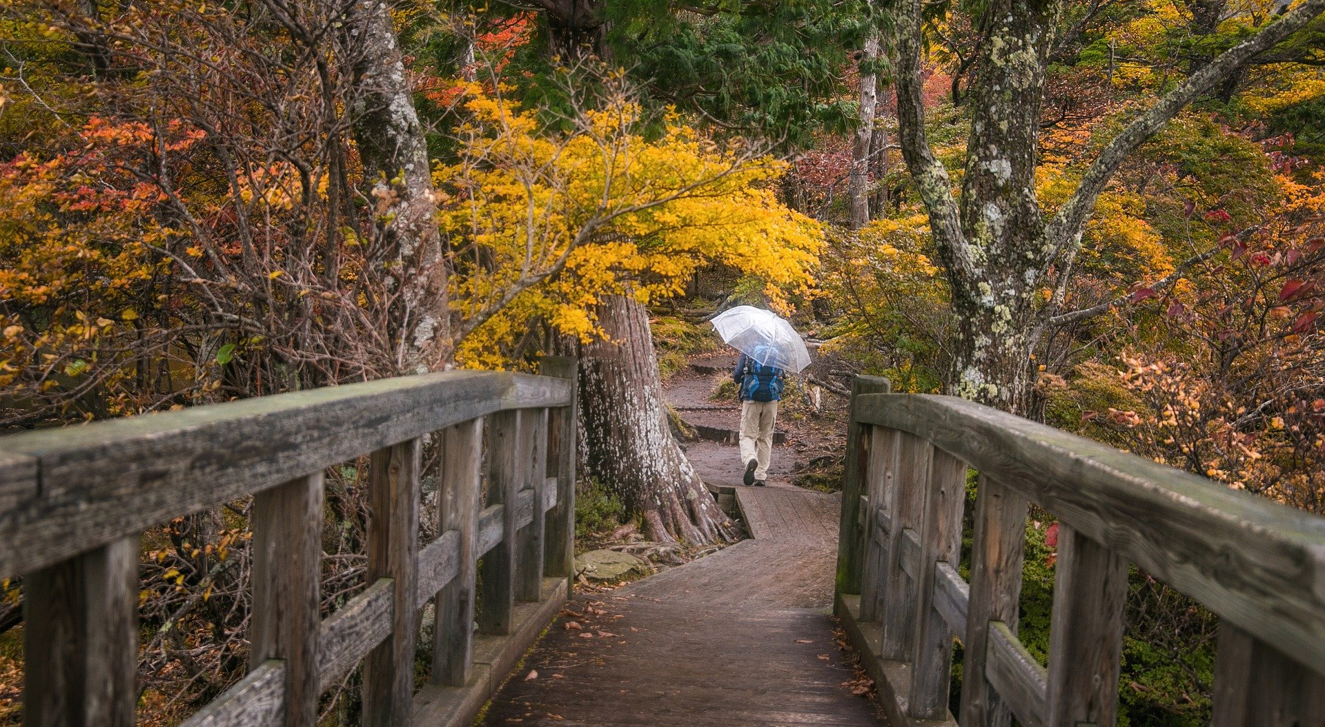

What is climate adaptation?
This guide focuses on helping land trusts identify adaptation actions in response to changing climate conditions. Adaptation actions are designed in response to the impacts of climate change that are already occurring or are expected to occur in the future, such as rising sea-levels or more intense storms. Mitigation actions address the root cause of human-caused climate change by reducing the atmospheric greenhouse gases responsible for climate change, either through emissions reductions or through nature-based solutions.

Many adaptation actions have benefits for mitigation because intact ecosystems maintain their important ability to sequester carbon. Adaptation projects can be designed to have mitigation benefits when carbon sequestration is identified as a goal at the outset of the adaptation planning process.

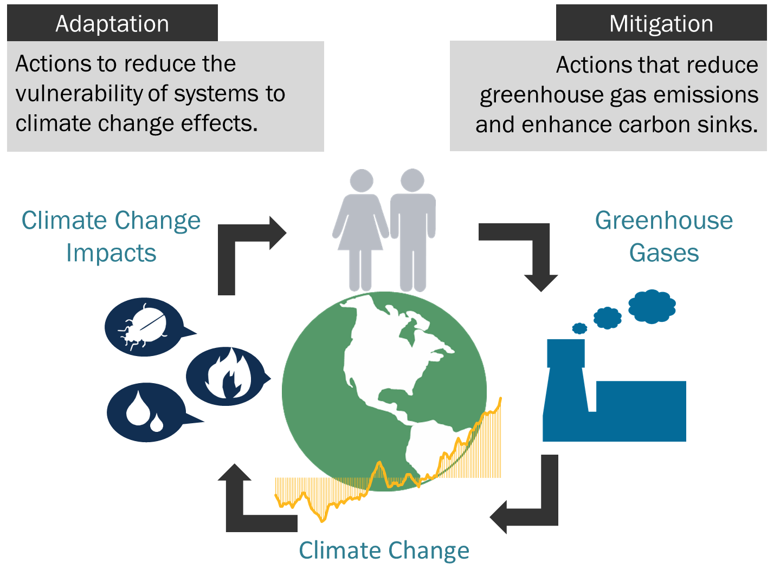

Land trusts can respond to climate change by adapting to changing conditions, as well as supporting actions that reduce the accumulation of greenhouse gases in the atmosphere.

The Adaptation Workbook
This Quick Guide outlines the key steps of developing an adaptation project, enabling you to rapidly start thinking about climate change impacts and adaptation actions.

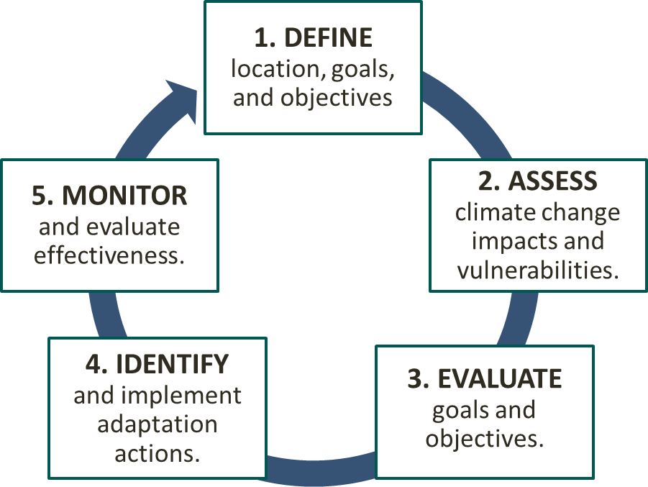
The process is based on the five-step Adaptation Workbook, developed by the Northern Institute of Applied Climate Science (NIACS). The Adaptation Workbook provides a structured, yet flexible approach for integrating climate change into conservation and stewardship projects.

This guide provides a short description and example for each step of the process. A four-page set of worksheets at the end of the guide can be used to do a quick and easy exploration of adaptation for a small project area.

When you are ready, you can use the complete Adaptation Workbook process to take a deeper dive into the topic and create a complete climate change adaptation plan.

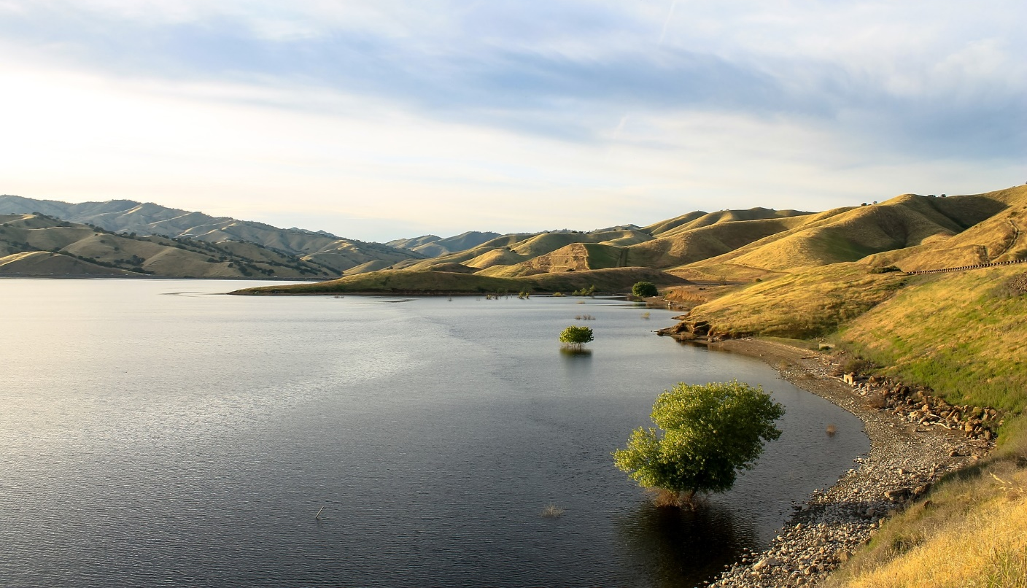

Step 1

DEFINE project goals and objectives.

What are your management goals and objectives for the project area?
Clearly-stated goals and objectives are important for helping you and your partners and stakeholders describe exactly where you want to go. As you set up a new project, you will want to answer two fundamental questions:

Where is your project located? The project could focus on one nature area or a single small parcel, which may be a good fit for the format of this Quick Guide. Larger and more complex projects could include a large property or multiple parcels scattered across a community or landscape; these are better suited to the full Adaptation Workbook. (Visit www.forestadaptation.org/workbook for more details.)

What are you trying to achieve? The project should articulate clear management goals and objectives to describe the intent of the project and the desired outcomes.
- Management goals describe the broad outcomes you are trying to accomplish. Goals outline the big picture and set the long-term vision for where you want to go.
- Management objectives are more specific actions that support the completion of a goal.
Using the house analogy, your goals form the foundation that you build on, while the objectives are the walls and roof that form the shell of the house. As much as possible, objectives should be SMART: specific, measurable, achievable, relevant, and time-bound.

Examples of Management Goals and Objectives for a Land Trust
Management Goal | Management Objective
Restore a diverse mix of prairie, savanna, and forest resembling Michigan’s historical landscape matrix. | Expand existing prairie by an average of 1 acre per year, resulting in an area dominated by native prairie and savanna vegetation at least 17 acres in size.
Improve accessibility for passive recreation. | Build 5 miles of trail that take into account resource protection and wildlife viewing opportunities (5 years).
Reduce invasive species cover to allow canopy trees to regenerate in natural areas. | Reduce area covered by invasive buckthorn from 10% to no more than 5% (10 years).
Maintain and improve the health of North Brook to promote coldwater fish habitat. | Stabilize 50 feet of eroding banks (5 years).

Step 2

ASSESS climate change impacts and vulnerabilities.

What climate change impacts and vulnerabilities are most important to this site?
Climate change will affect our natural landscapes and the human communities that depend upon them in many ways. Although we have a wealth of information about climate change impacts nationally and regionally, climate change will affect each area differently based on the local characteristics that are unique to that place.

In this step, you will identify the local factors that may increase or reduce the potential effects of climate change in your project area. Some examples of these factors are:
- Site conditions, such as topographic position, soils, or hydrology
- Past and current management that has affected the condition of the land
- Ecosystem composition and structure
- Susceptibility to pests, diseases, or other stressors that may become more frequent and severe
You can consult vulnerability assessments for information on the anticipated effects of climate change on ecosystems for a particular region. Some focused resources are posted here.

After describing local climate change impacts, you can rate your level of vulnerability:
- Low – Ecosystems are expected to readily cope with potential climate change impacts. Climate change is more beneficial to ecosystems than disruptive.
- Moderate – Climate change impacts are expected to alter ecosystems, but ecosystems will be able to cope with some impacts.
- High – Climate change impacts are expected to exceed the ability of the ecosystem to cope with impacts. Ecosystems may undergo changes that will disrupt important ecosystem functions and key environmental benefits.

Examples of Regional and Local Climate Change Impacts
Regional | Local and Project-Level Impacts
Changes in habitat suitability from northern to more southern species | Project area contains a diverse mix of species, including many that are prevalent in locations to the south.
Increased average precipitation/periods of flooding | Many low-lying areas in the preserve are already prone to flooding and wet trail conditions.
Increased late-season drought | Drought stress could exacerbate existing on-site issues with pests and diseases.
Increased average temperatures/high temperatures | Stream on property supports healthy populations of coldwater fish species and contains some of the most high-quality habitat in the nearby area.

Step 3

EVALUATE goals and objectives.

What management challenges and opportunities may occur as a result of climate change?
Once you have identified the climate change impacts on your project area, consider how these impacts could influence the goals and objectives that you identified in the first step.

Four questions can be useful to help you evaluate your project goals and objectives in the context of climate change:
- What new or different challenges need to be addressed as a result of climate change and related stressors?
- What new opportunities might be available as a result of anticipated changes?
- Are your current management practices enough to overcome the challenges and meet your management goals and objectives?
- Do any of your goals or objectives need to change?

Once you have thought about how climate change may create challenges or opportunities to your project, you may realize that there may be conditions where it may no longer be feasible to meet some of the goals and objectives that you identified in Step 1. If this is the case, this is an appropriate time to revise your goals or objectives before moving onto the next step.

Examples of Climate Change-Related Challenges and Opportunities
Challenges to Meeting Project Goals/Objectives from Climate Change | Opportunities for Project Meeting Goals/Objectives from Climate Change
Increasing droughty conditions could facilitate the expansion of invasive plant species. | Hotter, drier summers will benefit most native prairie species, and prairie community as a whole in the project area.
Flood conditions could limit suitable locations for trail building. | Increasing length of shoulder seasons could allow more time for trail building and trail use.
Increasing climate-caused disturbances could open areas to colonization by invasive species. | Drier late-season conditions could allow for new windows to conduct prescribed burning.
Heavy precipitation events may increase erosion and impact stream water quality. | Increases in storms/downed woody debris could increase stream habitat complexity.

Selecting Adaptation Strategies
Adaptation strategies will vary widely depending on the community and landscape context, including the geographic location, extent of development, ownership, and management goals. For this reason, there is no single answer on how to best adapt to climate change, and adaptation responses will vary by location based upon the magnitude of climate impacts, the inherent resilience of ecosystems, and the values and resources of local communities.

The Northern Institute of Applied Climate Science has led the development of Adaptation Strategies and Approaches for various natural resource topics, which can be used with the Adaptation Workbook. These “menus” provide topical lists of adaptation actions that not only help you move from broad ideas to specific actions but also help to express the adaptation intent of your actions.

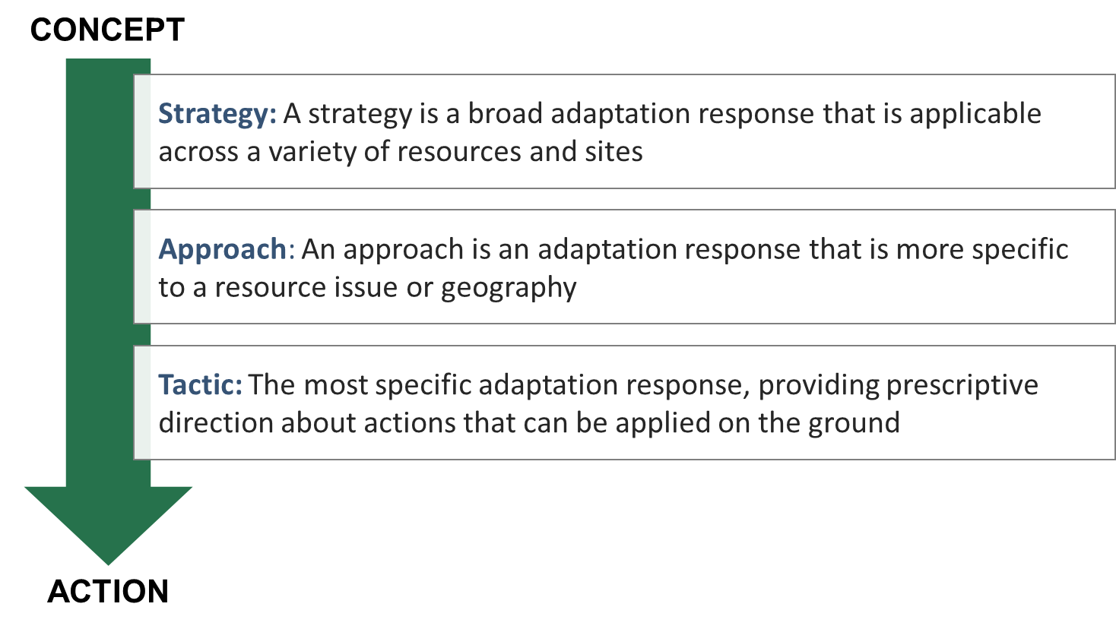

Adaptation Menus
Although menu items can be applied in various combinations to achieve desired outcomes, not all items on the menu will work together or work in every ecosystem. Land managers can use these menus to select appropriate actions based on their unique project location and goals.

Check out each of the Menus of Adaptation Strategies and Approaches:
Forest Ecosystems (pdf, interactive) | Forest Carbon (pdf, interactive)
Urban Forests (pdf, interactive) | Recreation (pdf, interactive)
Forested Watersheds (pdf, interactive) | Agriculture (pdf, interactive)
Non-forested Wetlands (pdf, interactive) | Fire-adapted Ecosystems (interactive) *draft menu
Tribal Perspectives (pdf)

Also in development: Wildlife Habitat management, Ocean Coastal Ecosystems, Great Lakes Coastal Ecosystems, Grasslands, Fire-adapted Ecosystems. Find all at www.forestadaptation.org/strategies.

Step 4

Identify and implement adaptation actions

You may need to alter your management practices to address new or increased challenges associated with a changing climate and environmental conditions. Identifying potential challenges and opportunities will position you to take action and adapt practices that will maximize the benefits your natural areas provide for ecosystems, wildlife, and human visitors.

What actions can enhance the ability of the ecosystem to adapt to anticipated changes and meet management goals?

Start by brainstorming and outlining specific actions or tactics that you want to evaluate for your project, and then consider:
- Time Frames – When would this action be implemented? Some actions may occur in the short term, while others may not occur for a long time or will occur only in certain situations (such as after a large disturbance).
- Benefits – What benefits does the action provide? For example, note if a tactic addresses your biggest challenge, addresses multiple challenges, or has co-benefits like improving carbon mitigation and visitor experiences.
- Drawbacks and Barriers –What drawbacks are associated with this action? Note any negative effects or potential barriers (e.g., legal, financial, infrastructural, social) that are likely to arise.
- Effectiveness – Does the action meet the desired intent?
- Feasibility – Can the action be implemented?

After considering the above items, you will be better able to select the specific actions or tactics that are a good fit for your situation. The preferred actions will likely be those that overcome the greatest challenges, have major benefits, and can be implemented given your available resources.

Examples of Adaptation Tactics, with Adaptation Strategy/Approach and Details
Adaptation Tactic (action and timeframe) | Adaptation Strategy or Approach | Benefits, Drawbacks, and Barriers (notes)
Collect seeds for restoration planting from a greater diversity of sites and increase diversity of prairie seed mixes. (in 2 yrs) | Use seeds, germplasm, or other genetic material from across a greater geographic range (Forest Approach 8.1) | Limited availability of sources for prairie seed of desired species.
Construct new trails away from frequently saturated areas and use boardwalks to provide access to wildlife viewing areas. (in 5 yrs) | Relocate Existing Infrastructure and Opportunities to Areas with Less Risk of Climate-Exacerbated Damage (Recreation Approach 6.2) | Boardwalks will increase cost but also minimize visitor impact to resource.
Use repeated physical removal of buckthorn along stream corridor to promote regeneration of native species and inhibit downstream spread. (over 10 yrs) | Prevent the introduction and establishment of invasive plant species and remove existing invasive species (Forest Approach 2.2) | Potential to use volunteers for buckthorn removal.

Step 5

Monitor and evaluate effectiveness.

What information can be used to evaluate whether the selected actions were effective and inform future management?
Monitoring is about asking the right questions that will help you ensure desired outcomes over time. There are different types of monitoring that you’ll encounter in science and management. In scientific research, we may have a question and a hypothesis, and with quality replication we can judge deviation through time. But, most of us will find this methodology difficult to implement because of the financial costs, time and effort involved. Instead, the focus should be on evaluating whether you are achieving the goals and objectives that you identified at the outset of the project and to what extent your actions were effective in helping you meet those goals and objectives.

Practice adaptive management. It has always been impossible to predict the future, and climate change makes that uncertainty even more apparent. Adaptive management supports decision-making in the face of uncertain future conditions by adopting a flexible approach that allows you to adjust your management as new information becomes available.
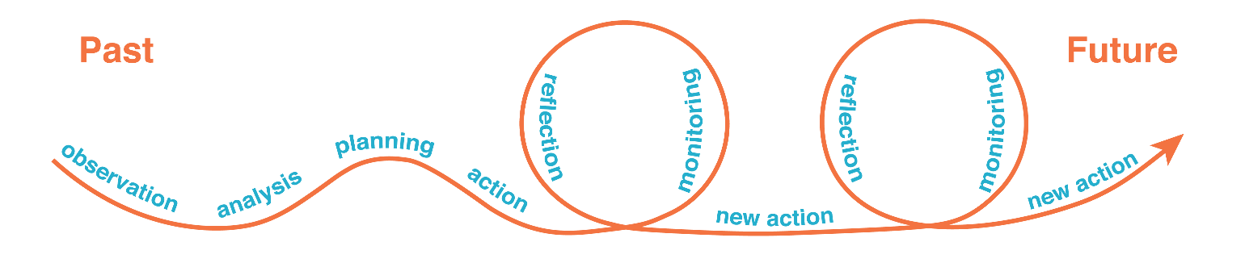
Examples of Monitoring Items and Details
Objective or Adaptation Tactic | Monitoring Item
Expand existing prairie by an average of 1 acre per year, resulting in an area dominated by native prairie and savanna vegetation at least 17 acres in size. | Diversity of native prairie spp. in restored areas 1, 5, and 10 years following restoration.
Construct new trails away from frequently saturated areas and use boardwalks to provide access to wildlife viewing areas. | # of days of trail closure due to wet conditions, # of user-reported problems.
Reduce area covered by invasive buckthorn from 10% to no more than 5%, prioritizing locations along stream corridor. | Percent buckthorn cover at 2 and 5 years following treatment.
- Vegetate stream corridor by planting and encouraging natural growth of native plants along stream banks.  - Install bridge over stream where popular informal trail crossing causes erosion. | Water quality measurements (e.g. suspended sediments, nutrients) before and after management intervention.

Quick Form – Adaptation Workbook

Project Name/Location:

Date:

1. DEFINE project goals and objectives.
Management goals describe the broad outcomes you are trying to accomplish, while management objectives are more specific actions that support the completion of a goal.

Management Goals | Management Objectives

2. ASSESS climate change impacts and vulnerabilities.
Consider how climate change might affect your local landscape and natural areas. Identify the 5 climate change impacts that are most likely to affect your project area (left column) and describe local impacts in greater detail (right column).

Regional Climate Impact | Local and Project-Level Impacts
- Sea-level rise
- Warmer temperatures and extreme heat
- Shorter, warmer winters
- Longer growing season
- Increased winter and spring precipitation
- More frequent heavy precipitation events
- Reduced soil moisture or drought
- Increased risk of wildfire
- Altered stream flows
- Changes in species ranges or assemblages (plant or animal)
- Damage from insect pests or pathogens
- Increases in nonnative plant species
- Other:

How vulnerable is your project area to climate change?
- Low – Ecosystems are expected to readily cope with potential climate change impacts.
- Moderate – Some impacts are expected, but ecosystems will be able to cope.
- High – Climate change impacts will likely exceed the ability of the ecosystem to cope with impacts. Important ecosystem functions and key environmental benefits may be disrupted.

3. EVALUATE goals and objectives.
Challenges to Meeting Project Goals/Objectives from Climate Change | Opportunities for Project Meeting Goals/Objectives from Climate Change
Look back at your goals and objectives from Step 1 and consider whether they are still feasible give the challenges and opportunities that you just identified. Do you need to change any of your goals and objectives?
No Yes (If yes, revise Step 1 before moving on.)

Step 4: IDENTIFY and IMPLEMENT adaptation actions.
What actions can help address climate change impacts and challenges, while also helping to derive the benefits that you value? Consider a variety of actions, including:
- Management actions that are already part of your everyday work or “business as usual” that also have benefits for climate adaptation.
- Possible small tweaks or enhancements that improve upon what you’re already doing.
- Any major deviations from what you might typically do, including wild and crazy ideas.

There are several menus of adaptation strategies and approaches. Select the one that is the most applicable to your project:
Forest Ecosystems (pdf, interactive) | Forest Carbon (pdf, interactive)
Urban Forests (pdf, interactive) | Recreation (pdf, interactive)
Forested Watersheds (pdf, interactive) | Agriculture (pdf, interactive)
Non-forested Wetlands (pdf, interactive) | Fire-adapted Ecosystems (interactive) *draft menu
Tribal Perspectives (pdf)

Adaptation Tactic (action and timeframe) | Adaptation Strategy or Approach from Menu (optional, or fill in later) | Benefits, Drawbacks, Barriers, Effectiveness (take notes)

Step 5: MONITOR and evaluate effectiveness.
What is an example of something you could monitor to evaluate whether your management actions helped to both achieve the management goals and increase the ecosystem’s ability to adapt to changing conditions?
Management Objective or Adaptation Tactic | Monitoring Item

Resources and references found in this document
Adaptation Strategies and Approaches. All adaptation menus can be found at forestadaptation.org/strategies . Some menus are included in the Adaptation Workbook online tool, adaptationworkbook.org/strategies.

The full version of the Adaptation Workbook publication can be found and downloaded at forestadaptation.org/workbook. The interactive online version is found at adaptationworkbook.org

National Climate Assessment (2018) describes climate impacts for all regions of the U.S., and provides sectoral information related to Forests, Water Resources, Infrastructure, Energy, etc. Find regional or national summaries at, nca2018.globalchange.gov. More information can also be found at the Adaptation Workbook Explore Impacts tool, adaptationworkbook.org/explore-impacts

The organizations who produced this document can be found at: Northern Institute of Applied Climate Science, www.niacs.org/. NIACS Climate Change Response Framework, forestadaptation.org/. Land Trust Alliance, www.landtrustalliance.org/

Forest Adaptation Strategies and Approaches
View all published menus here.

Strategy 1: Sustain fundamental ecological functions.
1.1. Reduce impacts to soils and nutrient cycling.
1.2. Maintain or restore hydrology.
1.3. Maintain or restore riparian areas.
1.4. Reduce competition for moisture, nutrients, and light.

1.5. Restore or maintain fire in fire-adapted ecosystems.

Strategy 2: Reduce the impact of biological stressors.
2.1. Maintain or improve the ability of forests to resist pests and pathogens.
2.2. Prevent invasive species establishment and remove existing invasive species

2.3. Manage herbivory to promote regeneration of desired species.

Strategy 3: Reduce the risk and long-term impacts of severe disturbances.
3.1. Alter forest structure or composition to reduce risk or severity of wildfire.
3.2. Establish fuelbreaks to slow the spread of catastrophic fire.
3.3. Alter forest structure to reduce severity or extent of wind and ice damage.
3.4. Promptly revegetate sites after disturbance.

Strategy 4: Maintain or create refugia.
4.1. Prioritize and maintain unique sites.
4.2. Prioritize and maintain sensitive or at-risk species or communities.
4.3. Establish artificial reserves for at-risk and displaced species.

Strategy 5: Maintain and enhance species and structural diversity.
5.1. Promote diverse age classes.
5.2. Maintain and restore diversity of native species.
5.3. Retain biological legacies.
5.4. Establish reserves to maintain ecosystem diversity.

Strategy 6: Increase ecosystem redundancy across the landscape.
6.1. Manage habitats over a range of sites and conditions.
6.2. Expand the boundaries of reserves to increase diversity.

Strategy 7: Promote landscape connectivity.
7.1. Reduce landscape fragmentation.
7.2. Maintain and create habitat corridors through reforestation or restoration.

Strategy 8: Maintain and enhance genetic diversity.
8.1. Use seeds, germplasm, and other genetic material from across a greater geographic range.
8.2. Favor existing genotypes that are better adapted to future conditions.

Strategy 9: Facilitate community adjustments through species transitions.
9.1. Favor or restore native species that are expected to be adapted to future conditions.
9.2. Establish or encourage new mixes of native species.
9.3. Guide changes in species composition at early stages of stand development.
9.4. Protect future-adapted seedlings and saplings.
9.5. Disfavor species that are distinctly maladapted.
9.6. Manage for species and genotypes with wide moisture and temperature tolerances.
9.7. Introduce species that are expected to be adapted to future conditions.
9.8. Move at-risk species to locations that are expected to provide habitat.

Strategy 10: Realign ecosystems after disturbance.
10.1 Promptly revegetate sites after disturbance.

10.2. Allow for areas of natural regeneration to test for future-adapted species.

10.3. Realign significantly disrupted ecosystems to meet expected future conditions.

From: Swanston et al. 2016. Forest Adaptation Resources: Climate change tools and approaches for land managers (2nd edition). USDA Forest Service, Northern Research Station. Gen. Tech. Rep. NRS-GTR-87-2. www.nrs.fs.fed.us/pubs/52760

