STREAMLINED APPLICATION PROCESSING PILOT PROGRAM FOR AHFA-FUNDED PROJECTS

- Sign on/Create a Landlord account at ERAAlabama.com using the apply/login as seen below.
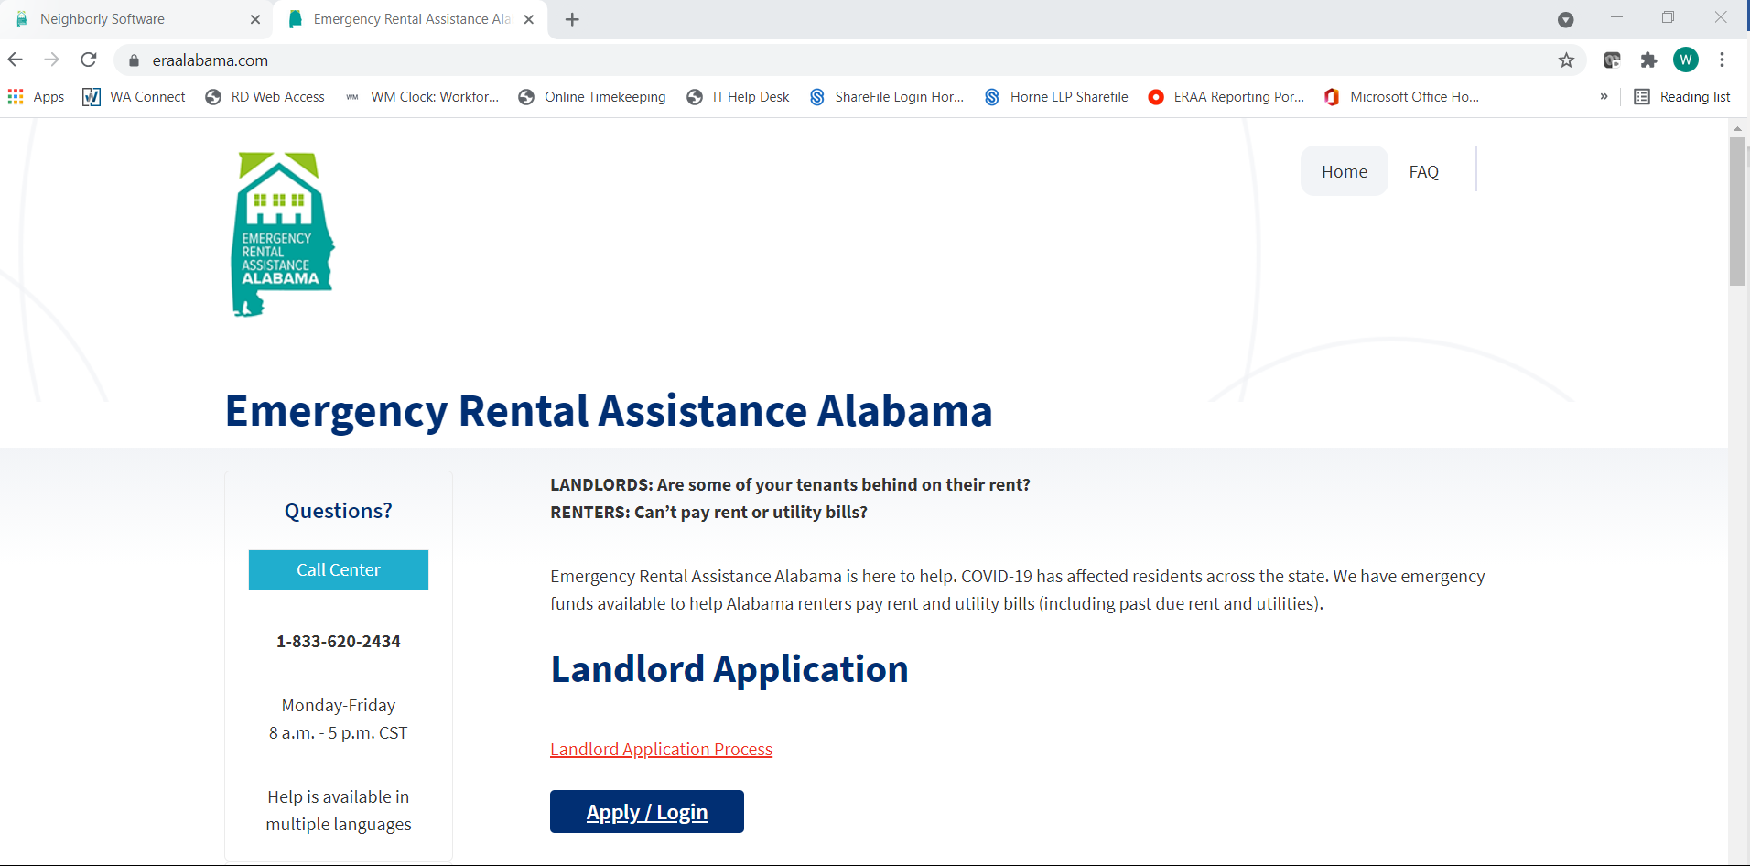

- Download the spreadsheet by first selecting the Application tab, then select tab B. Tenant(s) Information. You will then see “click here” highlighted in blue letters, select “click here” to download the spreadsheet.

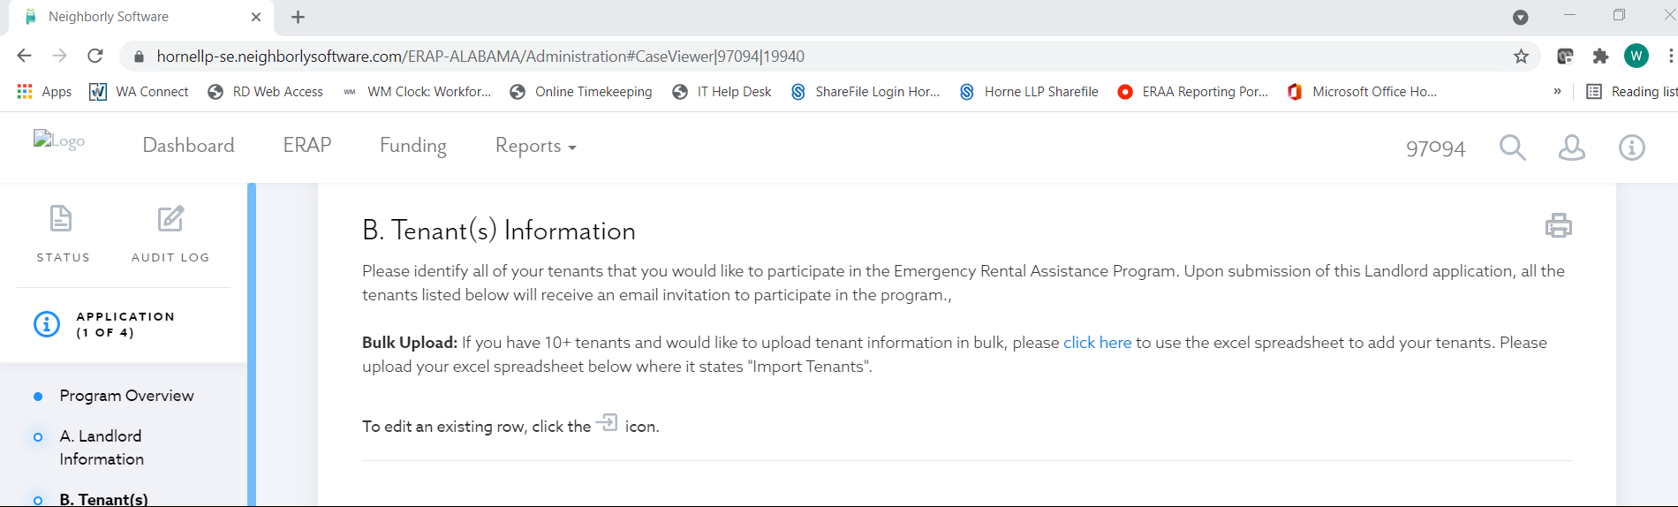

- Complete the spreadsheet with data requested with all tenants that qualify based on the program guidelines for tenants that need assistance for past due and/or current rent:
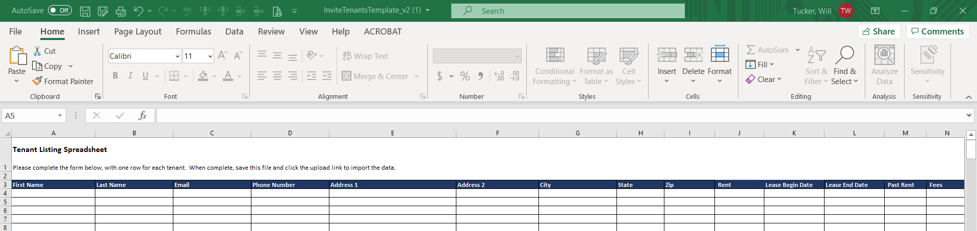
Note: a tenant does not have to be in arrears to qualify for the program.
  - All fields are required.
  - Required email format XXXXXX@XXXX.XXX
  - If there is no tenant email address, please upload the required documents and request your ERA Alabama Analyst to add the tenant.
  - Required Phone number format is XXX-XXX-XXXX.
  - Please enter only one phone number per tenant.
  - Enter tenant portion of monthly rent in the Rent Column J.
  - Please enter a “0” (zero) if there is no lease begin, lease end, past due rent or past due fees (columns K-N).

- Once the spreadsheet is complete, use the import tenants link on tab B. Tenant(s) Information.
  - If you receive a duplicate email error:
    - Continue to upload the required documents in the tenant section.
    - Copy and paste duplicate email rows to a new spreadsheet.
    - Delete duplicate email rows and attempt start the import process again.
    - Email new spreadsheet to your ERA Alabama analyst and request the tenant’s case be associated with your Landlord number.
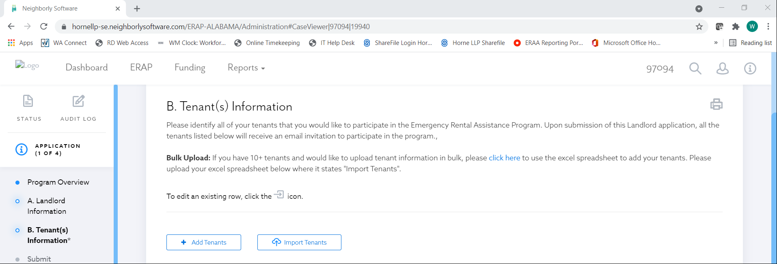

- Email all the tenants for which you have created a case and provide them with the attached ERA Alabama Tenant Certification document and have them return the completed signed document to complete the eligibility requirement for the program.

- For each tenant you will need to upload the following documents as one pdf per tenant in the order listed below and name the document using the following naming convention: AHFAProjectName_AptNo_ApplicantLastName.pdf.
  - Current Rental Ledger
  - Lease or leases covering the rental assistance requested
  - Photo ID for the Primary Applicant (Tenant listed on the spreadsheet)
  - ERA Alabama Tenant Certification
  - Tenant Income Certification
  - Utility bills for any utility that the tenant may request (ie. power, water, trash, internet, gas, etc.)

- Upload steps 6 to tab B. Tenant(s) information under documentation.
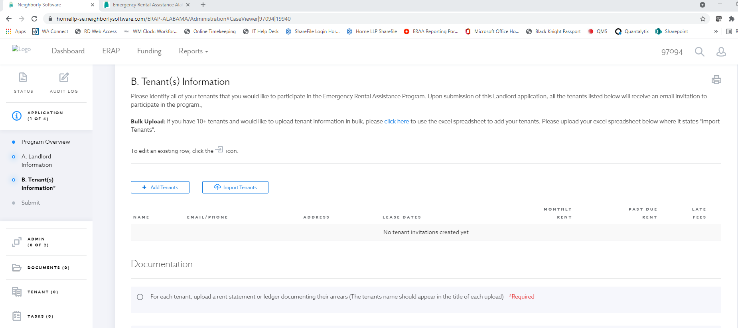

- After all information is complete and uploaded, you will need to contact ERA Alabama at ERAAHFAFunded@ahfa.com to be assigned an analyst. Attach as part of the email the ERA Project Rental Information Sheet:
  - Provide an estimated amount of total arrearage (past due rents) owed for your project.
  - Provide an estimated total of forward rent payments for your project.

- After all documentation has been successfully uploaded, frequently check your landlord application by logging back in as you did in step 1. Once an application is approved and ready for payment, you can expect an email from the supplier portal, Bill.Com, requesting ACH information (direct deposit).

