Getting in Shape Fiscally
A financial planning seminar

Key Seminar Details:

Saturday, March 9, 2019
Princeton Theological Seminary
Princeton, NJ
8:30 a.m. – 5:00 p.m., ET

Sponsored by Princeton Theological Seminary

- Seating limit: 30 registrants
- Board’s registration fee: None
- Meal fee: Meals will be cash basis in the cafeteria.
- Lodging: See registration site for options
- Confirmations include pre-seminar work and meal fee payment instructions.

Registration Information:

Registration closes February 18, 2019
Secure Board of Pensions registration site:
http://www.cvent.com/d/1bqt0f

Have questions about the seminar?
Contact the Board of Pensions at 800-PRESPLAN.
How “fiscally fit” are you? This one-day seminar is for plan members and seminarians looking to get their financial house in order. Attend and learn about:

- money danger signals and building budgets,
- terms of call and clergy taxes basics,
- debt reduction, saving, and investing, and
- estate planning basics.

About Board University Education Seminars

Do you have questions about retirement, taxes, financial planning, or terms of call? Board University can help.

Attend our financial and retirement planning seminars led by Board of Pensions experts, and leave with answers, better questions, and trusted resources.

Note: Board University programs educate and inform attendees. Participants are encouraged to seek professional advice and counsel for specific tax and legal questions.

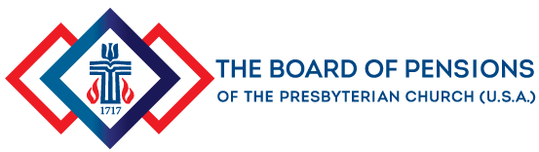
Learning through the stages of your life.
BOARD UNIVERSITY

