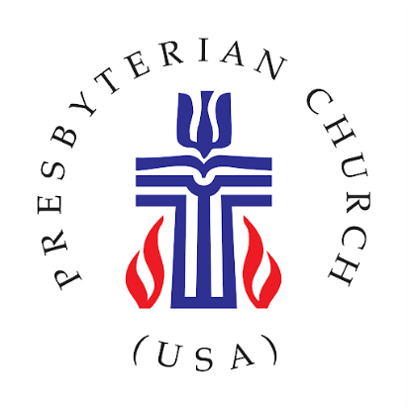
August 2020

Dear Presbytery Leader,

As you are well aware, there is a social uprising happening all around us. In the midst of the COVID-19 pandemic, there is a landscape of desire and demand for change in the racism that is prevalent and persistent in how marginalized communities are treated. In the wake of this, the Presbyterian Church (USA) is taking a public stand. But we cannot do this without you!

It is abundantly clear through the gospel narrative and the greater witness of the Bible, that God has called us, as people of faith, to seek justice for those most marginalized in our world. It is because of this that we are launching the Presbyterian Church (USA) Week of Action on August 24th – 30th. During this week we will be hosting a variety of virtual and in-person events. This endeavor is structured to provide a public witness that facilitates education, visibility, and action that reinforces our PC(USA) statements and policy around the support of eradicating racism and acknowledging that God loves all Black lives.

It is our hope that your presbytery and member congregations would take part in one or more of the events scheduled. All information can be found on the website, https://www.pcusa.org/weekofaction/. We would like to stand in unity and solidarity with those in Louisville and at the Presbyterian Center as we call for justice for Brionna Taylor, Tony McDade, George Floyd, and others who have lost their lives to state sanctioned racially targeted violence. For more information not listed on the website please feel free to contact, Rev. Shanea D. Leonard, Associate for Gender & Racial Justice who is the primary architect for the week’s events. Finally, please check out the Bearing Witness website, https://www.pcusa.org/bearingwitness/ , for yard signs and more information for on-going efforts to stand for justice beyond the week of action.

In Solidarity,

Rev. Shanea D. Leonard,
Associate of Gender & Racial Justice
Bearing Witness Committee
Presbyterian Mission Agency

