Local Bid Opportunities


Procurement Website:
https://www.utrgv.edu/procurement/
Procurement Policy:
https://www.utrgv.edu/procurement/_files/documents/purchasing/proceduresmanual/procurement-office-procedures-july-2022.pdf
Opportunities website:

utrgv.bonfirehub.com

Note: Bonfire registration will be required to Participate.


Procurement Website:
https://www.tsc.edu/about/purchasing/
Procurement Policy (How to do Business) :
https://www.tsc.edu/wp-content/uploads/2022/09/How-to-do-Business-with-TSC-Annual-Vendor-Seminar-Sept-1.pdf
Opportunities website:
https://tsc.bonfirehub.com/portal/?tab=login

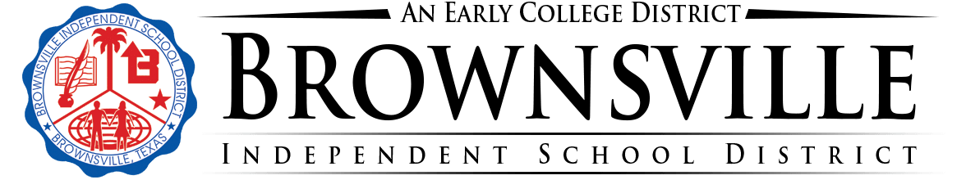
Procurement Website:
https://www.bisd.us/departments/l-w/purchasing
Procurement Policy:
https://resources.finalsite.net/images/v1691615623/bisdus/e7cm1ywjirfzy9an1u5g/PurchasingGuide_BISD2023-2024.pdf
Opportunities website:
https://bisdpurchasing.ionwave.net/Login.aspx
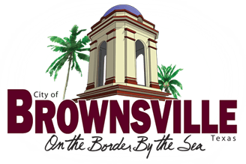
Procurement Website:
https://www.brownsvilletx.gov/402/Procurement-Contract-Management
Procurement Policy:
https://www.brownsvilletx.gov/2230/Doing-Business-With-the-City
Opportunities website:
https://brownsvilletx.bonfirehub.com/portal/?tab=openOpportunities


Procurement Website:
https://cityoflosfresnos.com/finance
Procurement Policy:
https://library.municode.com/tx/los_fresnos/codes/code_of_ordinances?nodeId=PTICH_ARTVIICIFIPR_S7.18PUPR ( Sec. 7.18. - Purchase procedure, Sec. 7.24 - Purchasing)
Opportunities website:
https://cityoflosfresnos.com/rfps%20


Procurement Website:
https://www.lfcisd.net/apps/pages/index.jsp?uREC_ID=1778787&type=d&pREC_ID=1956086&tota11y=true
Procurement Policy:
https://www.lfcisd.net/apps/pages/index.jsp?uREC_ID=1778787&type=d&pREC_ID=1956148
Opportunities website:
https://www.lfcisd.net/apps/pages/index.jsp?uREC_ID=1778787&type=d&pREC_ID=1956154


Procurement Website:
https://www.harlingentx.gov/page/finance.purchasing
Procurement Policy:
-Pending -
Opportunities website:
https://www.harlingentx.gov/page/finance.advertise.bids

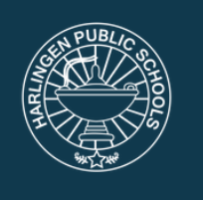
Procurement Website:
https://hcisd.edlioschool.com/apps/pages/index.jsp?uREC_ID=1223443&type=d&pREC_ID=1458264
Procurement Policy:
https://hcisd.edlioschool.com/apps/pages/index.jsp?uREC_ID=1223443&type=d&pREC_ID=1458277
Opportunities website:
https://hcisd.edlioschool.com/apps/pages/index.jsp?uREC_ID=1223443&type=d&pREC_ID=1458272

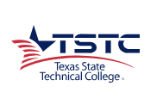
Procurement Website:
https://www.tstc.edu/about/procurement-services/
Procurement Policy:
https://www.tstc.edu/wp-content/uploads/2022/06/TSTC-Contract-Management-Handbook-Sept-2021-Final-ADA-Updated-Appendices-6.17.22.pdf
Opportunities website:
https://bids.sciquest.com/apps/Router/PublicEvent?CustomerOrg=TSTC


Procurement Website:
https://www.weslacotx.gov/departments/finance/purchasing.php
Procurement Policy:
https://cms9files.revize.com/weslacotx/Document%20Center/Finance/Purchasing/City_of_Weslaco_Purchasing_Policy.pdf
Opportunities website:
https://www.bidnetdirect.com/texas/cityofweslaco



Procurement Website:
https://cityofedinburg.com/departments/finance/purchasing.php
Procurement Policy:
https://cms7files.revize.com/edinburgtx/PURCHASING%20POLICIES%20&%20PROCEDURES%20MANUAL%2001.28.20FINAL.pdf
Opportunities website:
https://cityofedinburg.com/departments/finance/purchasing.php

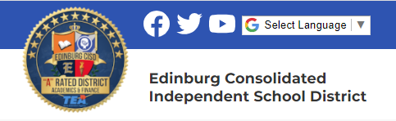
Procurement Website:
https://www.ecisd.us/apps/pages/index.jsp?uREC_ID=1311554&type=d&pREC_ID=1552662
Procurement Policy:

Opportunities website:
https://www.ecisd.us/apps/pages/index.jsp?uREC_ID=1311554&type=d&pREC_ID=calendar

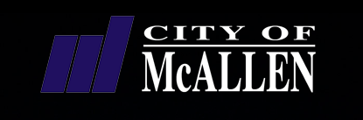
Procurement Website:
https://mcallen.net/departments/purchasing/home
Procurement Policy:
https://mcallen.net/departments/purchasing/city-s-bidding-portal
Opportunities website:
https://mcallen.procureware.com/home


Procurement Website:
https://pharr-tx.gov/purchasing/
Procurement Policy:
https://pharr-tx.gov/wp-content/uploads/downloads/2012/12/City-of-Pharr-Purchasing-Manual-FY-Aug-2012.pdf
Opportunities website:
https://pharr.procureware.com/Bids

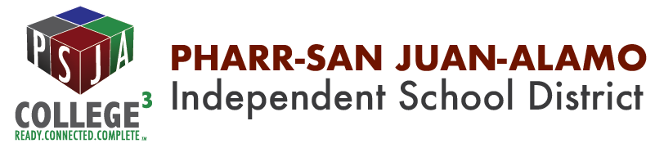
Procurement Website:
https://www.psjaisd.us/Domain/2230
Procurement Policy:

Opportunities website:
https://psjaebid.ionwave.net/CurrentSourcingEvents.aspx


Procurement Website:
https://missiontexas.us/city-departments/purchasing-department/
Procurement Policy:
https://mccmeetingspublic.blob.core.usgovcloudapi.net/missiontx-meet-7195375e26734b12844072bc17ae6d16/ITEM-Attachment-001-30d86177fe3d46ff8c71a1419714ecaf.pdf
Opportunities website:
https://missiontexas.us/bid-opportunities-2/
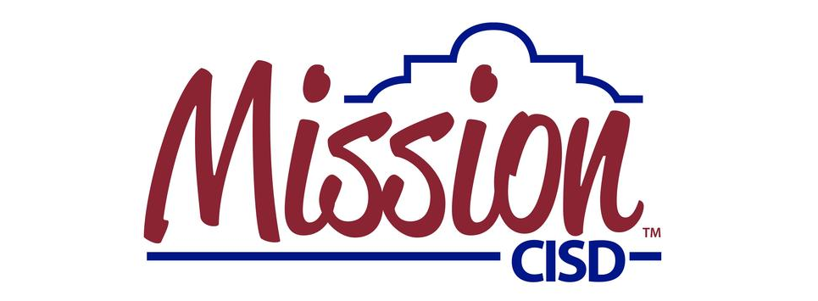
Procurement Website:
https://www.mcisd.net/apps/pages/index.jsp?uREC_ID=217607&type=d&pREC_ID=478739
Procurement Policy:
https://www.mcisd.net/apps/pages/index.jsp?uREC_ID=217607&type=d&pREC_ID=2419800
Opportunities website:
https://www.mcisd.net/apps/pages/vendoropportunities

