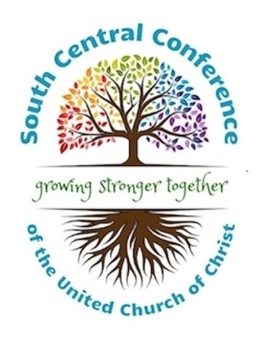

Important Update: 2026 Annual Meeting Format Change

Dear Friends in the South Central Conference,

Grace and peace to you.

We are writing to share an important update regarding our upcoming Annual Meeting. After careful consideration, the Executive Committee has made the decision to cancel our planned in-person gathering in College Station and move the meeting to a fully virtual format on Zoom.

This decision was not made lightly. In recent weeks, we became aware that a pre–World Cup game has been scheduled at the stadium in College Station during our meeting weekend. As a result, hotel prices—originally anticipated to be in the $80–$90 per night range—have risen dramatically, with current rates exceeding $200 per night. We explored multiple options, including alternative lodging and adjustments to our plans, but ultimately concluded that moving to a virtual format is the most responsible and equitable choice for our churches and participants.

Our Annual Meeting will now take place on Saturday, June 6, from 9:00 a.m. to 12:00 p.m. via Zoom. While the format will be different, we are committed to creating a meaningful gathering that includes not only the necessary business of the Conference, but also opportunities for worship and interaction.
For those who have already registered for the in-person meeting, full refunds will be provided. Registration will still be required for the virtual meeting, with a $5 fee to help cover the minimal costs associated with hosting the event.

We also want to acknowledge what is lost in this shift. Gathering in person matters. The relationships we nurture, the conversations in hallways, the shared meals and moments of worship—these are not easily replicated online. Because of this, we are planning an in-person event this fall focused on learning, fellowship, and worship, creating space for the connections that sustain and strengthen our life together. The clergy retreat originally scheduled prior to Annual Meeting will also be postponed and incorporated into this fall gathering.

As a reminder, our bylaws do allow for virtual meetings, and our usual quorum requirements will remain in place.
Thank you for your understanding, your flexibility, and your continued commitment to the shared ministry of the South Central Conference. Even as circumstances change, our connection to one another remains strong.

If you have questions, please don’t hesitate to reach out.

With gratitude and hope,

The Executive Committee
Rameen Zahed, President
Carol Etter, Treasurer
Ken Ehrke, Secretary
Molly Carlson, Conference Minister

