MassHire Central Career Centers
MULTI-INDUSTRY VIRTUAL JOB FAIR
DATE: Thursday, September 30th
TIME: 10:00 a.m. to 2:00 p.m.
Joining us this September will be employers from the Blakstone Valley Chamber!
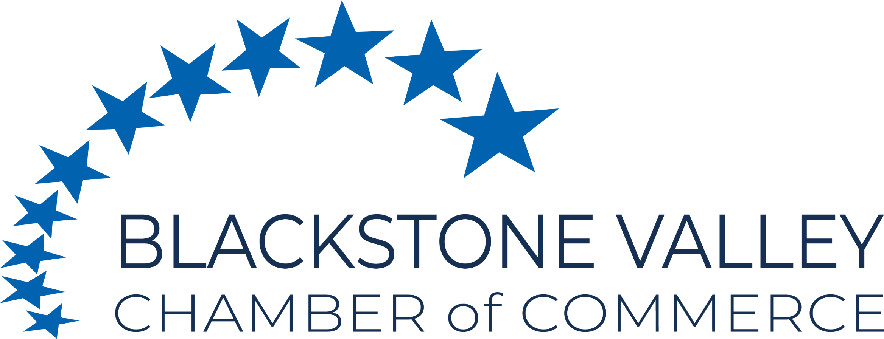
Invited job seekers are from multiple industries

SUCH AS:

- Healthcare
- Manufacturing
- Transportation Logistics and Warehousing
- Food Service
- Hospitality
- Administration
- Social Services
- Sciences and Technology
- Retail and Sales
- And More!

Welcome employers from Worcester, Milford, and Southbridge areas!
LOCATION: ONLINE - Premier Virtual
REGISTRATION DEADLINE: THURSDAY, 09/23/21
Open and free for any employer

PLEASE NOTE: MassHire offices are currently closed to the public. This event is taking place online.
HOW IT WORKS:

The Virtual Job Fair is being held on Premier Virtual, an online platform that allows job seekers to view employers’ virtual booths, view the companies’ information, review their job openings, and submit their resumes. Job seekers and employers can also instant message and video chat each other through the platform. Visit this link on YouTube to learn more about Premier Virtual.
What is Premier Virtual? - YouTube

Interested employers must pre-register at this link: https://masshirecentralcc.com/employers/recruitment/virtual-job-fair-employer-registration-page/

Employers who complete the pre-registration form on the MassHire website will be sent a unique link to register on Premier Virtual on the Monday before the event. Upon registering for the event on Premier Virtual, employers must provide their names, emails, phone numbers, and their company logo. Employers can select which areas they would like to recruit from (such as Worcester and Southbridge). Employers can add multiple recruiters to join the event. Adding YouTube videos describing your company and Zoom links for video interviewing to your virtual booth are optional, but recommended.

