Press Release

February 12, 2026
For: Immediate Release
Leslie Reichert
bv.emergency.shelter@gmail.com
508-266-5122
www.bvemergencyshleter.org

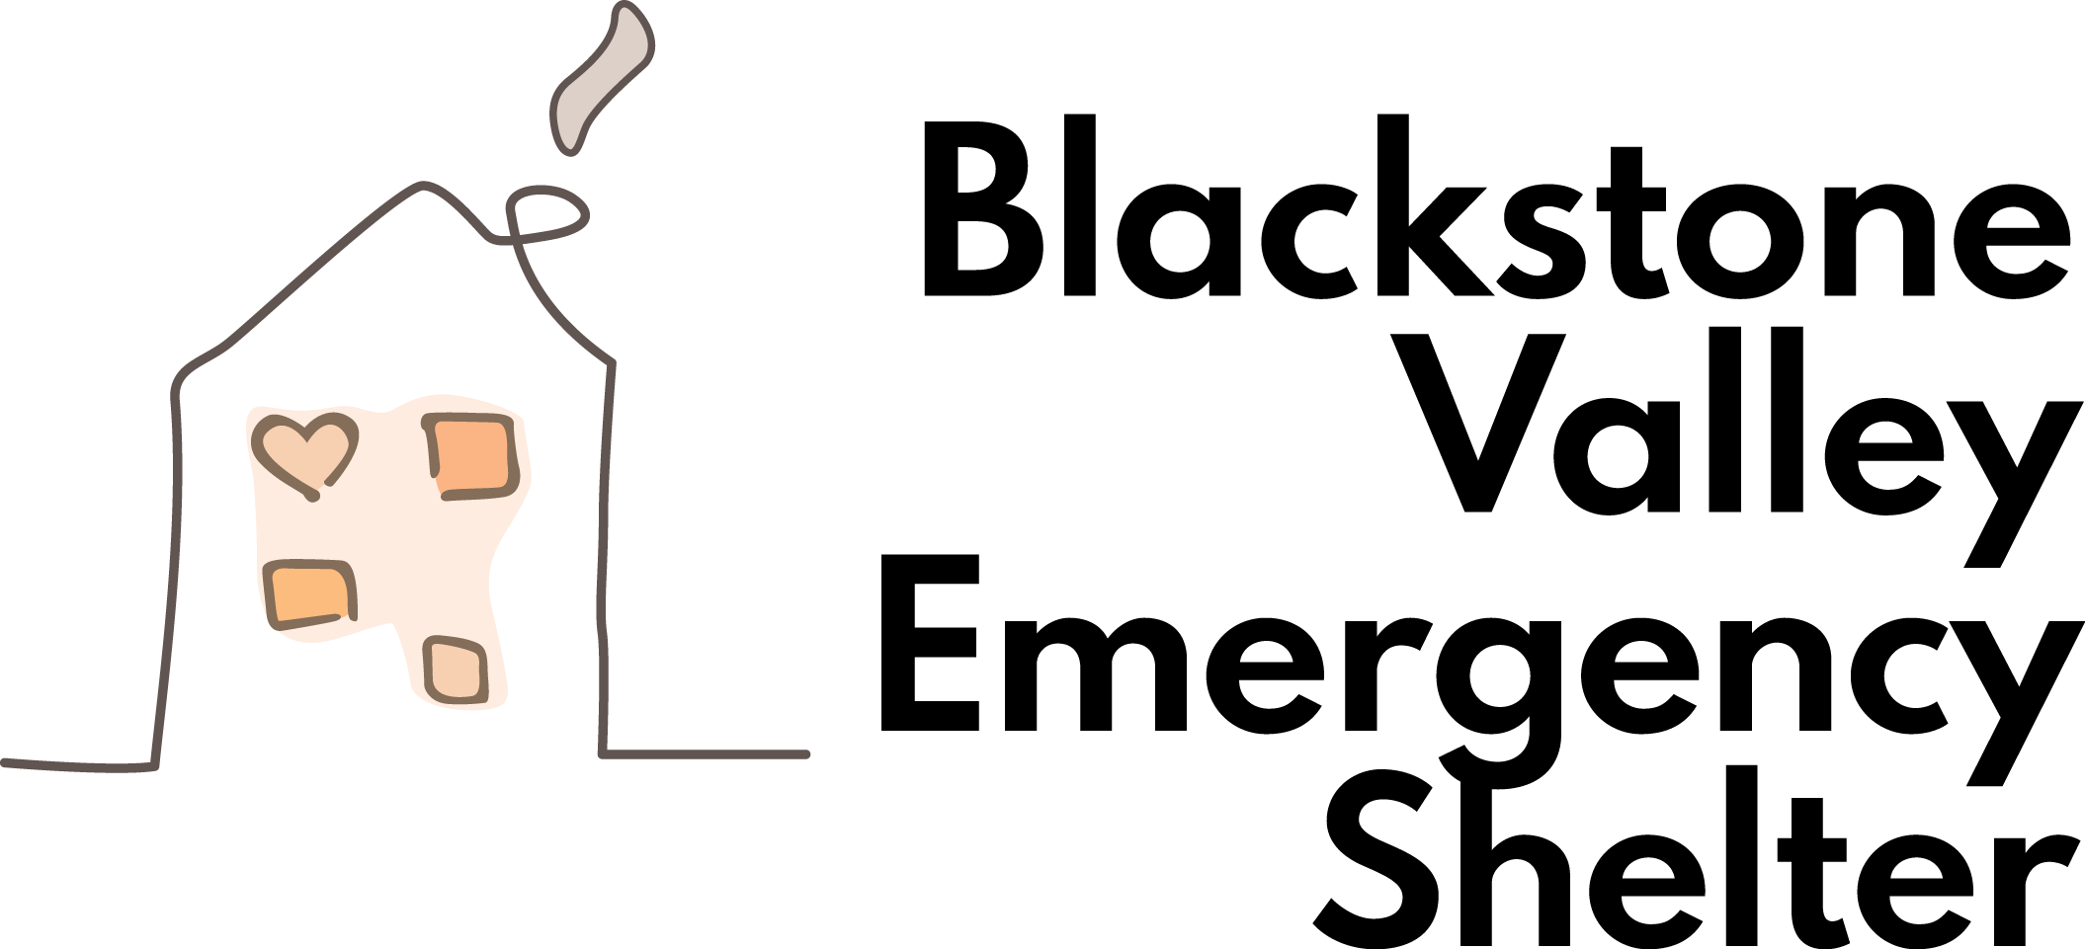

Blackstone Valley Emergency Shelter Announces Vendor Lineup
For Annual Blackstone Valley Tasting Event at Blissful Meadows

UXBRIDGE: The Blackstone Valley Emergency Shelter (BVES) is thrilled to announce an exciting lineup of vendors and sponsors for the highly anticipated 2026 Blackstone Valley Tasting Event, taking place Saturday, March 7, 2026, at Blissful Meadows Golf Club, 801 Chocolog Road, Uxbridge, Ma 01569 from 7:00pm-10:00pm.
This year’s event continues to grow in both flavor and impact. Join us for an unforgettable evening of flavor, fun, and fantastic pours! Whether you’re a seasoned connoisseur or just love great food and drinks, this tasting experience has something for everyone. Meet brand representatives, learn about unique flavor profiles, and enjoy a selection of passed hors d’oeuvres and stationary displays designed to elevate every sip. Bring your friends and raise a glass to great taste! Must be 21+ to attend.
Guests will enjoy tastings from an outstanding group of regional partners, including: Spicy Water Distillery, Broken Creek Vineyard, Rushford & Sons Brewhouse, GlenPharmer Distillery, Redwood Empire Whiskey, Courthouse Brew Co., CraftsRoots Brewing Company, Friendly Fine Wine & Spirits, and Jubilee Chocolate.
These exceptional vendors will offers a diverse selection of wine, beer, and spirits, giving guests the opportunity to discover new favorites while enjoying an unforgettable evening of community connection. In addition to the tastings, the evening will feature chef-curated savory bites, decadent desserts, an exciting live auction, and the event’s ever-popular raffle table.
The Blackstone Valley Tasting Event would not be possible without the generous support of its sponsors. BVES extends its heartfelt thanks to Alfonzo Reality, Authentic Interiors, Country Bank, Foxy Travel, Gaudette Insurance, Homefield Credit Union, J&S Auto, Linn Butler (Miss Stager), Mike Butler Painting, Fidelity Bank, Millbury National Bank, Wiersma Insurance, Webster First, and our Silver sponsor, UniBank for their continued commitment to strengthening our community.
Proceeds from the event will directly benefit the Blackstone Valley Emergency Shelter’s mission to provide emergency shelter, temporary housing, and supportive services to individuals and families experiencing homelessness across the Blackstone Valley. Fund raised help provide safe accommodations, food, transportation, and long-term stabilization services that move individuals toward permanent housing.
“The Tasting Event is truly a celebration of community,” said Leslie Reichert, Founder & CEO of the BVES. “It’s an opportunity to come together, enjoy a wonderful evening, and make a meaningful impact for our neighbors in need.”

Tickets are available online at bit.ly/BVTastingEvent2026 or by scanning the QR code found on our promotional flyer. For more information, sponsorship opportunities, please visit our website at www.bvemergencyshelter.org.
###

