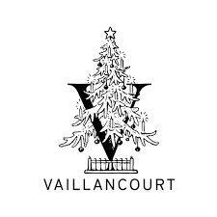

2021 Events!

Christmas Opening with Starlight Santa
Friday, November 5, 2021 9:00 am - 7:00 pm
Christmas Opening with Starlight Santa

2021 Vaillancourt Christkindlesmarkt & Artisan Show
Friday, November 12, 2021 11:00 am - 8:00 pm
Saturday, November 13, 2021 10:00 am - 6:00 pm
2021 Vaillancourt Christkindlesmarkt & Artisan Show

#DickensWeekend: A Christmas Carol with Gerald Charles Dickens
Saturday, November 27, 2021 2:00 pm
Saturday, November 27, 2021 6:00 pm
Sunday, November 28, 2021 12:00 pm
Sunday, November 28, 2021 4:00 pm
#DickensWeekend: A Christmas Carol with Gerald Charles Dickens

Mini Outdoor German Christmas Wine Markets
Saturday, December 4, 2021 10:00 am - 4:00 pm
Saturday, December 11, 2021 10:00 am - 4:00 pm
Saturday, December 18, 2021 10:00 am - 4:00 pm
Mini Outdoor German Christmas Wine Markets

