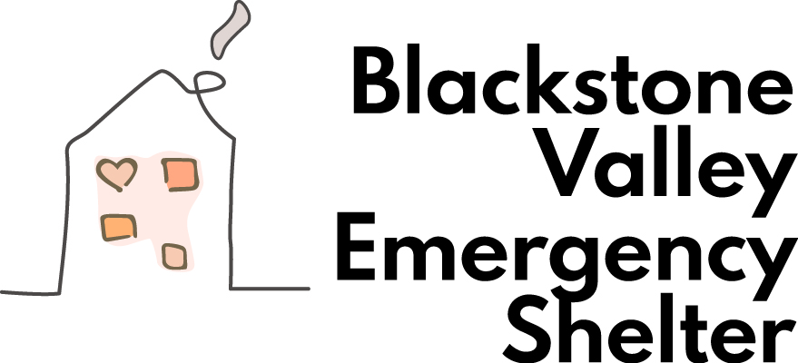

2025 Sleep Out for Homelessness

Join us as we observe Homelessness Awareness Month. Show your support by participating in the Blackstone Valley Emergency Shelter “Sleep Out for Homelessness” on November 7, 8, or 9, 2025.
How does it work?
- Step 1: Plan a Sleep Out Event on November 7, 8, or 9 in your backyard, a campground, your organization’s property, or even your living room—just pick a safe space.

We require that you obtain all the proper permission to “sleep out” at the location of your choice.

- Step 2: Sign up for your Sleep Out using the registration link below.
https://www.zeffy.com/en-US/peer-to-peer/sleep-out-for-homelessness

- Step 3: Find sponsors to help us raise funds for BVES. Once you register, we will send you the sponsorship sheet. You will be responsible for mailing the funds to us or using the donation link below. Please indicate “Sleep Out” on the memo line.
https://www.zeffy.com/en-US/peer-to-peer/sleep-out-for-homelessness

4: Share your experience with others.
Unable to sleep out? No worries - support our organization by making a donation and participating, and watching others through our website (www.bvemergencyshelter.org) or Facebook page (@bvemergencyshelter).

