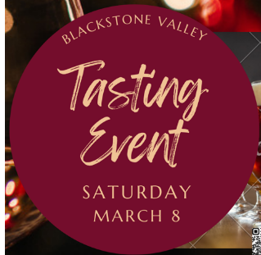
December 27, 2024
Dear Friends,
The Blackstone Valley Emergency Shelter has teamed up with the Blackstone Valley Rotary to host the
20th Annual Wine & Chocolate Tasting Charitable Event which we are renaming the
Blackstone Valley Tasting Event
Featuring: local breweries, distilleries and wineries,
a live auction, raffles, prizes, and vendors.
It will take place on Saturday, March 8, 7:00 PM at
Blissful Meadows Golf Club, Uxbridge, MA
How can you help? You can show your support simply by attending the event, sponsoring the event, placing an ad in our program, or donating an item for our auction.
Diamond Sponsor $2000 Full Page Ad & Table Sponsorship
Platinum Sponsor $1000 Full Page Ad
Gold Sponsor $500 Half-Page Ad
Table Sponsor $300 Sign on Wine Table & Business Card Ad
Silver Sponsor $100 Business Card Ad

Proceeds from this event will benefit the Blackstone Valley Emergency Shelter, which provides essential support to individuals experiencing homelessness in the Blackstone Valley, as well as the scholarship programs of the Blackstone Valley Rotary Club. With an anticipated attendance of approximately 250 people, your generosity will make a meaningful impact. We deeply appreciate your consideration and support, and we look forward to welcoming you to the event.
Leslie Reichert
CEO, Blackstone Valley Emergency Shelter
508-751-0799
www.bvemergencyshelter.org for more information and tickets or use the QR code below.

