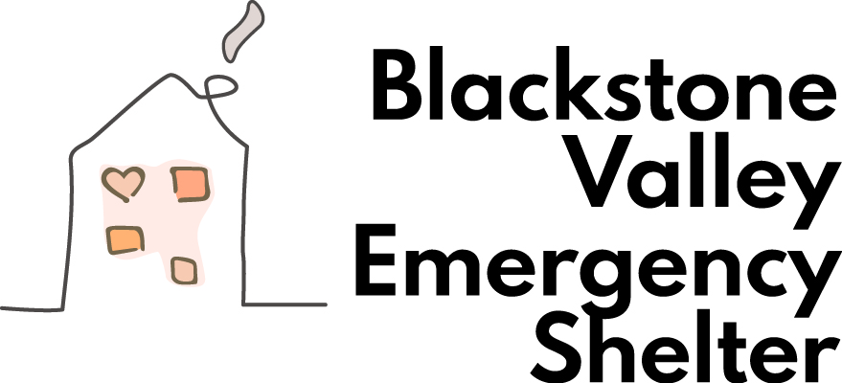

2026 Sleep Out for Homelessness
Join us as we kick off the National Week of Hunger and Homelessness Awareness and show our support for the Blackstone Valley Emergency Shelter by participating in the Sleep Out for Homelessness on 6, 7, or 8, 2026.
How does it work?
- Step 1: Plan a Sleep Out Event on November 6, 7, or 8 in your backyard, campground, organization, or other safe space.
- Step 2: Sign up for your Sleep Out with the Blackstone Valley Emergency Shelter using the registration link below.
https://www.bvemergencyshelter.org/event-details/bves-sleepout-2026-10-years-of-hope-in-action-1
- Step 3: Donate a monetary gift to BVES by mailing a check to Box #332, Whitinsville, MA 01588, or use the donation link below. Please indicate Sleep Out on the memo line.
https://checkout.square.site/merchant/MLAVZ6XK0T19Q/checkout/JQIPWI2XC2PK473ZF7P5O7FE
4: Share your experience with others.
Unable to sleep out? No worries - support our organization by making a donation and participating, and watching others through our website or Facebook page!

