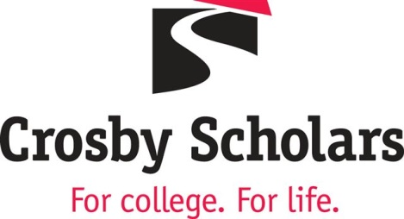

Program Specialist - II

Position Information
Company | Crosby Scholars Community Partnership  www.crosbyscholars.org
Working Title | Program Specialist II (serving grades 6 through 10)
Job Category | Professional
Position Type | Staff
Cycle of Appointment | 12 months
Hours Worked Per Week | Full-Time
Work Schedule and Hours | Monday-Friday, some evenings and weekends required
Salary Range | $37,500 – $42,000 Salary range: commensurate with experience and qualifications.
Job Summary | The Program Specialist II partners with the Program Assistant Director to execute strategic and integrated plans to effectively deliver the Middle and High School Programs; assuring students (grades 6-10) and families are being served with current and accurate information and offered personalized services. The main responsibilities include:  - Remain current on best practices and trends in the delivery of college and career preparation services to middle and high school students and parents  - Plan and assist with annual recruitment efforts.  - Collaborate with various staff members and other internal departments on the implementation of engagement strategies for middle and high school parents.  - Collaborate with Outreach Teams to meet the needs of students.  - Track and implement plans for middle and high school students’ program participation and completion.  - Coordinate special student engagement initiatives including but not limited to the Leadership Council, Crosby Club and college tours.  - Monitor 6-10 Program email accounts and independently respond to inquiries.  - Manage programming details and complete execution of academies including planning, staffing, creating Zoom links, and promotion to increase student attendance.  - Design and deliver presentations and other materials.  - May occasionally supervise volunteers and lead internal projects.  - Extensive independent usage of technology and workflow systems (including but not limited to our customized database platform, email/text messaging platforms, and running reports and updating student data using PowerBI).
Required Qualifications | - A four-year degree.  - Excellent verbal and written communication skills.  - Highly organized and detail oriented.  - The ability to work independently with limited supervision.  - Proficient in Microsoft Office Suite and Google Drive.  - Ability to collaborate effectively with leadership, peers and colleagues.
Preferred Qualifications | - Previous experience working in a school setting.  - Proven experience working with diverse student populations.  - Comfortable speaking in small and large group settings  - Bilingual (Spanish) fluent speaking and written translation skills.
Desired Knowledge, Skills and Abilities | - Ability to establish and maintain effective working relationships with school personnel and parents.  - Ability to respond quickly and effectively to uncertainty and change.  - Ability to work in a fast-paced environment.  - Ability to consistently be at work and on time, respond to management direction and seeks feedback and coaching for continuous improvement.  - Ability to embrace and promote an inclusive environment.  - Ability to balance multiple priorities and tasks.
Working Conditions | Most of the work will be performed independently or amongst a team in an office setting and in schools. Must be able to do light lifting and have a valid NC driver’s license with reliable transportation. A pre-employment background check and drug screening are required.

