Sign up for Amazon Smile! ☺

Amazon donates 0.5% of the price of your eligible Amazon Smile purchases to charitable organizations.

1. You must always start at <https://smile.amazon.com/> to support The Branch Museum of Architecture and Design.
2. To add The Branch Museum of Architecture and Design as your charitable organization go to <https://smile.amazon.com/>
3. On the bottom right where it says **Or pick your own charitable organization:** enter *The Branch Museum of Architecture and Design*

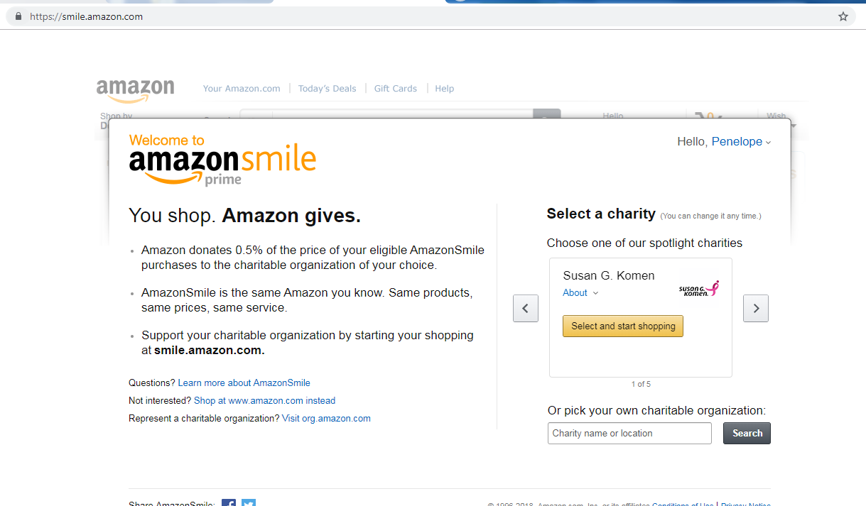

1. Click on the button to select The Branch Museum of Architecture and Design

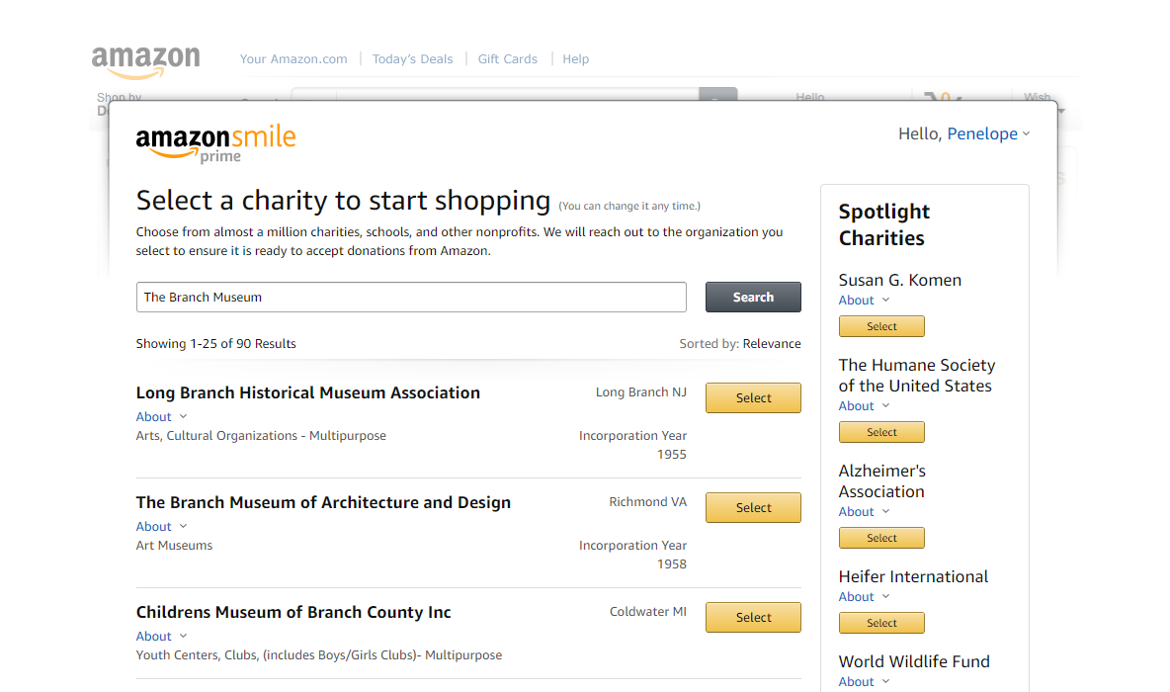

1. Select the check box so you know that you must always shop at <https://smile.amazon.com/> in order to support The Branch Museum of Architecture and Design

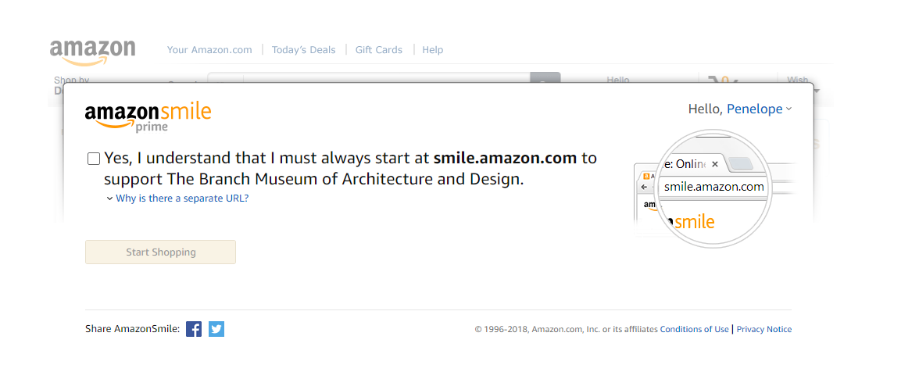

1. You will receive a Thank you message and the organization you are supporting will be listed when you arrive at <https://smile.amazon.com/>  
   