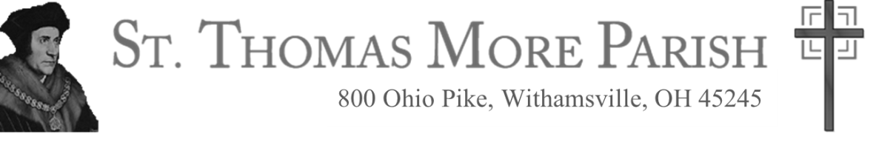

Greetings Parents,

This is a very special year…a holy year…for your children, your whole family, and our parish community. We travel together on faith journeys as we prepare our children to celebrate for their first time the incredible sacraments of Reconciliation and Eucharist. While activity centers around preparing the children, it is also another opportunity for all of us to deepen our relationship with Jesus and better comprehend the enormity of these incredible gifts and their spiritual impact in our everyday lives.

Jesus instituted the sacraments. The better we know Him, the better we understand the love behind these sacraments and their benefit for us. His life was about bringing us into a more intimate relationship with Himself, God the Father, and the Holy Spirit. Through the sacraments He continues deepening each one of our relationships with Him. They constantly reveal the depths of God’s love and Will for us, making it easier and more natural for us to know and love Him as do we come to appreciate, once we become parents, the loving sacrifices and difficult choices our parents made.

Because God created us to be in relationship with Him, He also created us to be in relationships with His other children through community. Just as Jesus came to know and teach the Apostles as a group, so do we prepare our young disciples through “sacramental gatherings,” culminating in communal sacramental celebrations.

The Gathering Dates for this year are listed below. **Each child and at least one parent** are required to attend each gathering.

**Sacramental Dates**

|  |  |  |  |
| --- | --- | --- | --- |
| Sun 10-03-21 | 11:15-2:30 pm | First Reconciliation Retreat | Parish Dining Hall |
| Thur 10-28-21 | 6:30 - 8:00 pm | First Reconciliation Gathering with Fr. Bill | Parish Dining Hall |
| Thur 11-18-21 | 7:00 - 9:00 pm | First Reconciliation Celebration | Church |
|  |  |  |  |
| Sun 2-06-22 | 11:05 - 1:00 pm | First Communion Gathering | Parish Dining Hall |
| Sun 2-13-22 | 10:00 -11:30 am | First Communion: The Mass | Church |
| Sat 3-12-22 | 9:00 am – 2:30 pm | First Communion Jesus Day Retreat | Parish Dining Hall |
| Thur 5-05-22 | 6:15pm | Individual Communion Photos | Marian Grotto |
|  | 6:45pm | Group Communion Photo | Church Steps |
|  | 7:00 - 7:30 pm | May Crowning with Rosary Procession | Church Steps |
| Thur 5-12-22 | 6:00 – 7:00 pm | First Communion Rehearsal | Church |
|  |  |  |  |
| Sun 5-15-22 | 10:00am | First Communion Celebration | Church |

***Mark these dates and times*** *in your calendars and planners now!*

We look forward to sharing part of your, your children’s, and our amazing journey to Jesus together. We are praying for His abundant graces and close Presence to all of us throughout this special time.

Yours in Christ,

Deacon Bob Brazier Becky Ready

Coordinator of Religious Education (CRE) Director of Religious Formation (DRE)