WELCOME TO ST. THOMAS MORE’S
CATHOLIC AT HOME ADVENT BOOKLET

At Mass, after praying the Lord’s Prayer, we hear
“. . . as we await the blessed hope and the coming of our Savior, Jesus Christ.”
During Advent, we wait in joy, hope and anticipation for the coming wonderful experiences
* Feast of Christmas * Coming of Christ into our lives in new ways *
* Return of Christ in glory at the end of time *
We wait, looking forward to celebrating God’s loves that was so great He sent his Son down to the world - to save us. Far from empty, it is a time hope-filled with God’s promises to us.
We offer here home celebrations for Advent – taking advantage of this unusual time to celebrate our faith more particularly with our family!!

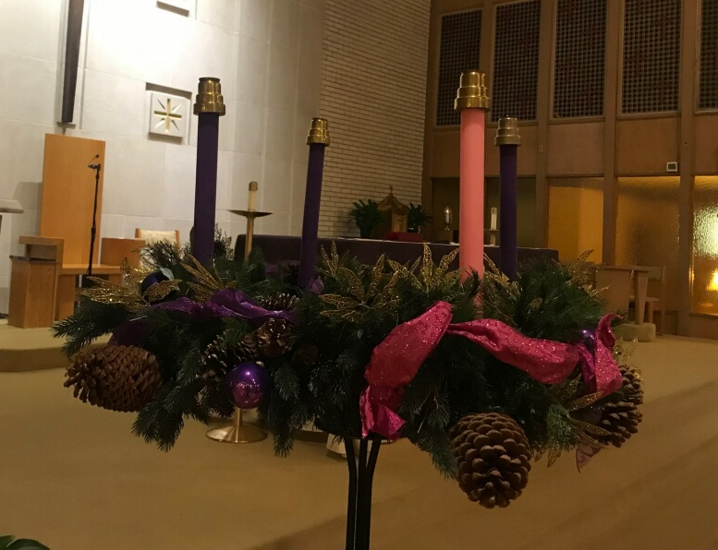

ADVENT WREATH

HISTORY
Likely originating among pre-Christian Germanic people, wreaths held lit candles during December to anticipate the coming light of spring. Eastern European Christians adapted the tradition so that in the 16th century, Advent wreaths prepared for the coming of Jesus, the Light of the world.
SYMBOLISM

A prayerful way to reflect the passage of the Advent season, lighting the Advent Wreath candles banishes the darkness just as Jesus’s birth brought Light to our world and our hope for salvation. His Presence in every Catholic Church’s tabernacle throughout the world continues to share His Light.

Why Evergreens? Evergreens are a sign of the everlasting life we’ll share one day with Jesus.

SAMPLES

Advent Wreaths can be made of almost anything. Below are a few traditional examples, but be creative and tailor it to your family’s style, culture, and ways of celebrating Christmas!
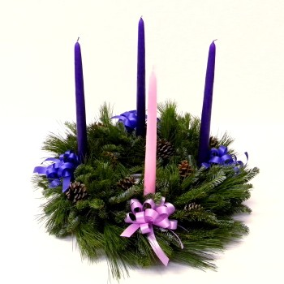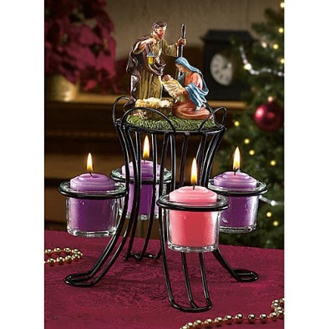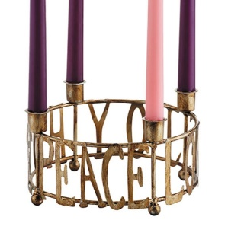
HOW TO MAKE
Materials (usually $10-$15)
Item Commonly Used
Frame Metal (craft store, theCatholicGiftShop.com, or CatholicSupply.com
Fastener to attach items to the wreath Green floral wire
Garland (material that covers frame) Evergreen boughs
Decorative items Pine cones, ornaments
Ribbon
Candles Advent taper candles (3 purple, 1 rose/pink)

Instructions:
- Lay garland on top of the metal frame.
- Tie on with Fastener, making sure frame remains flat.
- Use Fastener to attach Decorative items.
- Wrap ribbon around the garland loosely, adding a bow on one side.
- Add a bow, if desired. Creating it then adding it is usually easier.
- Add the candles.
- Bless the Advent Wreath on Saturday before the First Sunday of Advent (see below).
Prayers
Each night beginning on the Sunday of Advent, dim the lights and gather the family around the Advent Wreath. Every week has a different theme on which to meditate and for which there are different prayers. You can repeat the prayer below each night, or find others you prefer.
https://www.ourcatholicprayers.com/support-files/adventwreath.pdf
https://onlineministries.creighton.edu/CollaborativeMinistry/Advent/Daily-prayers.html
Thy and Thee are traditionally used in the prayers below, and many prefer them for their sense of reverence. You can change these to Your and You if you prefer.
Week 1: HOPE
O Lord, stir up Thy might, we beg Thee, and come, that by Thy protection we may deserve to be rescued from the threatening dangers of our sins and saved by Thy deliverance. Through Christ our Lord. Amen.
Week 2: LOVE
O Lord, stir up our hearts that we may prepare for Thy only begotten Son, that through His coming we may be made worthy to serve Thee with pure minds. Through Christ our Lord. Amen.
Week 3: JOY - The joyful Sunday in Advent (known as “Guadete”) is represented by rose (or pink) instead of the penitential purple color.
O Lord, we beg Thee, incline Thy ear to our prayers and enlighten the darkness of our minds by the grace of Thy visitation. Through Christ our Lord.
Week 4: PEACE
O Lord, stir up Thy power, we pray Thee, and come; and with great might help us, that with the help of Thy Grace, Thy merciful forgiveness may hasten what our sins impede. Through Christ our Lord.

ADVENT WREATH BLESSING
All make the sign of the cross as the leader says:
Our help is in the name of the Lord.
Response (R/.) Who made heaven and earth.
Then the Scripture, Isaiah 9: (lines 1-2 and 5-6) or Isaiah 63 (lines 16-17 & 19) or Isaiah 64 (lines 2-7) is read:
Reader: The Word of the Lord.
R/. Thanks be to God.
With hands joined, the leader says:
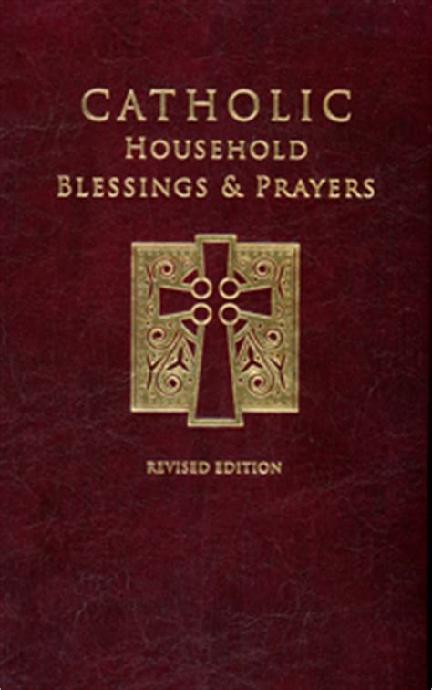
Lord our God,
we praise you for your Son, Jesus Christ:
he is Emmanuel, the hope of the peoples,
he is the wisdom that teaches and guides us,
he is the Savior of every nation.
Lord God,
let your blessing come upon us
as we light the candles of this wreath.
May the wreath and its light
be a sign of Christ’s promise to bring us salvation.
May he come quickly and not delay.
We ask this through Christ our Lord.
R/. Amen.
The blessing may conclude with a verse from
“O Come, O Come, Emmanuel”:
O come, desire of nations, bind
in one the hearts of humankind;
bid every sad division cease
and be thyself our Prince of peace.
Rejoice! Rejoice! Emmanuel
shall come to thee, O Israel.
—From Catholic Household Blessings & Prayers

From the first Sunday of Advent)
ADVENT CALENDARS
Believed to originate from Christians in the early 19th century, the Advent Calendar counts down the 24 days of December (or from the first Sunday of Advent, 26 days for 2020), ending on Christmas Eve.
Daily engaging your family in anticipation of the Christmas season keeps the focus on the birth of the baby Jesus. Heightening joy while helping us learn one aspect of our salvation history, each day shares a new treasure of Scripture, good deeds, prayers, and even candies.
Our local Innervisions Religious Store on Beechmont offers Advent calendars to hang up or you can find them at https://shop.catholicsupply.com/store/c/421-Advent-Calendars.aspx.
You can also download Advent Calendars from many sites, including Loyola Press: https://www.loyolapress.com/catholic-resources/liturgical-year/advent/calendars/printable-advent-calendars/
Be sure to find one focused on faith! New secular Advent calendars focus on receiving a pleasure now and anticipating the physical gifts rather than giving to others or seeking gifts of faith.

ADVENT SUNDAYS & FEAST DAYS FOR LITURGICAL YEAR 2020-2021
The following is a list of the dates of the Sundays and major feast days that fall in Advent 2020.
- First Sunday of Advent (Sunday, November 29, 2020)
- Feast of Saint Nicholas (Sunday, December 6, 2020)
- Second Sunday of Advent (Sunday, December 6, 2020)
- Immaculate Conception (Tuesday, December 8, 2020)
- Our Lady of Guadalupe (Saturday, December 12, 2020)
- Feast of Saint Lucy (Sunday, December 13, 2020)
- Third Sunday of Advent (Gaudete Sunday) (Sunday, December 13, 2020)
- Fourth Sunday of Advent (Sunday, December 20, 2020)
- Christmas Eve (Thursday, December 24, 2020)
- Christmas (Friday, December 25, 2020)

ADVENT ACTIVITIES TO DO AS A FAMILY
From: www.Reallifeathome.com
☆ Make and deliver treats to neighbors
☆ Give Jesus a birthday gift by giving a gift to someone in need
☆ Donate a bag of food to a local food pantry or food bank
☆ Pray for good things for someone who has been unkind to you
☆ Visit an elderly friend or relative who doesn’t get many visitors
☆ Make a handmade gift for someone
☆ Celebrate the feast days of St. Juan Diego and Our Lady of Guadalupe with a Mexican-‐themed meal & celebration
☆ Go to a weekday Mass or Adoration
☆ Surprise someone by doing a task or chore they normally do
☆ Genuinely compliment someone who isn’t expecting it
☆ Make a creative project that helps you reflect on the true meaning of Christmas
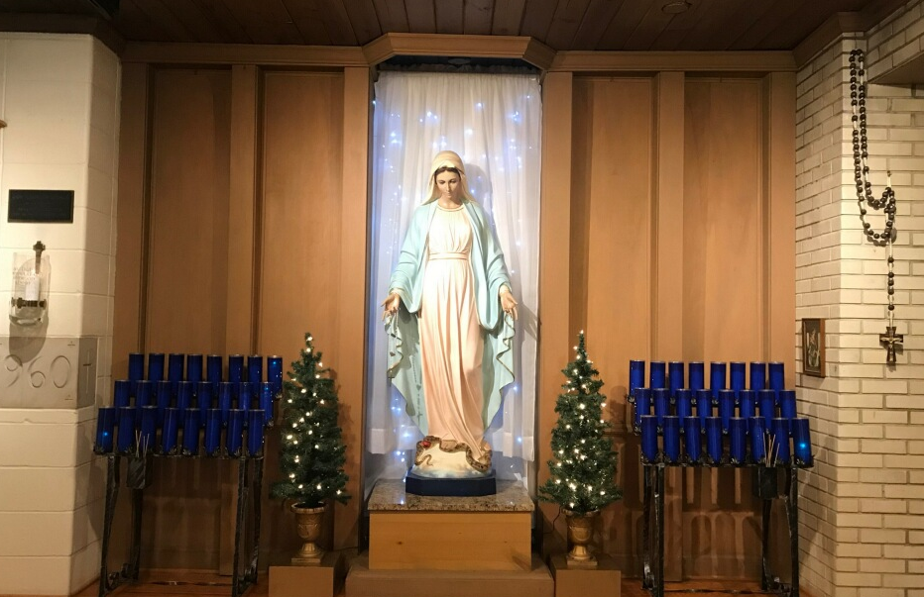
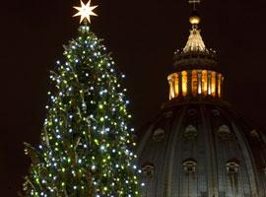
CHRISTMAS TREE
A relatively modern tradition, found first in medieval mystery plays, the Christmas Tree represents the tree of paradise while the Christmas lights or candles symbolized Christ, the Light of the world. Set up just before Christmas, it remains until the Solemnity of Epiphany (in January). Traditionally, it remains unlit until after the blessing.
Home Christmas trees may be blessed by a parent or another family member, in connection with the evening meal on the Vigil of Christmas or at another suitable time on Christmas Day.

BLESSING OF A CHRISTMAS TREE
When all have gathered, a suitable song may be sung. The Leader reads the blessing while others respond as indicated by: R/.
The leader makes the sign of the cross, and all reply “Amen.”
The leader greet those present in the following words:
Let us glorify Christ our light, who brings salvation and peace into our midst, now and forever. R/. Amen.
In the following or similar words, the leader prepares those present for the blessing:
My brothers and sisters, amidst signs and wonders Christ Jesus was born in Bethlehem of Judea: his birth brings joy to our hearts and enlightenment to our minds. With this tree, decorated and adorned, may we welcome Christ among us; may its lights guide us to the perfect light.
Someone reads a relevant sacred Scripture (e.g., Titus 3:4 – 7, Ezekiel 17:22-24)
Reader: The Word of the Lord.
R/. Thanks be to God.
The intercessions are then said. The leader says:
Let us ask God to send his blessing upon us and upon this
sign of our faith in the Lord. R/. Lord, give light to our hearts.
That this tree of lights may remind us of the tree of glory on
which Christ accomplished our salvation, let us pray to the
Lord. R/. Lord, give light to our hearts.
That the joy of Christmas may always be in our homes, let
us pray to the Lord. R/. Lord, give light to our hearts.
That the peace of Christ may dwell in our hearts and in the
world, let us pray to the Lord. R/. Lord, give light to our hearts.
After the intercessions the leader invites all present to pray the Lord’s Prayer.
The leader then says the prayer with hands joined:
Lord our God,
we praise you for the light of creation:
the sun, the moon, and the stars of the night.
We praise you for the light of Israel:
the Law, the prophets, and the wisdom of the Scriptures.
We praise you for Jesus Christ, your Son:
he is Emmanuel, God-with-us, the Prince of Peace,
who fills us with the wonder of your love.
Lord God,
let your blessing come upon us
as we illumine this tree.
May the light and cheer it gives
be a sign of the joy that fills our hearts.
May all who delight in this tree
come to the knowledge and joy of salvation.
We ask this through Christ our Lord.
R/. Amen.
The tree’s lights are illuminated and the leader concludes the rite by signing himself or herself with the sign of the cross and saying:
May the God of glory fill our hearts with peace and joy, now and forever.
R/. Amen.
The blessing concludes with a verse from “O Come, O Come, Emmanuel”:
O come, thou dayspring, come and cheer
our spirits by thine advent here;
disperse the gloomy clouds of night
and death’s dark shadow put to flight.
Rejoice! Rejoice! Emmanuel
shall come to thee, O Israel.
—From Catholic Household Blessings & Prayers
BLESSING OF A NATIVITY SCENE
The family Nativity scene emphasizes the “reason for the season,” placing us at that first Christmas day beside the manger. Children are drawn to, and mesmerized by, nativity scenes!
One tradition is to hide baby Jesus until Christmas morning when He appears in the stable, on his birth day. Another tradition places the three magi further from the stable and each day one child is permitted to move them a small distance closer to the stable until they arrive on the Epiphany, January 6th. (The Epiphany is typically celebrated on a Sunday nearest January 6th, but the feast day is always January 6th.)
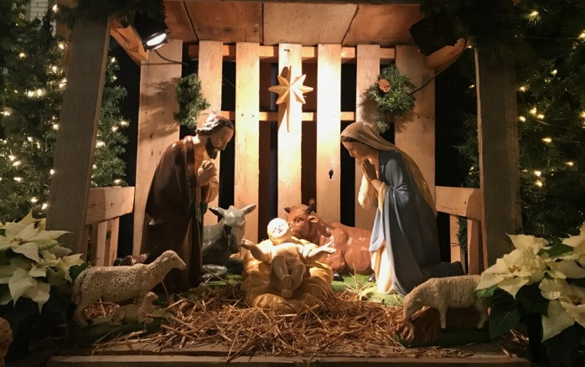
To heighten the Nativity scene’s spiritual meaning, bless it with the following prayer of the Church.
The leader prays with hands joined:
God of every nation and people,
from the very beginning of creation
you have made manifest your love:
when our need for a Savior was great
you sent your Son to be born of the Virgin Mary.
To our lives he brings joy and peace,
justice, mercy, and love.
Lord,
bless all who look upon this manger;
may it remind us of the humble birth of Jesus,
and raise our thoughts to him,
who is God-with-us and Savior of all,
and who lives and reigns forever and ever.
R/. Amen.

Thank you for living this Advent Season in a special way that helps keep our focus on the reason for the season.
Please share your experiences and pictures of your Advent preparations throughout these 4 weeks so that we can continue to celebrate as a community.
(These will be posted on the website,
but no names will be included with the pictures.)

