LITANY OF THE SACRED HEART OF JESUS
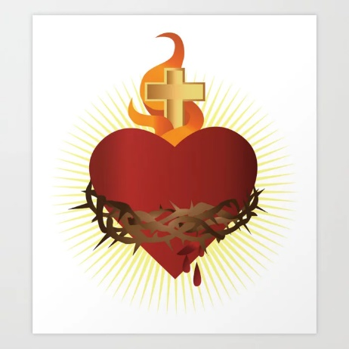
Lord, have mercy on us.
Christ, have mercy on us.
Lord, have mercy on us. Christ, hear us.
Christ, graciously hear us.
God the Father of Heaven, have mercy on us.
(Repeat have mercy on us. after each line)
God the Son, Redeemer of the world,
God the Holy Spirit,
Holy Trinity, one God,
Heart of Jesus, Son of the Eternal Father,
Heart of Jesus, formed by the Holy Spirit in
the Virgin Mother's womb,
Heart of Jesus, substantially united to the
Word of God,
Heart of Jesus, of infinite majesty,
Heart of Jesus, holy temple of God,
Heart of Jesus, tabernacle of the Most High,
Heart of Jesus, house of God and gate of heaven,
Heart of Jesus, glowing furnace of charity,
Heart of Jesus, vessel of justice and love,
Heart of Jesus, full of goodness and love,
Heart of Jesus, abyss of all virtues,
Heart of Jesus, most worthy of all praise,
Heart of Jesus, King and center of all hearts,
Heart of Jesus, in whom are all the treasures
of wisdom and knowledge,
Heart of Jesus, in whom dwells all the fullness of the Godhead,
Heart of Jesus, in whom the Father was well pleased,
Heart of Jesus, of whose fullness we have all received,
Heart of Jesus, desire of the everlasting hills,
Heart of Jesus, patient and rich in mercy,
Heart of Jesus, rich to all who call upon You,
Heart of Jesus, fount of life and holiness,
Heart of Jesus, propitiation for our offenses,
Heart of Jesus, overwhelmed with reproaches,
Heart of Jesus, bruised for our iniquities,
Heart of Jesus, obedient even unto death,
Heart of Jesus, pierced with a lance,
Heart of Jesus, source of all consolation,
Heart of Jesus, our life and resurrection,
Heart of Jesus, our peace and reconciliation,
Heart of Jesus, victim for our sins,
Heart of Jesus, salvation of those who hope in You,
Heart of Jesus, hope of those who die in You,
Heart of Jesus, delight of all saints,
Lamb of God, who takes away the sins of the world,
Spare us, O Lord.
Lamb of God, who takes away the sins of the world,
Graciously hear us, O Lord.
Lamb of God, who takes away the sins of the world,
Have mercy on us.
Jesus, meek and humble of Heart,
Make our hearts like unto Thine.
Let us pray.
Almighty and eternal God, look upon the Heart of Thy most beloved Son and upon the praises and satisfaction which He offers Thee in the name of sinners; and to those who implore Thy mercy, in Thy great goodness, grant forgiveness in the name of the same Jesus Christ, Thy Son, who lives and reigns with Thee forever and ever. Amen.

