Dutchess County Department of Community & Family Services

FREE SEMINAR
“Creating Your Path To College”
For high school students and their parents/caregivers

Monday, October 22nd, 6 p.m.
East Fishkill Community Library
348 Route 376
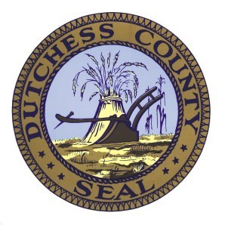
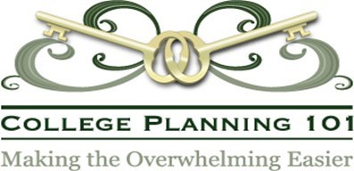
Hopewell Junction, NY

Learn how to track important events and successes in high school, and create a résumé to work with as you progress through high school. Learn about the ACT and SAT tests, and which test is best for you.

Hosted by the Division of Youth Services and presented by Stephanie Mauro, Founder and President of College Planning 101, with 18+ years of financial services experience.

Pre-registration is required by October 18th

Register via e-mail to Sheila.Stuewer@dfa.state.ny.us
Please provide names and specify if student or parent/caregiver. Questions, call 486-3354.
Accessibility accommodations will be provided upon request if made 2 weeks before seminar.

