Wild Week in the Wilderness with Mr. Haynie
Summer Experience for Middle and High School
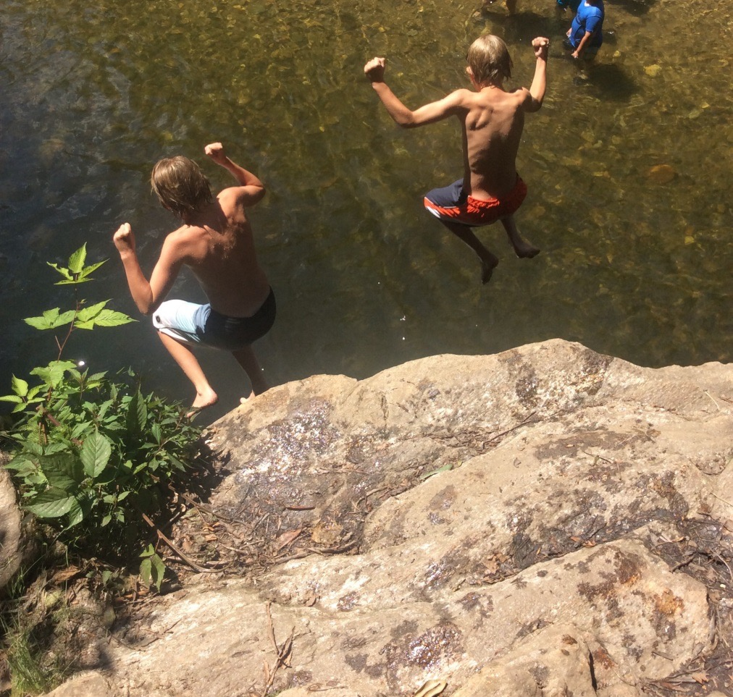
We are about to kick off our 10th year of traveling to the mountains for a “Wild Week in the Wilderness”! This is a jam-packed trip of swimming, hiking, camping, sliding, laughing, playing, and exploring!! This year, we are offering five trips (four Middle School/one High School) you can’t miss!
Join us for an experience that your child will never forget!
Middle School:
There are two sessions going out for each grade level during the same week. Upcoming 5th-6th grade trips are single gender(if the number of campers allow it). Upcoming 7th-8th grade trips will be co-ed. There are 12 spots on each trip. Students from other schools are also welcome to join in on the adventure. Mr. Haynie, Ms. Bowers, Mrs. Haynie, Ms. Mueller, and Will Hutchisson will lead these two sessions. We will spend two nights in Pisgah National Forest, and two nights at our new campsite at 5 Springs in Tamassee, SC!!!
The cost for your child to attend is $650. Below, you will find what we provide for each student on the trips.
- Transportation to and from Charleston , 5 Springs, and Pisgah National Forest in NC
- Camping fees
- All meals while on the trip (except two road meals at Subway)
- Tents and cooking equipment
- Your child will return from the trip knowing how to prepare/cook you a meal
- Two certified CPR/First Aid Instructors to accompany the group
- Two certified lifeguards for all water activities
- Complete equipment for group games and activities
- Two paid ice cream stops along the way
- At least 300 pictures and videos from the trip
- A combination of 30 years experience in the field of Outdoor Education from the instructors
- Voted “The best trip in the world” for the past nine years by former campers
Dates:
June 8-12 (rising 5th - rising 6th grades) Two sessions. Single gender. One boy/One Girl trip.
June 15-19 (rising 7th- rising 8th grades) Two sessions. Co-ed

High School-
This trip is setup to be co-ed and open to all rising 9th - rising 12th grade students who have attended at least two years of WWW trips (one being a high school trip). Ms. Mueller and Mr. Haynie will lead this trip. We will spend two nights in Pisgah National Forest, two nights at our new campsite at 5 Springs in Tamassee, SC, and three nights at the Blue Ridge Assembly YMCA in Black Mountain, NC.
The cost for your child to attend is $1,150. Below, you will find what we provide for each student on the trip.
• Transportation to and from Charleston, YMCA, 5 Springs, and Pisgah National Forest in NC
• Whitewater rafting, mountain biking, high ropes course, hiking, swimming pool with diving boards, gymnasium, furnished house with kitchen at YMCA
• All meals while on the trip (except two road meals at Subway)
• Tents and cooking equipment
• Your child will return from the trip knowing how to prepare/cook you a meal
• Two certified CPR/First Aid Instructors to accompany the group
• Two certified lifeguards for all water activities
• Complete equipment for group games and activities
• Two paid ice cream stops along the way
• At least 300 pictures and videos from the trip
• A combination of 30 years experience in the field of Outdoor Education from the instructors
• Voted “The best trip in the world” for the past nine years by former campers
June 22nd-29th Maximum campers-14

Registration will begin at 8:00 am on Sunday, December 1, 2019. All you need to do to reserve a spot for your child is to email Mr. Haynie at bhaynie@charlestoncollegiate.org Be sure to list your child’s name and the dates of the trip.

*Middle School Trips-A $350 deposit (by check, made out to CCS) is due Monday, December 2, 2019. Please put your child’s name and camp dates in the Memo portion of the check. The remaining $300 (by check, made out to CCS) will be due on April 1, 2020. Your deposit is non-refundable after March 15th. After May 1st, your trip is non-refundable (it is transferable if you find a replacement for your child).
* High School Trip- A $600 deposit (by check, made out to CCS) is due Monday, December 2, 2019. Please put your child’s name and camp dates in the Memo portion of the check. The remaining $550 (by check, made out to CCS) will be due on April 1, 2020. Your deposit is non-refundable after March 15th. After May 1st, your trip is non-refundable (it is transferable if you find a replacement for your child).

