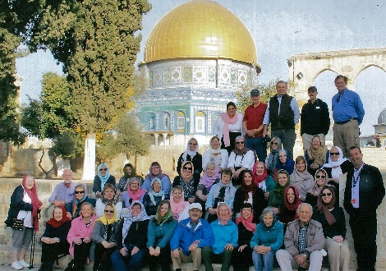
What a beautiful year, my year of jubilee! I want to thank all who remembered me with gifts and cards. I began my jubilee year with a pilgrimage to the Holy Land with Fr. Earle King and a group from the Episcopal Church in Grand Island, NY. We spent 13 days visiting the holy sites and walking where Jesus walked. St. George Guest House in Jerusalem was our home base. There we had sessions with Archbishop Suhail Dawani of the Episcopal Church in Jerusalem; Ophir Yarden on the "Contemporary issues− an Israeli Perspective”; as well as a presentation on Islam. It was good to hear various perspectives on the issues that the Israeli and Palestinian people face daily.
We visited and prayed at the Wailing Wall and the Church of St. Anne and Bethesda, where we had a healing service. I was especially touched by the Holocaust History Museum where people reverently moved from room to room in silence. We spent two days in Nazareth, visiting and praying at Shepherd's Field and the Church of the Nativity in Bethlehem, venerating the place where Jesus was born. Here we stayed at the Sisters of Nazareth Hostel. The Hostel is built above a recent excavation which holds the remains of the home where Jesus grew up and we had the privilege of visiting this site.
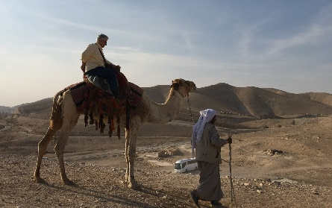
Next we traveled to the Jordan River where we renewed our baptismal vows; and then to Capernaum, the Town of Jesus. It was amazing to walk through the ruins of the home of Peter and of the synagogue where Jesus preached.
Other places visited included: Mt. Eremos where Eucharist was celebrated near the Sea of Galilee, the Church of the Primacy of Peter, and Tabgha− where Jesus performed the multiplication of the Loaves. We had a beautiful boat ride on the Sea of Galilee. I can never again hear about Jesus walking along the Sea of Galilee and not remember the beauty of the sea. We spent time at Jacob’s Well, rode camels in the Judean wilderness, and floated on the Dead Sea.
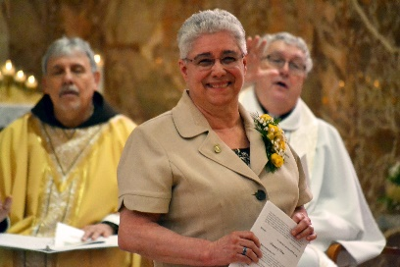
Profound moments for me were our visits to the Holy Sepulcher, where we visited and prayed at the tomb of Jesus, the anointing stone on which Jesus was prepared for burial; and the Garden of Gethsemane, where I had the profound experience of going to confession. Our last morning in Jerusalem, we walked and prayed the Stations of the Cross through the Old City. I keep reveling in my days in the Holy Land.
The actual jubilee celebration in Allegany on May 27, 2018 was beautiful. It was a gift to celebrate with my Franciscan sisters, family and friends. This memorable day was filled with morning prayer, the celebration of Eucharist, and a festive meal. I appreciate the work of all who made the day so special. All of my bandmates are from Brazil and had their jubilee celebration with their families and the sisters there. I missed their presence, but we were together in spirit.
The jubilee year ended with a Franciscan pilgrimage to Rome and Assisi. We spent two days in Rome and then onto Assisi where we stayed at the Casa Papa Giovanni.
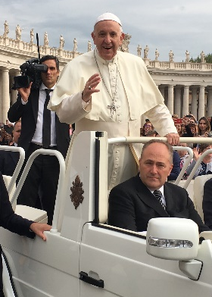
In Rome we visited St. Peter’s Basilica, where we had an audience with Pope Francis and ended the day with the celebration of the Mass at St. John Latern Basilica.
On our way from Rome to Assisi we stopped at Greccio, where we spent about five hours visiting the site and celebrating the Eucharist in the church.
Places visited while in Assisi included: Chiesa Nuova, believed to be the home where St. Francis spent the first 25-years of his life and La Rocca Maggiore, where we prayed for peace.
I love Assisi! There is a sense of moving from 21st century back in time to the 11th-12th century with all its history, religious significance, and how the spirituality of that time has impacted our lives today.
Other places visited were: San Damiano, Santa Maria Maggiore, the Portziuncola, the Carceri, the Basilica of St. Clare, LaVerna, and the Basilica of San Francesco.
It is hard to find quiet places where one can pray in these holy places. The crowds of people coming through were non-stop. But I had about 20 minutes of quiet time one afternoon at San Damiano. Another pilgrim and I returned to visit San Damiano as we did not have sufficient time there when our group visited. We wanted to sit in the space where St. Clare passed away. Much to our amazement no one was there, and I had the opportunity to be in the presence of this holy space. It was an awesome 20 minutes of communing with St. Clare.
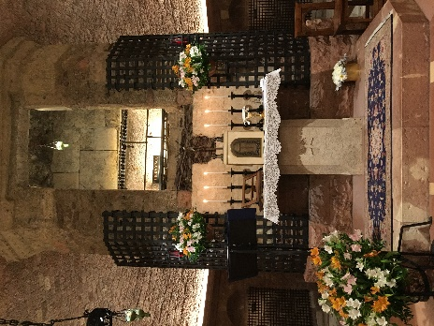
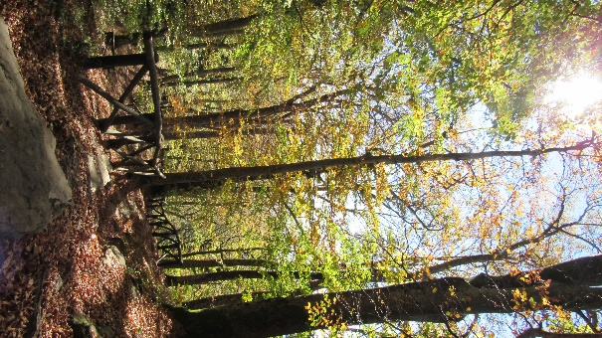
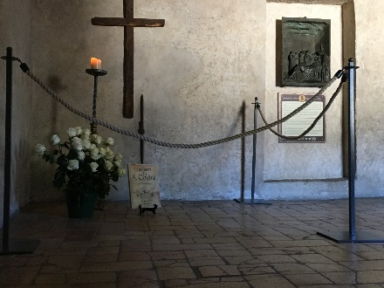
Our time at the Carceri was just too short. I wanted to follow the path through the woods where the early friars had their caves, but time did not permit. But I was able to find much quiet time at LaVerna. We had the option for a bag lunch where we could go off on our own, and I chose to do this. I took my lunch and began the trip up to the highest point of the mountain. I stopped in the quiet for a nice lunch and just bathed in the quiet and beauty of all that surrounded me. However, I did not make it to the highest peak and I was beginning to slip and slide on the falling leaves and did not want to fall and break a leg or an arm. So, I renegotiated my time and decided to make my way down the mountain to the Stigmata Chapel where it was quiet and I pondered the episode of Francis’ Stigmata. It was precious time for me.
Our final day was an historic visit and prayer at the Basilica of St. Francis. We were privileged to celebrate Mass at the tomb of St. Francis, a beautiful way to complete our pilgrimage.
I do not want to forget our visit to the Portiuncola, where we were blessed to celebrate Mass in the little chapel − the home of the Franciscan Order.
It was a year of grace and blessings for me. It is a year that I will continue to reflect on so that I can continue to glean the graces of time and place.
San Damiano

