CARIBBEAN CRUISE 2022

Join Others with Ataxia on this Amazing Adventure at Sea! (Open to All with Physical Limitations)

COME SAIL AWAY WITH US for 8 Wonderful Nights on Royal Caribbean’s Allure of The Seas, Round-Trip Ft. Lauderdale

JANUARY 22 – 30, 2022
Visit Puerto Plata (Dominican Republic), St. Thomas, St. Maarten and St. Kitts. Enjoy three glorious days at sea.

Royal Caribbean’s Allure of The Seas
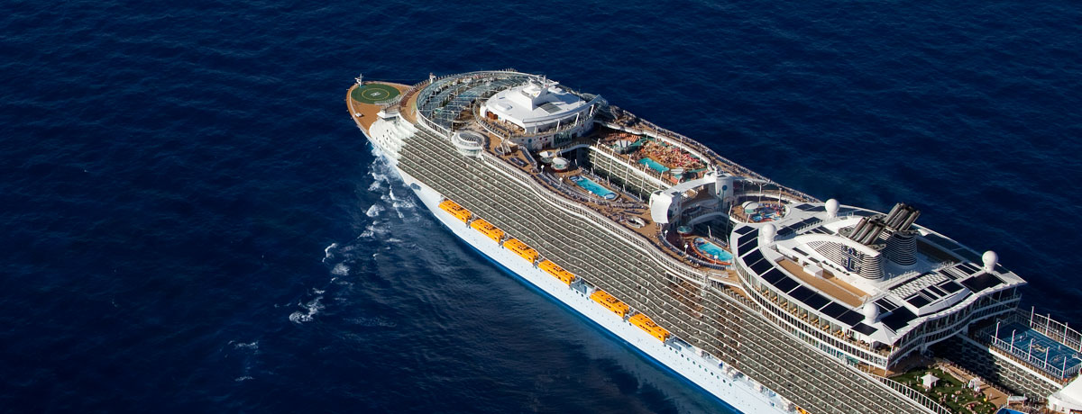

Seven Distinct Neighborhoods
Come aboard the Allure of the Seas, one of the biggest cruise ships in the world. Even though this vessel is just under twelve hundred feet and weighs over one hundred thousand metric tons, the true eye opener are the numerous luxuries that come on this Royal Caribbean cruise. The Allure of the Seas features a movie theater that can hold almost fourteen hundred people, twenty five different dining options, a dance hall, an ice skating rink and yes, even a Starbucks coffee shop.
On the outside, the Allure of the Seas looks like just another passenger vessel, only significantly bigger. But on the inside you’ll find that it much more resembles its own town in a very unique way, comprised of seven different neighborhoods. In these neighborhoods, the Allure of the Seas features a carnival, multiple restaurants, water park, lounge areas, disco, family friendly activities, and a kids fun zone, among other things.

Starbucks and Dining
As we have already mentioned, the Allure of the Seas features a Starbucks coffee shop (the first at sea) and over twenty five different dining options. There are also multiple different restaurants with a wide variety of gourmet food on the menu, such as steak, seafood, traditional breakfast meals, Italian, and even Brazilian. On the Allure of the Seas, you’ll be treated to excellent dining room service and exotic food that you might not get another chance to try in your lifetime.

Entertainment
Embarking on any Caribbean cruise vessel is an once-in-a-lifetime experience to be remembered forever, but did you ever think that you could be treated to some excellent entertainment services? The Allure of the Seas features cinema 3D theaters and live-action theaters of award winning plays, bars and nightclubs, ice shows, a casino, a jazz club, comedy club, and a karaoke bar. Believe it or not, but there are also live parades that occur on special nights throughout the vessel. The Allure of the Seas definitely isn’t your typical Caribbean cruise ship. Sometimes you’ll think you were on vacation on the mainland, but then again, there’s always that stunning view of the high seas to remind you exactly where you are. Guests onboard Allure of the Seas will now be able to enjoy the Broadway hit musical Mamma Mia.

Prices Starting From:
- Fully Accessible Inside Cabins: $1213.29 per person
- Fully Accessible Ocean View Balcony Cabins: $1543.29 per person
- Please call for additional categories
We have a total of 22 fully accessible cabins with roll in showers and additional cabins for those not needing accessible. First come, first serve! All prices are based on double occupancy. Please call for third and fourth person pricing. Prices are inclusive of taxes, port charges and gratuities. Additional costs are airfare, hotel, insurance, shore excursions, alcohol and soft drinks, spa services and all items of a personal nature.

