Post Vaccination Flying – Are You Ready To Get On Board?

- Here, There & Everywhere
02/09/2021
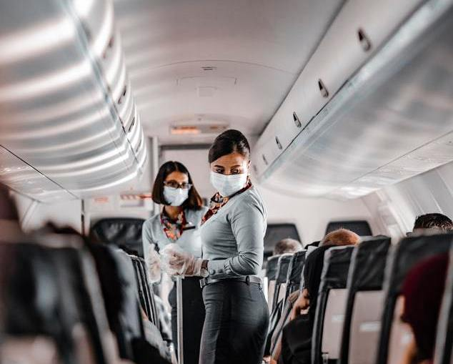

50Plus-Today is more like a curated resource for adults age 50+ than a blog, and we are supported partially by our readers. When you buy via the links on our site, we may earn an affiliate commission. We do not accept incentives for our reviews; all opinions are our own.
Views: 239
by Debra Kerper
Table of Contents
- How do you feel about air travel right now?
- Ready for take off?
- Is it prudent to travel now?
- More about masks
- Post vaccination travel tips
- The bottom line

How do you feel about air travel right now?
If you’re like me, you dream of a life that looks “near normal” and yearn to board an airplane bound for destinations near and far. Some people, all ages, already started traveling by air again – or perhaps never stopped. However, I’m not sure I’m ready. Are you?
If you’re between 50 and 64, and lucky enough to be free of pre-existing medical conditions, your vaccination date is still a big uncertainty. Those of us age 65 and over, plus younger people between 16 and 64 with chronic medical issues, are receiving vaccines now as supplies become available.

Ready for take off?
When I received my first dose of the vaccine, I was beyond ecstatic. I plan to get my second at the end of February. For a brief minute, I convinced myself the vaccine offered me full protection against the evil virus that invaded our lives almost one year ago. As I used to take trips monthly, you can imagine how ready I am to get back to it. However, once the cloud of euphoria settled, I took some time to digest the available scientific facts. The old phrase, “The truth hurts” certainly applies here; we all want to believe the vaccine is the ultimate cure for Covid-19, but in reality, we may still be at risk. Though the vaccine makes travel much safer, we don’t know yet if it’s possible for vaccinated people to pick up Covid-19 and spread it to others.

Is it prudent to travel now?
Experts from the Centers for Disease Control (CDC) and the White House Covid-19 Task Force say, “Now is NOT the time to travel even if you have been vaccinated”. And they tell us now isn’t the time to take off our masks and ignore social distancing. Their reasoning is largely based on the now prevalent variances popping up around the world, and the uncertainty regarding how well the vaccine will respond to these new mutations.
Here’s the good news: We know the Covid-19 vaccination most likely prevents serious illness that could result in hospitalization and/or death. Sounds good to me. I’m anxious to get going. My first stops will be to see grandkids in various parts of the country and my sisters in Phoenix. I decided, however, that I’m more comfortable waiting a bit before I resume my travels. When I do take a trip, I’ll take advice from the experts and purchase the masks recommended for air travel such as the KN95 face masks.

More about masks
Here’s what you need to know about the masks required for travel:
Masks MUST cover your nose and mouth and be secure under your chin.
They CANNOT have an exhaust valve or vent.
Masks MUST be made of breathable material but NOT mesh or lace type material.
Face shields are only allowed if used with a mask, not instead of a mask.

Post vaccination travel tips
The decision to fly, or not, and where to travel, is a very personal one. It’s my hope others follow guidelines set forth by the CDC and the airlines, and not try to circumvent the system. If you do plan to fly, here are my recommendations for travel in a covid-19 world:
*Limit drinking and eating so you do not have to remove your mask for these activities.
*Be respectful of others and keep your distance.
*Travel with wipes to clean your seat, armrests and table.
*Be proactive and do not assume these areas were already properly cleaned for you.
I have many friends, colleagues and family members who traveled by air in recent months. They returned with glowing reports of their experiences and most say the airports are fairly empty. However, those airports were not major hubs. Expect bigger crowds in large international airports such as Dallas-Ft. Worth or Chicago O’Hare. And, know that in the larger airports, most of the airplanes travel at full occupancy. The only airline currently blocking middle seats is Delta.

The bottom line
If you decide you are comfortable flying, vaccinated or not, have a great trip and be safe! For some people, the need to get away makes travel worth the risk for them. I understand. Just be sensible about it. The rules put in place may be somewhat of a nuisance, but the goal is to keep everyone as healthy as possible. We all need to do our part.

About the author
Debra Kerper, CATA, ACC, has helped people explore the world since 1993. She owns Easy Access Travel, a Cruise Planners Franchise that is part of the American Express Retail Travel Network.
The goal of Easy Access Travel is to ensure that everyone, regardless of age or physical limitations, has the opportunity to travel. Debra, an older adult, has lived with lupus since age 20 and is a bilateral lower limb amputee. She travels extensively using various types of mobility aids (scooter, wheelchair, etc.). Debra speaks nationally about “How to Travel with Special Needs” and loves to share her expertise with everyone. Learn more at easyaccesstravel.com or call Debra at 800.920.8989.

