Downcoding Appeal Letter Example

[DATE]

[Address]

PATIENT INFORMATION

[Name]
[Member/Group Number] [Claim Numbers]
[Dates of Service]

Dear [ENTER PLAN CONTACT]

On [enter date], my practice performed [enter service] reported with [enter CPT code]. In response, the code was downcoded by your company to [enter CPT code]

I believe that the care I provided was appropriately reported and the attached documentation from the patient visit supports the code initially reported. I am requesting a review of the attached documentation and to be paid for the level of care that I provided to my patient. I am also including the patient's chart, special testing and documentation from the date(s) being audited. I’ve included below the CPT guidance related to the use of the E/M codes.
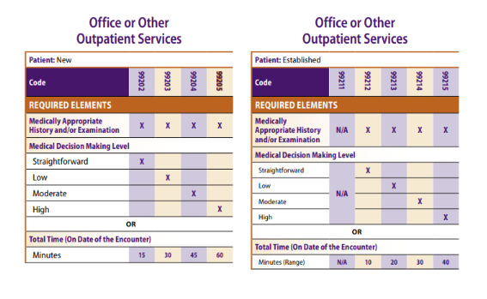

[ENTER ELEMENTS PROVIDED DURING EXAM]

If the claim edit is upheld, I require a letter explaining which required elements were absent from the chart to be forwarded to our office.

I would also like to make clear that the American Optometric Association opposes this type of downcoding and believes it is inappropriate for any insurer to make these decisions using an algorithm rather than a review of the patient’s charts. This case will be forwarded to the AOA for additional review.

Thank you for your reconsideration. If additional information is needed, please contact [ENTER INFORMATION]

Sincerely,

[ENTER DOCTOR NAME]

