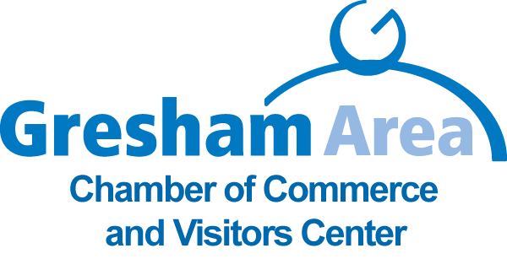
OFFICE MANAGER Gresham Area Chamber of Commerce
Would you like to have 496 bosses? Don't say "no" yet. There is a lot of joy making 496 bosses successful. That is the goal and the fulfillment in the current available staff position. And the team is rock solid too !
Detailed, accurate, proficient, motivated and confident in:
General administration knowledge and specific financial experience
Proficient in Microsoft 10, Quick books, Excel, Power point,
Computer operations and software applications
Graphics design and production
Office Administration
Knowledge of greater Gresham region
Not for profit/Chamber of Commerce operations
Office machines and support equipment operation
Recording and dissemination of information
Specific tasks include but are not limited to:
Direct responsibility keeping ChamberMaster industry data base accurate
Accurately perform accounting tasks
Event planning coordination assistance
Board relations, front line assistance
Maintain chamber brand through direct management of social media, newsletter, website, face book, power point, etc
Support and provide customer service in tourism related opportunities
Job Type: Full-time Pay: $43,000.00 - $50,000.00 per year
401(k) Matching Health Insurance Paid Time Off
Education: Bachelor's (Preferred) 2 years experience
Position available immediately
SEND RESUME TO: lynn.ceo@greshamchamber.org

