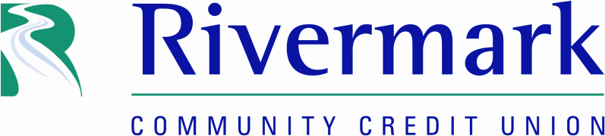

RIVERMARK DONATES ADDITIONAL $10,000 TO OREGON FOOD BANK
The Community Credit Union Offers Funds as a Challenge Grant to Encourage Community Giving

PORTLAND, OR – JUNE 3, 2020 – Today Rivermark Community Credit Union announced that it is donating $10,000 to the Oregon Food Bank and inviting other local businesses to join in this supplemental fundraising effort to address a dramatic increase in need.

With Oregon Food Bank’s 1,400 food assistance sites are experiencing 20-70% increases in people accessing food assistance, their need for support has never been greater. “Our donation alone won’t bridge the gap, but together with other businesses that are surviving the pandemic, we can make a real difference,” said Rivermark President and CEO Seth Schaefer.

Rivermark’s $10,000 grant supplements the funds it raised and the 102,000 pounds of food it collected for Oregonians in need during the KGW Great Food Drive in March. Rivermark has co-sponsored the annual food drive for the last four years as part of its commitment to combat food insecurity – one of the three pillars of its community giving program.

This year’s food drive was challenged by the COVID-19 virus and the Oregon Food Bank’s need to temporarily halt food donation deliveries when Oregon’s initial social distancing guidelines were put in place. When the shut-down occurred, Rivermark had already collected twelve large barrels of food donations at its seven locations. To get the food immediately out to those in need, Rivermark entered into a partnership with JOIN PDX, a nonprofit organization that supports people experiencing homelessness. JOIN PDX is an Oregon Food Bank distribution partner and part of Portland’s COVID-19 Mutual Aid Network.

Given the crisis, the month-long KGW Great Food Drive was extended to six-weeks and the Oregon Food Bank ultimately received the equivalent of 3.5 million pounds of food—dramatically increasing previous year’s donation totals – but still falling far short of the amount needed to meet current needs.

“The crisis we find ourselves in is unprecedented. It is ongoing, and affects everyone,” said Mike Davis of the OFB. “We are so appreciative of our long-standing partnership with Rivermark, especially during these uncertain times for so many Oregonians. Together, we will emerge stronger.”

About Rivermark
Rivermark Community Credit Union serves over 85,000 members at its seven area branches and online. Headquartered in Beaverton, Oregon, Rivermark has been offering superior financial services with a member focus since 1951. For more information about Rivermark visit their website at www.rivermarkcu.org.

About Oregon Food Bank
Oregon Food Bank (OFB) believes that food and health are basic human rights for all. Hunger is not just an individual experience; it is also a community-wide symptom of barriers to employment, education, housing and health care. To end hunger in Oregon, OFB builds community connections to help people access nutritious, affordable food today, and community power to eliminate the root causes of hunger for good. Learn more at oregonfoodbank.org

###
Contact:
David Noble, SVP Marketing
P: 503.526.3635
E: dnoble@rivermarkcu.org

