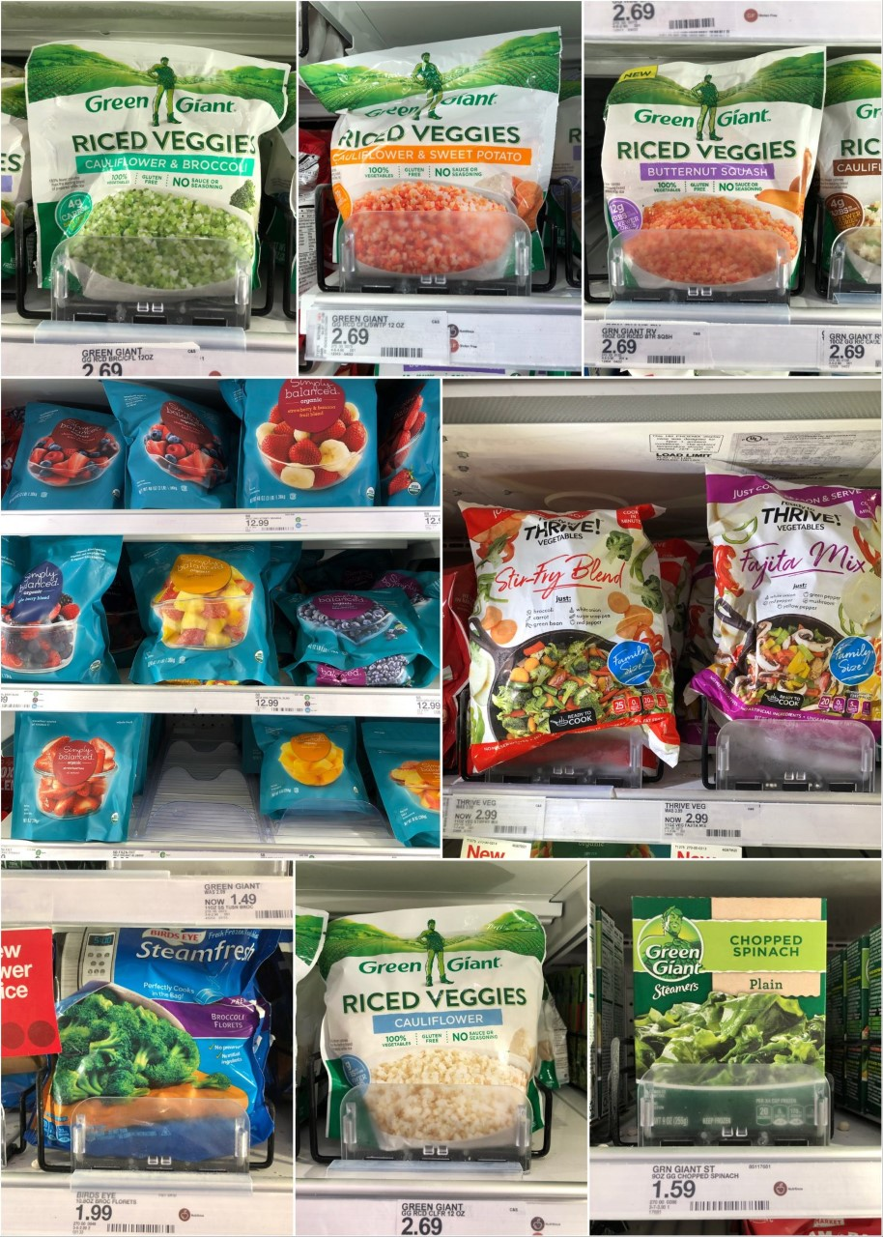 (Courtesy of Creative Market)
Choose Frozen Produce:
Buying frozen fruits and vegetables at the store is a better nutritional option than canned produce and a better financial option than fresh produce. Generally, frozen produce is better nutritionally because canned foods tend to have higher sodium and added sugar to preserve the goods. With less added sugar and salt, produce is also typically frozen when it is at its peak nutritional value, thus preserving its nutrient content fairly well. Compared to fresh produce, frozen fruits and vegetables last much longer, which allows for decreased waste and less trips to the store to re-buy the food. Additionally, frozen produce is oftentimes more affordable than fresh produce so next time you are at the store make sure to compare the prices.

Avoid Highly Processed Meats:
Although it may be more cost-effective to choose processed meat choices like salami, SPAM, hot dogs, and canned meats, the health risks of over-consuming these highly processed food products can be harmful. Specifically, processed meats are higher in sodium which can increase the risk for high blood pressure and heart disease. In order to maintain good protein intake and reduce your grocery store bill, mix in a few plant-based protein options into your weekly meals. These can include lentils, black beans, and tofu. Plant-based sources of protein usually come in bulk that last for multiple meals/servings, are nutritionally dense, and are just as low-priced as processed meat choices.

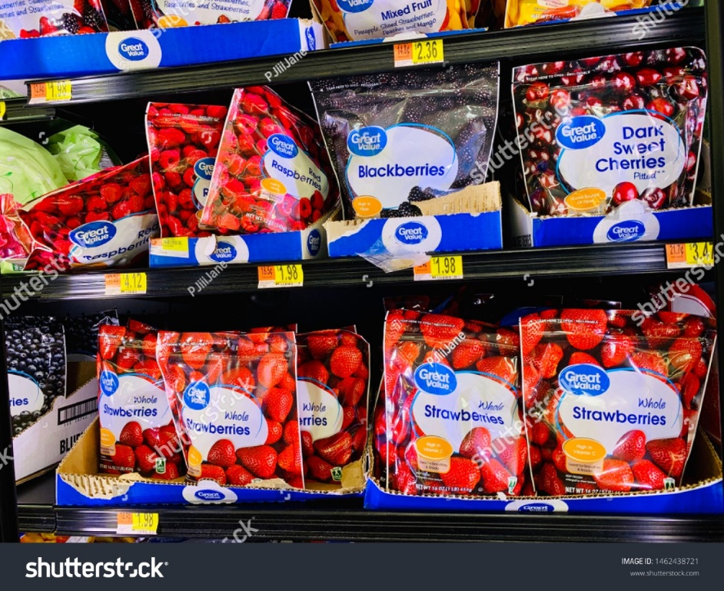
Choose Generic Brands Rather than Name-Brands:
You may have noticed that when you go to the grocery store, food products have varying prices depending on what brand sells them. Name-brand foods are foods that are sold by companies that are typically well-known brands including Jenny Craig, Nestle, and Green Giant. Sometimes right next to the name-brand product is a food item that is the exact same, but just sold by a different, lesser-known company. These generic brands are usually the exact same nutritionally, but for a lower price. Therefore, when shopping at the grocery store, check the different prices to pick the food item that is the lowest price.

The Bottom Line
It is important to continue to eat full, nutrient-dense meals for our optimal health. Although healthier foods may seem too expensive to afford this year, following these tips to shop healthy on a budget may help decrease your overall economic burden.

