Q1: MOTION IS LOTION – SHOULDER HEALTH

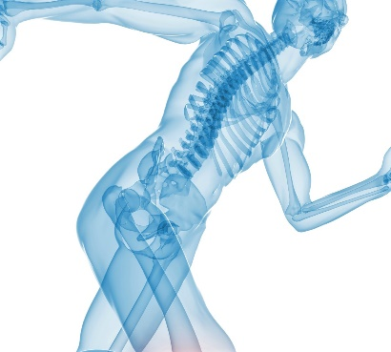
The shoulder is the body's most complicated joint. It's where the ends of the collarbone, upper arm bone, and shoulder blade meet. It's also prone to arthritis which is a wearing away of the cartilage between the bones. It is also prone to tears or tendonitis (inflammation) in the rotator cuff.
Repetitive shoulder stress injuries can take place in either the soft tissue of the shoulder joint, or in the ligaments or a tendon. The pain can either be sharp or achy and dull, or a pinch. Or the pain can manifest as tightness. Sometimes, because the neck and the shoulder are so intimately related, you can experience a little numbness or tingling. If you have symptoms of a repetitive stress injury in the shoulder the best thing to do is to acknowledge the symptoms. You may feel pain when you work or when you sleep in certain positions.
If you are starting to experience symptoms, a way to help is 1) put ice on the injury (after work) or 2) try some gentle range of motion exercises.
Of course, you should always seek a professional opinion before starting any program or routine to ensure you are supporting and not causing any potential further injury.
Simple but effective gentle range of motion moves can be done regularly and with very little equipment or time required, starting off easy and building up reps and frequency.
WE’RE HERE TO HELP! CONTACT MIKE MARCELO, YOUR BAYSPORT PHYSICAL THERAPIST AND GET YOUR FREE INJURY CLINIC CONSULTATION! CALL OUR REDWOOD SHORES OFFICE TO BOOK YOUR APPOINTMENT TODAY! 650-593-2800

