Mill CReek Academy

Return to SchooL

Parent Information Guide

2020-2021

LEADING THE CHARGE OF LIFELONG LEARNING

Amanda Riedl, Principal
Stacy Stackhouse, Assistant Principal
Jacqueline Ottosen, Assistant Principal
Rachel Naylor, Assistant Principal

Table of Contents

TOPIC | PAGE
School Options | 4
Cleaning & Sanitizing | 4
Personal Protective Equipment & Precautions | 6
Health Protocols | 7
Kindergarten Information | 8
First Day of School | 8
Arrival | 9
Dismissal | 11
Lunch/Recess/Resource | 12
In the Classroom | 13
Transitions | 14
Academics | 15
Visitors Policy | 15
Drills | 16
ESE- Exceptional Student Education | 16
Extended Day Program (ACE) | 17
After School Events | 17

School Options

Elementary Option 1 – School-Based Brick & Mortar
Children will go to school five days a week. Early release days will continue to occur every Wednesday. There could be a move to full-time distance learning if required by Department of Health or Governor’s Executive Order. In the event of quarantine, students will be provided an opportunity to continue learning during the quarantine period through the classroom teacher. Parents can elect to move to School-Based Distance Learning at any time. This would be at least until the end of Quarter One.

Elementary Option 2 – School-Based Distance Learning
Students remain attached to the current school while receiving instruction online. Teaching will mirror the pace and rigor of brick and mortar. Students choosing this option make a nine-week commitment. Mill Creek Academy will be utilizing a distance learning cohort model. Currently, identified teachers at each grade level will be teaching our distance learning students.

Things to Consider:
Should some families choose to move to distance learning after the school year has begun, administration may have to move additional staff to assist with distance learning which may mean the displacement of students from one brick and mortar classroom to another. Students cannot be guaranteed the same distance learning teacher as their brick and mortar teacher.

Cleaning and Sanitizing

OMNI Shield – Yes leave it
What is it? When applied to a surface or incorporated into a material, OMNI Shield forms a covalent bond with a surface (substrate) and creates a microbiostatic antimicrobial coating. The coating forms a nano-bed shield of spikes (self-assembling monolayer), each of which carry a positive charge that attracts the negatively charged bacteria. Once attached, the molecular spikes pierce the cell and rupture its membrane, causing the bacterial microorganism to die. OMNI Shield is water-based, non-toxic to humans and animals, contains no harmful chemicals or heavy metals, and is bound to the surface (substrate) meaning it cannot leach into the surrounding environment and is foggable in interior environments. OMNI Shield creates a microscopic shield on porous and non-porous surfaces to destroy bacteria on contact for up to 90 days after cleaning, even for surfaces that post treatment are immersed in water.

Where will it be applied? OMNI Shield will be applied to all frequently touched services. Frequently touched surfaces would include door handles, sink handles, playground equipment, drinking fountains, desktops, reception countertops, tables, chairs and other surfaces as needed.

Cleaning and Disinfection
During school occupancy cleaning and disinfection procedures will be conducted in accordance to CDC Guidelines. As an added precaution, frequently touched surfaces will be cleaned periodically throughout the day utilizing disinfectants recognized for use on COVID-19.

In the event of a possible exposure, related areas will remain unoccupied until the area can be disinfected in accordance with the CDC guidelines. Disinfection procedures will be conducted by either trained MCA custodial staff, a SJCSD COVID-19 Response Team or professional contracted services experienced in disinfecting procedures.

Hand sanitizer will be available in every classroom with additional stations in high traffic areas.

Frequent visual and verbal hygiene reminders will be provided by teachers and staff.

Personal Protective Equipment & Precautions

PPE Supplies for Mill Creek Academy
provided by the SJCSD
- Non-Contact Infrared Thermometers for all classrooms
- Desk Shields for all classrooms
- Cloth face masks for faculty
- Cloth face masks with adjustable ear loop for K-5
- Cloth face masks for 6-8 grade students
- Neck gaiters for kindergarten students to supplement masks
- Disposable face masks
- Face Shields for all teachers and support personnel
- Cleaning Spray – all classrooms
- Dry wipes – all classrooms
- Gloves – all classrooms
- Hand Sanitizer – 1 gallon w/ pump for each classroom
- Mobile hand sanitizer stations – placed in high traffic areas
- Safety signage (floors, walls, mirrors and free-standing signs).
- OMNI shield solution and sprayer

Face Coverings
Staff and students are required to wear face coverings at arrival, dismissal, transitions, and anytime they cannot socially distance.
- Masks, gaiters, and face shields are accepted face coverings.
- MCA will provide a child with a cloth mask, as needed.
- Disposable face masks will also be available, as needed
- Students with disabilities or medical conditions that prevent any type of face covering will be addressed on a case-by-case basis.

Safe Zones – Students will be given the opportunity throughout the day to have a “safe zone,” mask-free zone. We know that wearing a mask all day can be difficult. Students will have opportunities to remove their masks when in a safe zone.

- Classroom – when using a Desk Shield or when able to honor the social distancing guidelines.
- CAFÉ – when eating
- Recess – when playing at recess with their cohort

Desk Shields
Desk Shields will be provided on student stations. This will allow students to remove their masks while at their desk in the classroom. Once students leave their desks, and cannot socially distance, students will be required to wear their masks. This may be at small groups, group activities or partner work.

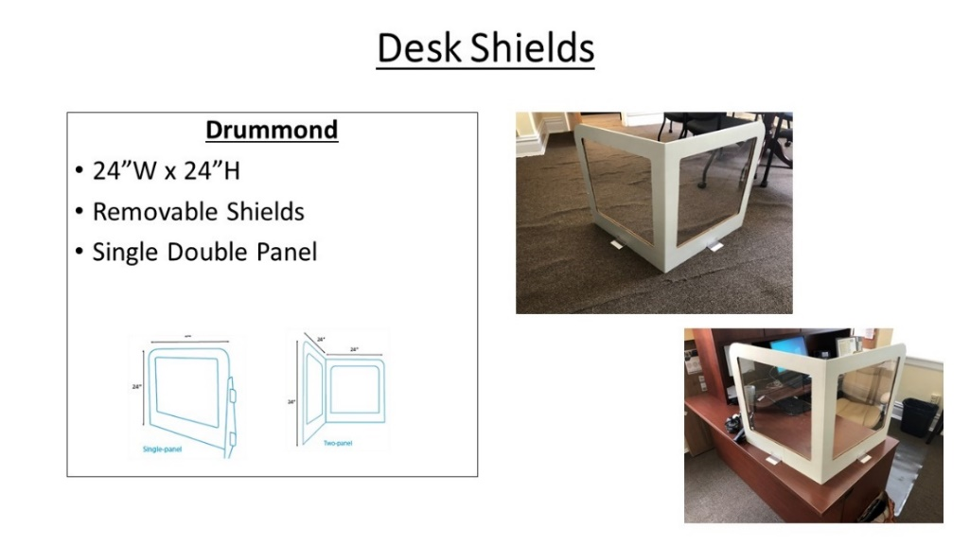

Classroom
Each classroom will receive cleaning spray, dry wipes, gloves, 1 gallon hand sanitizer, and a face shield will be provided for the teacher. Each teacher will have his/her own non-contact infrared thermometer for taking students temperatures upon arrival.

Health Protocols

Student Becomes Sick on Campus
- Student will be immediately removed from the classroom by the nurse and taken to an isolated space
- School nurse will:
  - conduct a health assessment
  - contact parent/guardian for pick-up. Upon arrival parent/guardian will call the building and student will be walked to the car.
  - explain next steps to the guardian
  - report case to the Department of Health who will begin contact tracing

Communication when Staff/Student tests positive for COVID-19
- Due to the requirements of FERPA and HIPAA, we cannot share information with everyone. On a case-by-case basis, we can share directly to families of students who are directly impacted as defined by who has had direct close personal contact with the student/staff member who tested positive.
- Our Director of Health Services is in constant contact with the local Department of Health and we follow their guidelines for notification and contact tracing.

You know your child best. If your child does not feel well, please stay home and seek medical assistance.

Kindergarten information

Staggered Start
Kindergarten teachers will schedule a day for students to come into the school on either Monday, August 31st, Tuesday, September 1st, Wednesday, September 2nd, or Thursday, September 3rd to meet with their teacher in a smaller group setting. This will be done during Kindergarten tours in August.

If families are doing distance learning or are uncomfortable coming to the school, a virtual meeting can be arranged.

All students will attend their first full day of Kindergarten on Friday, September 4, 2020.

First Day of School
Unfortunately, due to the need of minimizing people in the building, parents will not be permitted to walk their children to class. We will have multiple adults at each entrance to help your child find where they need to go.

Kindergarten students will all sign up for a date to attend staggered start during the first week of school. The first day for all Kindergarten students is Friday, September 4, 2020. Staff members will be at all arrival areas to help kindergarten students to their classrooms.

All students will report directly to their homeroom class on Monday, August 31. Staff members will be in all arrival areas to help direct students to class.

Arrival
- Families are asked to check the temperature of their child each day prior to leaving for school.
- Students being dropped off at PPU will use the PPU doors for entry; bus riders will use the main entry doors & the Bus doors during arrival.
- Hand sanitizing stations will be available at all school entrances.
- Students will report directly to their classroom/homeroom upon arrival.
- Parents should not drop students off at PPU until 8:00AM. Students should not gather outside the PPU doors.
- Buses will unload students in a staggered manner to allow for more distancing during arrival
- Masks will be required until a temperature check is complete at the classroom/homeroom class.
  - Masks will be provided to students, if needed
  - Temperature checks will be conducted by the classroom/homeroom teacher (before instruction begins), cafeteria staff (if child eats a school breakfast) or Extended Day worker (if arriving for morning extended day)
  - Students with a temperature below 100.4 will be permitted to stay in school. Any student with a temperature at or above 100.4 will be referred to the nurse.
- Staff will monitor hallway flow and will direct students to follow a specific “traffic pattern”.
- Breakfast will be provided using social distance protocols
- Extended Day program will follow all safety and temperature protocols

If your child is a Bus Rider:
- Buses will run at normal capacity
- Frequent sanitization, antimicrobial surface treatment will occur on each bus
- Masks are required on all bus routes
- Masks will be required until students arrive in class for a temperature check
- Students will utilize hand sanitizing stations upon entry to school
- Masks will be provided to students if they do not have one upon arrival

If your child is a Car Rider:
- Students should be wearing a mask as they exit the vehicle
- Social distancing should be maintained as students enter the building
- Students will utilize hand sanitizing stations upon entry to school
- Masks will be provided to students if they do not have one upon arrival

If your child is a Biker or Walker:
- Students should wear their mask as they arrive on the campus
- Social distancing should be maintained
- Students will utilize hand sanitizing stations upon entry to school
- Masks will be provided to students if they do not have one upon arrival

Dismissal
- All students will be required to wear masks during dismissal
- Dismissal will be staggered to decrease the number of students in the hallways and loading zones
- Adults will help to monitor students to their appropriate dismissal locations

If your child is a Bus Rider:
- Buses will have a staggered dismissal to aide with social distancing during dismissal
- Students will be required to wear masks during dismissal and while on the bus
- Adults will be present in the Bus loading zone to help students during bus loading

If your child is a Car Rider:
- Parents will receive a car line tag to place in the front window to help with calling students.
- Students will be required to wear mask while waiting for their cars and while going to their cars.
- Adults will be present in the Parent Pick-Up area to help students remain socially distanced.

If your child is a Biker or Walker:
- Students will be required to wear their masks until they exit the school campus

Lunch, Recess, & Resource

Lunch:
- Elementary students will sit with their classroom cohort and be distanced from other cohorts.
- All students will have assigned seats in the cafeteria.
- The cafeteria serving line will have social distancing markers to remind students to keep appropriate distance
- Hand sanitizer will be available at the entrance to the cafeteria.

Resource:
- Elementary students will attend Resource classes. Recommended use of PPE, social distancing, and cleaning will be followed.
- During physical activities masks do not need to be worn.
- Cardboard testing partitions will be used in the computer labs – yes we have these, but
- Students will have assigned seats.

Recess:
- Recess will continue to be scheduled in accordance with the state statute.
- During the transition to and from recess, students will wear their masks and maintain distance from other classes.
- While students are playing at recess with their cohort, masks do not need to be worn.
- Each cohort will be assigned a zone on the playground to keep each class socially distanced from other cohorts.

Recess Zones

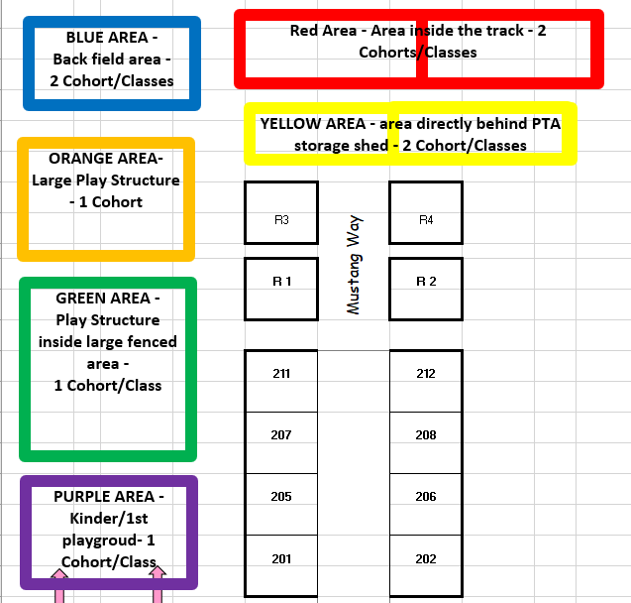

in the classroom

What does inside the classroom look like?

Brick and Mortar
- When students arrive to their classrooms, they will have their temperature taken.
- Hand sanitizer will be available in all classrooms, K – 8. Students will be asked to sanitize their hands upon entering/exiting the classroom throughout the day.
- Students will be asked to sanitize hands upon entering/exiting the bathroom throughout the day.
- Students will have assigned seats in the classroom.
- All desks/tables will have desks shields
- When students are unable to social distance, masks will be required. This may be during small group instruction, carpet time, partner work, or group assignments.
- Frequent visual and verbal hygiene reminders will be given throughout the day to help students
- Students will be given opportunities to use “safe zones” to have a break from wearing masks during the day. See above for “safe zone” areas.

School-Based Distance Learning
- For each grade level/subject area, there will be identified distance learning teachers.
- The distance learning classroom schedule will reflect a regular day at the building.
- Distance Learning Teachers will be using Schoology as the primary learning tool.
- At the end of the first quarter, we will make adjustments to the Distance Learning rosters based on SJCSD recommendations and parent requests to return to brick and mortar.
- A detailed learning schedule, classroom expectations, and more will be coming to parents during meet and greet.

Exceptional Student Education
- ESE support services (OT, PT, Speech/Language, DHH, VI, MHC, Behavior Specialist/Technicians) will provide services as dictated by the students’ IEPs.
- ESE groups will consist of students from different cohorts. ESE teachers will be sanitizing and cleaning after each group and will ensure proper safety protocols and social distancing in the classroom.
- Students participating in school-based distance learning may choose to receive ESE services at MCA. These therapies include (speech, language, OT, or PT) or specially designed instruction or related services provided by an ESE teacher.
- Schedules have already been developed for all students with IEP’s. Should a students want to receive services on campus, times will be given to families.
- All accommodations will be followed as written in the IEP.
- During pre-planning Case Managers will call all distance learning families and brick and mortar families who may have a change in schedule. Any changes in the way ESE services or related services in a student’s IEP or EP are provided due to school-based distance learning or cohort requirements should be discussed in advance with the parent and recorded on the Individualized Continuity of ESE Services Plan.
- Completion of the Individualized Continuity of ESE Services Plan does not require an IEP/EP meeting. The district is not recommending a change to the IEP/EP, we are simply documenting how these services will be provided in the event distance-learning or changes due to cohort requirements are necessary

Supplies
- Students will be encouraged to have their own supplies and not to share them with other students.
- Parents are encouraged to write the students’ names on these supplies.
- Classroom supplies, those that were included on the “boy/girl list” for K -5 OR “classroom supplies” for middle school, do not need to be labeled as these supplies will be shared by the class.
- If manipulatives or other classroom supplies need to be shared, they will be wiped down frequently and/or be individualized for students.

Absences
If your child is absent due to quarantine, the brick and mortar teacher will provide instruction. Teachers will be taking attendance for distance learning. Assignments are expected to be made up if your child is absent.
Absentee Forms- Please make sure to complete the electronic Absentee form located on the MCA homepage when a student is absent.

Transitions

Elementary
Throughout the day, students will be transitioning to lunch, resource, recess, arrival, and dismissal. During all transition times students are required to wear a mask.

Elementary students will stay in line as they transition to ensure proper distance between classes. Teachers will teach appropriate line procedures to help students maintain distance while in line. Teachers will utilize a specific route in the hallway to maintain social distancing from other cohorts.

Middle School
Middle school students will be transitioning to each of their seven classes, lunch, restrooms, arrival and dismissal.

Middle School students will be required to wear a mask for each transition. Hallways will have an established “traffic pattern” to decrease student contact during transitions.

Middle school students will be required to hand sanitize each time they enter/exit a new space.

Academics

Instructional Continuity Plan
The SJCSD created an instructional continuity plan for all teachers to follow in the district curriculum maps. Embedded within the maps are the standards that were covered in the fourth quarter of the previous grade. Standards have been identified as being GAP Standards, need explicit instruction, and BLENDED Standards, blended with grade-level standard. Teachers will also be meeting with the grade level before (example: 2nd grade teachers will meet with 1st grade teachers) to better understand the needs of the previous students. This will help to ensure the best continuum of learning at MCA.

Grading
Both the distance learning teachers and brick and mortar teachers will continue to work in their Professional Learning Communities to have common assessments. Teachers will follow the pacing guides established in the district curriculum maps to assess students. Grades for all students are located on the Home Access Center. For more information on HAC, please go to: https://www.stjohns.k12.fl.us/hac/. Or call the MCA Front Office at (904) 547-3720.

Testing
Students will be taking the Fall iReady Diagnostic. This assessment helps our teachers to identify students’ needs. Both brick and mortar and distance learning students will take this diagnostic.

Parent/Teacher Conferences – yes this is correct
Fall conferences will be scheduled during the first quarter. Parents can request a parent/teacher conference virtually or in person.

Volunteer/Visitor Policy
Visitor and volunteer access to campus is restricted. Visitors and volunteers must be on official school business (IEP Meeting, Parent/Teacher Conference, etc.) by appointment to enter. Visitors and volunteers are subject to COVID screening/clearance before entry. Visitors and volunteers, at this time, are not allowed to eat in the cafeteria with a child. Of course, once the pandemic has subsided, we look forward to having you return!

Drills
- Students will be introduced to all school safety procedures and drills during the first week of school
- Safety drills will be introduced and practiced either with the use of appropriate PPE or virtually during the first quarter based on district recommendations.

Extended Day Program
- The Extended Day program will follow the same safety guidelines and procedures that are in place daily at MCA.
- Students will be assigned to a specific group to make a cohort. The cohort will play at recess in zones and sit together for activities.
- If cohorts need to combine, masks must be worn, or social distancing observed.
- At this time, no outside vendors or clubs will be part of the Extended Day program at Mill Creek Academy.

Arrival for Extended Day (mornings)
- Parents will bring students to the main office entrance to sign-in for extended day
- Parents and students will be required to wear a mask
- Extended day staff will meet students and check each student’s temperature before entering the building.
- Students must wear masks in the cafeteria unless social distancing can be observed
- Students MUST arrive prior to 7:50AM for Extended Day due to the arrival of buses.

Dismissal from Extended Day (afternoons)
- Guardians will pick students up at the Cafeteria side door
- Guardians will be required to wear a mask when picking up extended day students
- Guardians will be asked to maintain social distancing while waiting for their child.

after school events

Teacher Meet and Greet
The Teacher Meet and Greet will be virtual through Schoology.

PTO Events and Meetings
Nery De Los Santos is our MCA PTO President. We will hold all PTO meetings virtually until volunteers are allowed into the building. Please consider joining the PTO using this link: https://mcapta.weebly.com/membership.html

Clubs
At this time, we will not be hosting any outside vendors (STEM Club, Chess Club, etc.) and school based clubs (Safety Patrol, Music Club, Art Club, Robotics etc.) will not be meeting. This will be reassessed after the first quarter.

Curriculum Chat Night
In person Curriculum Chat Night will not be taking place this year. Curriculum Chat Night will be scheduled for mid-September and will be hosted virtually. Stay tuned for specific dates and details!

