2019 Official Credential Card Idaho PTA Convention—Meridian, Idaho
This card certifies that:
(Full Voting Delegate Name)

(Address) (City)

Has been duly authorized to represent:

(Name of Local PTA/PTSA Unit)

At the 114th Annual Convention of the Idaho Congress of Parents and Teachers, Inc. in Meridian, Idaho on April 12-13.

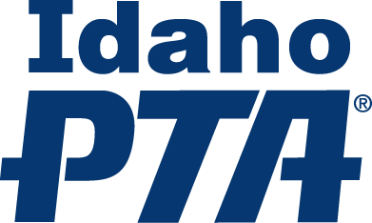
Signed: Date:

2019 Official Credential Card Idaho PTA Convention—Meridian, Idaho
This card certifies that:
(Full Voting Delegate Name)

(Address) (City)

Has been duly authorized to represent:

(Name of Local PTA/PTSA Unit)

At the 114th Annual Convention of the Idaho Congress of Parents
and Teachers, Inc. in Meridian, Idaho on April 12-13.
Signed: Date:

