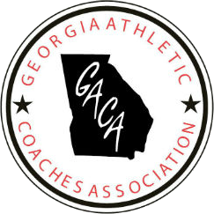
Georgia Athletic Coaches Association
Hall of Fame Foundation
4th Annual Golf Tournament
Monday July18, 2022

What: 4th Annual GACA Hall of Fame Golf Tournament
Where: Oak Mountain Golf Club, Carrollton, Georgia
When: July 18, 2022 9:00 A.M. Shotgun Start
Format: 4 Man Scramble
Tees: Under 65- White Tees
65 and over- Green Tees
Mulligans: Mulligan Packages will be available
Door Prizes: Mulligan tickets give you a chance to win prizes at a drawing after the tourney.
Awards: Awards for first, and second place- Closest to the pin and longest drive
Cost: $500 per team. Make Checks payable to the GACA and mail to:
GACA
P.O. 1120
Jesup, Georgia 31598
Entry Fee includes. Golf, Range Balls, Dinner, and golf gift

Special Motel Rates for players wishing to come early.

TEAM INFORMATION
Name | Cell | Email | Address
1

2

3

4

For more information contact:
Bill Bailey- 770-328-6769
Email: bbailey6951@yahoo.com

