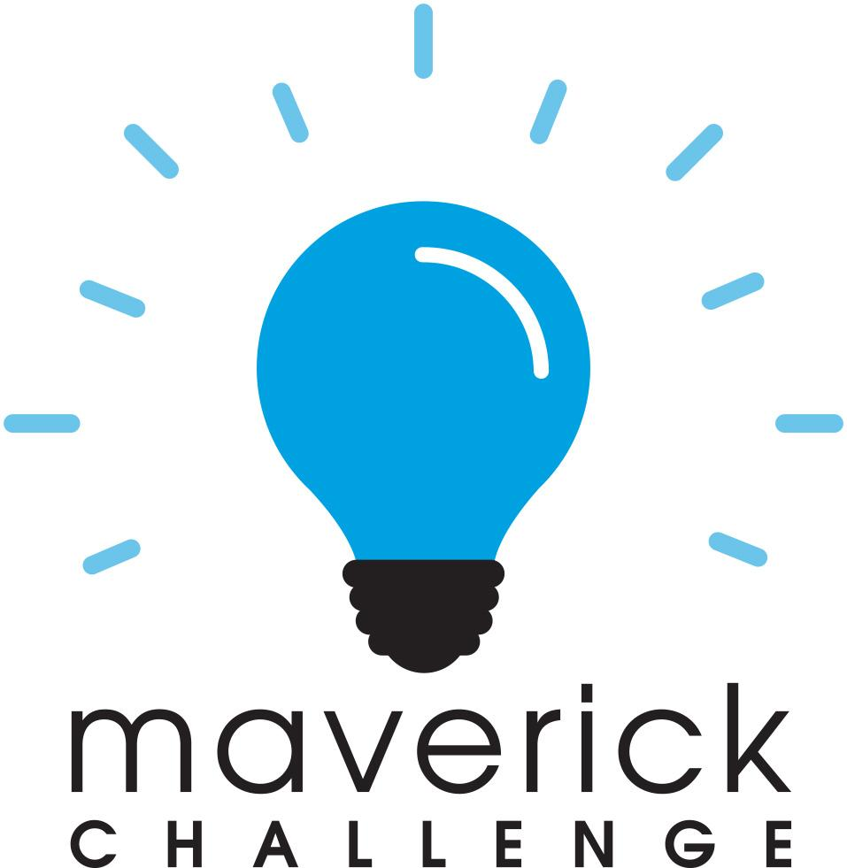

FOR IMMEDIATE RELEASE

Program Contact:
Columbus Area Chamber of Commerce
500 Franklin Street
Columbus, Indiana 47201
(812) 379-4457

Student Entrepreneurs Receive Over $3,000 for their Innovative Ideas

Columbus, IN - Over the past weekend, 9 students representing 6 counties in Southeastern Indiana pitched their business plans at a regional finals competition for a chance at winning cash prizes as part of the next-generation youth entrepreneurship initiative known as the Maverick Challenge.

Coordinated by the Columbus Area Chamber of Commerce, the Maverick Challenge is designed to show high school students the viability of a career in entrepreneurship through a hands-on business planning experience. This year, over 280 students from Bartholomew, Dearborn, Franklin, Jackson, Jennings, Monroe, and Scott counties participated in the program. Since its inception in 2008, more than $100,000 has been awarded to students.

This year’s winners presented four innovative ideas to a panel of judges in a very tight competition. In first place, Jesse Kogge, Julia Layton, and Aidan Mahaffey of the Academy of Science and Entrepreneurship & Bloomington High School North (Monroe County) won $1,500 for their pitch, AR Odyssey. In second place, Trey Nebergall of Columbus North High School (Bartholomew County) won $1,000 for his pitch, Aspire Group. Judges’ Choice - Spotlight on Innovation was awarded to Madie Hoog and Lana Lischkge of Oldenburg Academy (Franklin County), and they received $350 for their pitch, GutterButler. Finally, the Judges’ Choice for Research and Preparation was awarded to Maggie Connell of Seymour High School (Jackson County) for her pitch, Sunset Vistas. Connell was awarded $175.

Students participating in the Maverick Challenge complete an online curriculum on business foundations to help them take their ideas from a concept to a developed business plan. Students work with local mentors throughout the competition to improve their business plans, and students pitch these business plans in multiple rounds of judging at both the county and regional levels. This year, the regional finals were held virtually via Zoom.

2020-2021 Maverick Challenge Regional Winners
1st Place - AR Odyssey - Jesse Kogge, Julia Layton, & Aidan Mahaffey - Academy of Science and Entrepreneurship & Bloomington High School North, Monroe County
Business Idea: Hands-on computer science education app for 10-13 year old students that incorporates augmented reality.

2nd Place - Aspire Group - Trey Nebergall - Columbus North High School, Bartholomew County
Business Idea: Full service real estate media company that provides professional photography, video, drone, and 3D tours for real estate agents. (https://aspiregroupmedia.com/)

Judges’ Choice - Spotlight on Innovation - GutterButler - Madie Hoog & Lana Lischkge - Oldenburg Academy, Franklin County
Business Idea: Automatic rain-gutter opener designed to simplify life for cistern users and make owning a cistern more efficient.

Judges’ Choice for Research & Preparation - Sunset Vistas - Maggie Connell - Seymour High School, Jackson County
Business Idea: An independent retirement community in Seymour, IN.

2020-2021 Maverick Challenge Regional Finalists
Socially Grown - Devin Fluhmann - Lawrenceburg High School, Dearborn County
Business Idea: Helps businesses establish their brand on social media by creating social media posts for businesses and identifying social media trends.

Puplink - Ashley Miller - Scottsburg High School, Scott County
Business Idea: Sleek GPS dog collar connected to an app so that pet owners can be notified when their pet has left the designated area.

Regional Partners for the Maverick Challenge include: AIM Young Professionals, Brownstown Chamber of Commerce, Columbus Area Chamber of Commerce, Jackson County Industrial Development Corporation, Jennings County Economic Development, IUPUC, Mid-America Science Park, The Mill, Oldenburg Academy, Seymour Chamber of Commerce, Southeastern Indiana SBDC, Innovate WithIN

###

Launched in 2008, the Maverick Challenge aims to further develop the innovative spirit of our region by reaching out to high school students and showing them viable career opportunities through entrepreneurship. Since then, more than $100,000 in prize monies have been awarded. Student awards in Bartholomew County are sponsored by certified public accounting firm Agresta, Storms & O’Leary, and the program is also supported by grants from the Carl Marshall and Mildred Alman Reeves fund and the Old National Bank Foundation.

A portion of the photos taken at the regional finals. More photos available upon request.

1st Place - AR Odyssey - Jesse Kogge, Julia Layton, & Aidan Mahaffey (below)
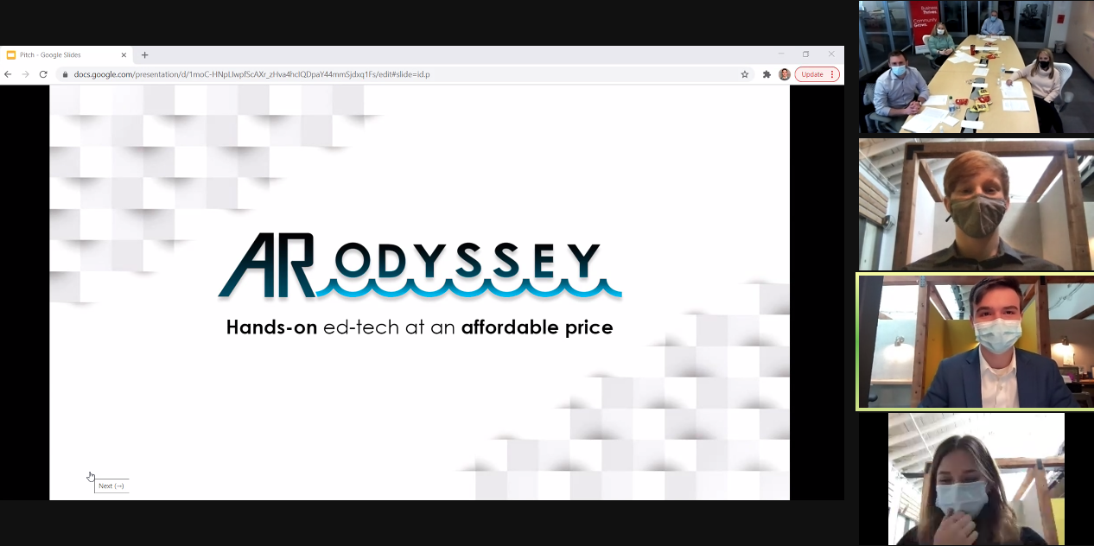

2nd Place - Aspire Group - Trey Nebergall (below)
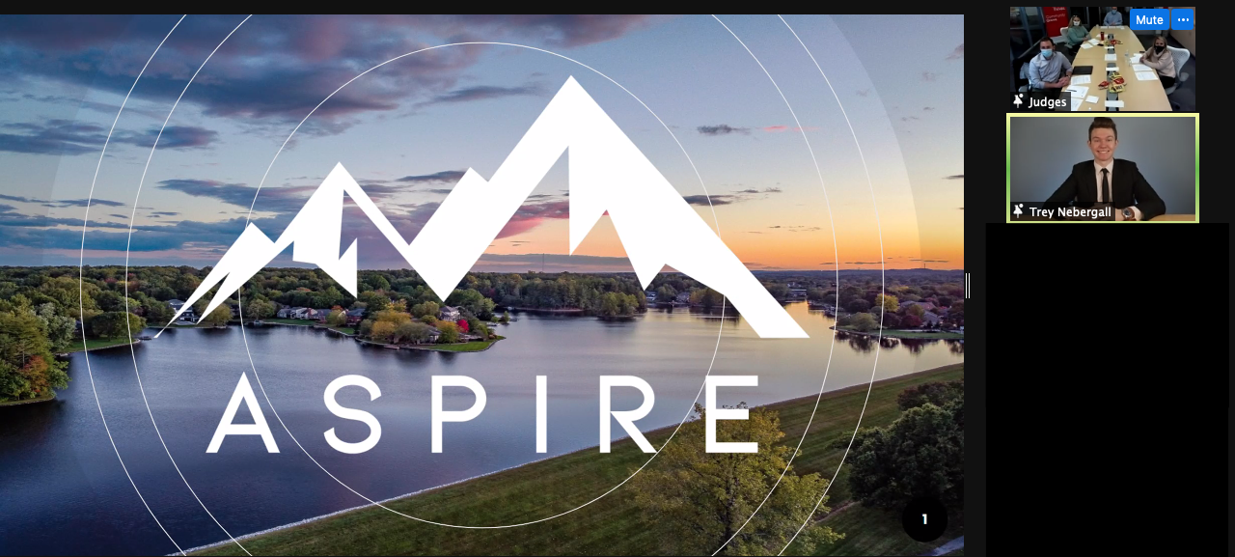

Judges’ Choice - Spotlight on Innovation - GutterButler - Madie Hoog & Lana Lischkge (below)
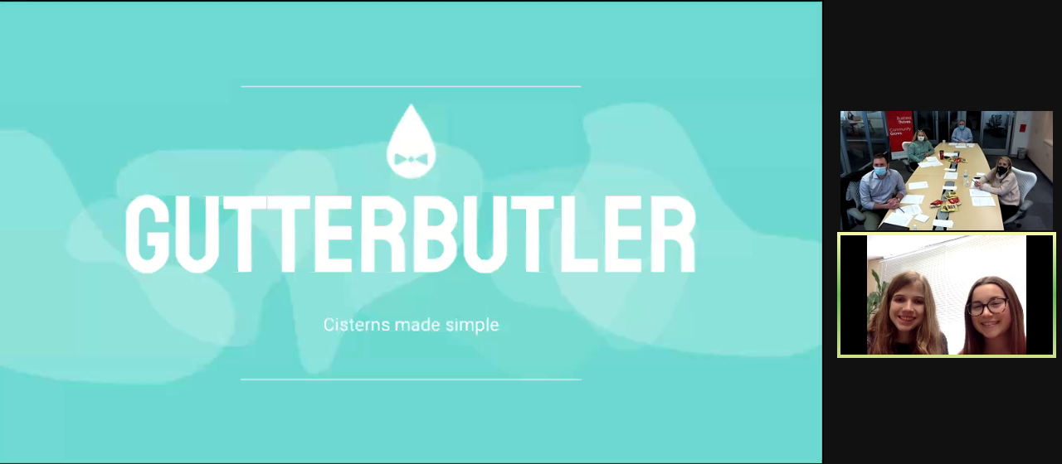

Judges’ Choice for Research & Preparation - Sunset Vistas - Maggie Connell - (below)
