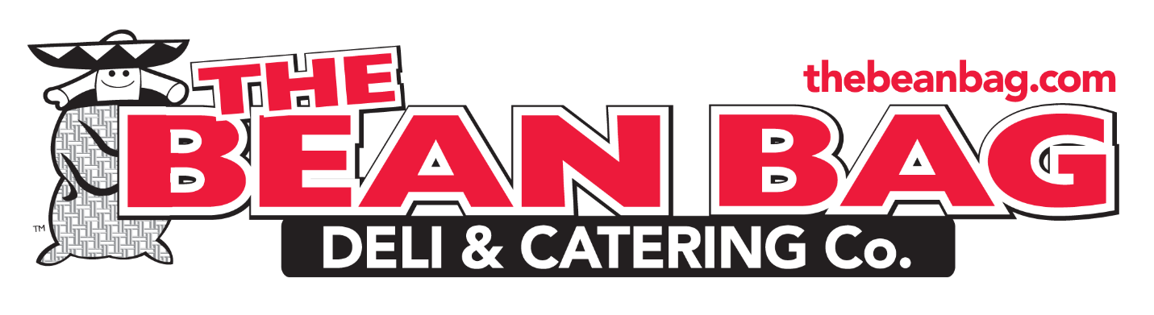
If you’ve been to the Dawg Dish concession stand or joined us for the Bulldog Bash hopefully you may have grabbed some delicious Bean Bag Bakery cookies or brownies, donated by our wonderful sponsor Bean Bag Deli & Catering Company, home of the Bean Bag Bakery!
Their sweet treats are not to be missed! But Bean Bag is not just for cookies. Their catering services are top notch for corporate and social events of all sizes. Planning an upcoming graduation party? Mother’s Day brunch? Father’s Day BBQ? Business conference? Want to send a cookie box to your favorite camper or college student? Bean Bag has you covered!
Show Bean Bag how much WCHS appreciates them and check out all they have to offer at www.thebeanbag.com. Don’t forget to tell them you are a Churchill Bulldog and how you heard about them!
