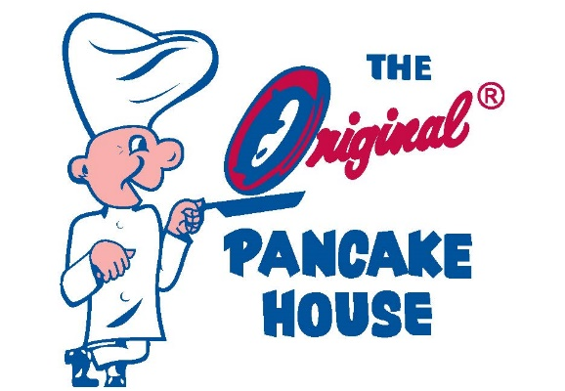
We are thrilled that The Original Pancake House chose to support Churchill Athletics as a WCHS Booster Club Sponsor this year! The Original Pancake House locations in Bethesda and Rockville are both favorites among the Churchill community for brunch and lunch! Known as "The First Name in Pancakes" OPH is best known for their breakfast specialties served all day, but they also have terrific sandwiches, burgers, salads, and wraps!
Family-owned and operated by MoCo locals, OPH is a generous sponsor of schools across Montgomery County with ties currently (and for many decades past) to Churchill.
OPH loves hosting team and group breakfasts and offers a special rate for student groups! (*Must call ahead to schedule. Ask for David!)!
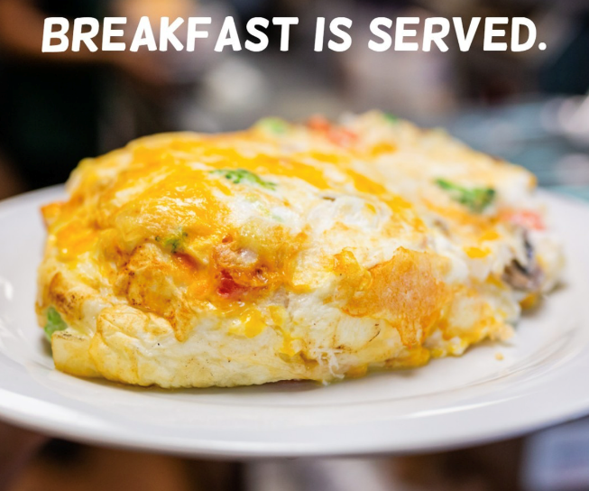
Spring teams make sure to plan a pre- or post-game meal this season!

