JTCC TAKES FIRST STEPS IN PARTNERSHIP WITH CHURCHILL
TO GROW TENNIS IN POTOMAC
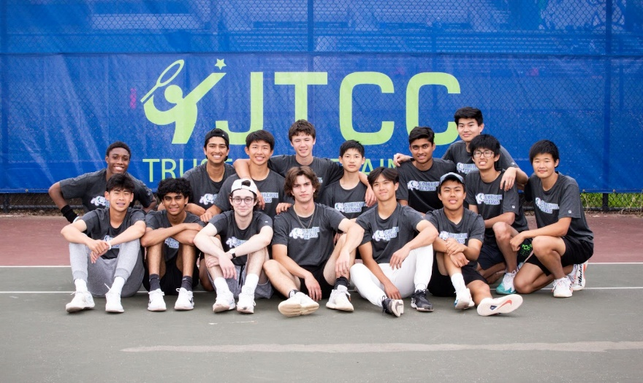
At the start of 2022, the Junior Tennis Champions Center (JTCC) began a partnership with Churchill Athletics. In March, JTCC supplied and installed new tennis court windscreens that in the past have notoriously been exposed to extreme winds during the boys’ and girls’ varsity tennis seasons. The windscreens have been a huge hit with both teams and the Churchill tennis-playing community!
County Champions & undefeated Boys’ Tennis Team in front of
new windscreens.
This past June, JTCC repaired numerous cracks across the six courts in preparation for next year's high school tennis season and for their inaugural Potomac Champs Camp, which was hosted at Churchill over the summer. There was a great turnout and response to the camp, which was attended by many current and future Churchill students. “JTCC has been wonderful to our athletics program, and we are lucky to have them partnering with us,” said Jesse Smith, Athletic Director at Winston Churchill High School.
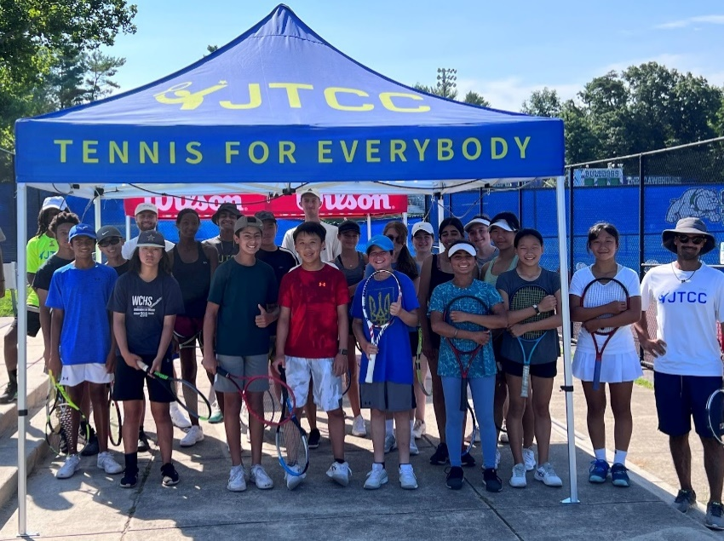
As this partnership evolves, JTCC will continue to support the boys’ and girls’ tennis teams with equipment upgrades, court maintenance, and apparel. JTCC plans to launch community outreach programs where they introduce the sport of tennis for free to underserved communities in and around Montgomery County.
Churchill Hosts Inaugural JTCC Potomac Champs Camp
In addition to summer camps, JTCC will bring some of its world-class junior and adult tennis programs to Churchill. “Here at JTCC, we have loved collaborating with an amazing school and amazing people. In such a short amount of time, we have accomplished so much at Churchill, and we are very excited to be a part of such a great community in Potomac. We hope to see continued growth and expansion in the coming years,” said Joe Wilkerson, Senior Vice President at JTCC.
The Junior Tennis Champions Center, a nonprofit organization based in College Park, Maryland, is committed to transforming lives through tennis by making the sport accessible for people of all ages and abilities.

