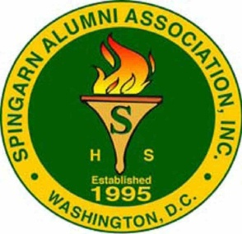
Save The Dates
The General Body Membership meeting dates for 2025
Membership meets every 2nd Saturday of each month
Starting times are 12:00 Noon
January 11

February 8

March 8

April 12 - Banquet
May 10
Closed for Summer Break
(June 1 through July 31st )

August 9
September 13
[Annual Scholarship & Membership Cookout]
Lake Arbor CC
October 11
November 8
December 13
Locations - TBD

