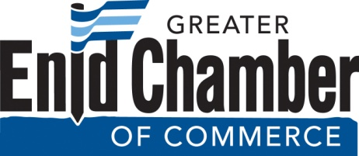

Per the Greater Enid Chamber of Commerce bylaws, the Nominating Committee has submitted the proposed slate of directors to replace the directors whose terms are expiring on June 30, 2018. This slate is open to petition. If no petitions are filed by 5:00 pm Friday, May 11, 2018, the nominations shall be closed and the nominated slate of candidates shall be declared elected.

The Proposed Slate of Directors
Term of Office: July 1, 2018 - June 30, 2021
Todd Hamilton, BancCentral
Finny Mathew, INTEGRIS Bass Baptist Health Center
Dan Schiedel, United Way of Enid & NW Oklahoma
Jason Turnbow, Security National Bank
Taylor Venus, Long, Claypole & Blakley Law

Nominations by petition: Additional candidates for Directors may be nominated by petition bearing the signatures of at least fifteen (15) members of the Chamber (signers must be members of the Chamber in good standing) along with the signature of the nominee (nominee must be a member of the Chamber in good standing) indicating his or her acceptance to serve if elected. Such petition(s) shall be filed with the Nominating Committee no later than 5:00 pm on Friday, May 11, 2018 at the Chamber office, 210 Kenwood Blvd. The determination of the Nominating Committee as to the validity of the petition(s) shall be final. If a valid petition is received, the Nominating Committee shall conduct a ballot election per the by-laws of the organization.

Directors whose three-year terms are expiring include: Dalen McVay, Todd Hamilton, Kandi Nelson, and Sandi Daniels-Peoples (Dalen McVay will continue to serve on the board as Immediate Past Chairman. Todd Hamilton previously filled an unexpired term and is eligible to serve a full three-year term on the board). We thank all of these directors for their service. If you have any questions concerning the single slate election or the right to petition, please call Jon Blankenship at the Chamber office, 580.237.2494.

OFFICIAL POSTING DATE Tuesday, May 1, 2018

