
St. Martin’s Episcopal Church
Bridgewater, New Jersey
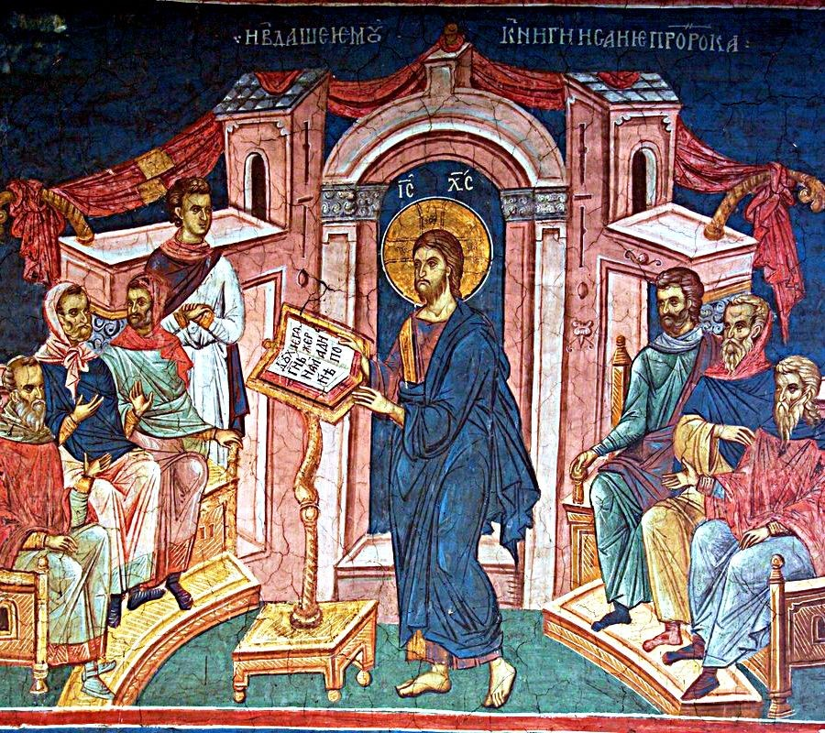
An Abbreviated Celebration of the Holy Eucharist with Spiritual Communion Rite 2
Sixth Sunday after Pentecost
July 04, 2021 + 10:30 am

Opening Hymn (Please stand to sing) Vv. 1, 2 Hymnal 1982 Hymn 657
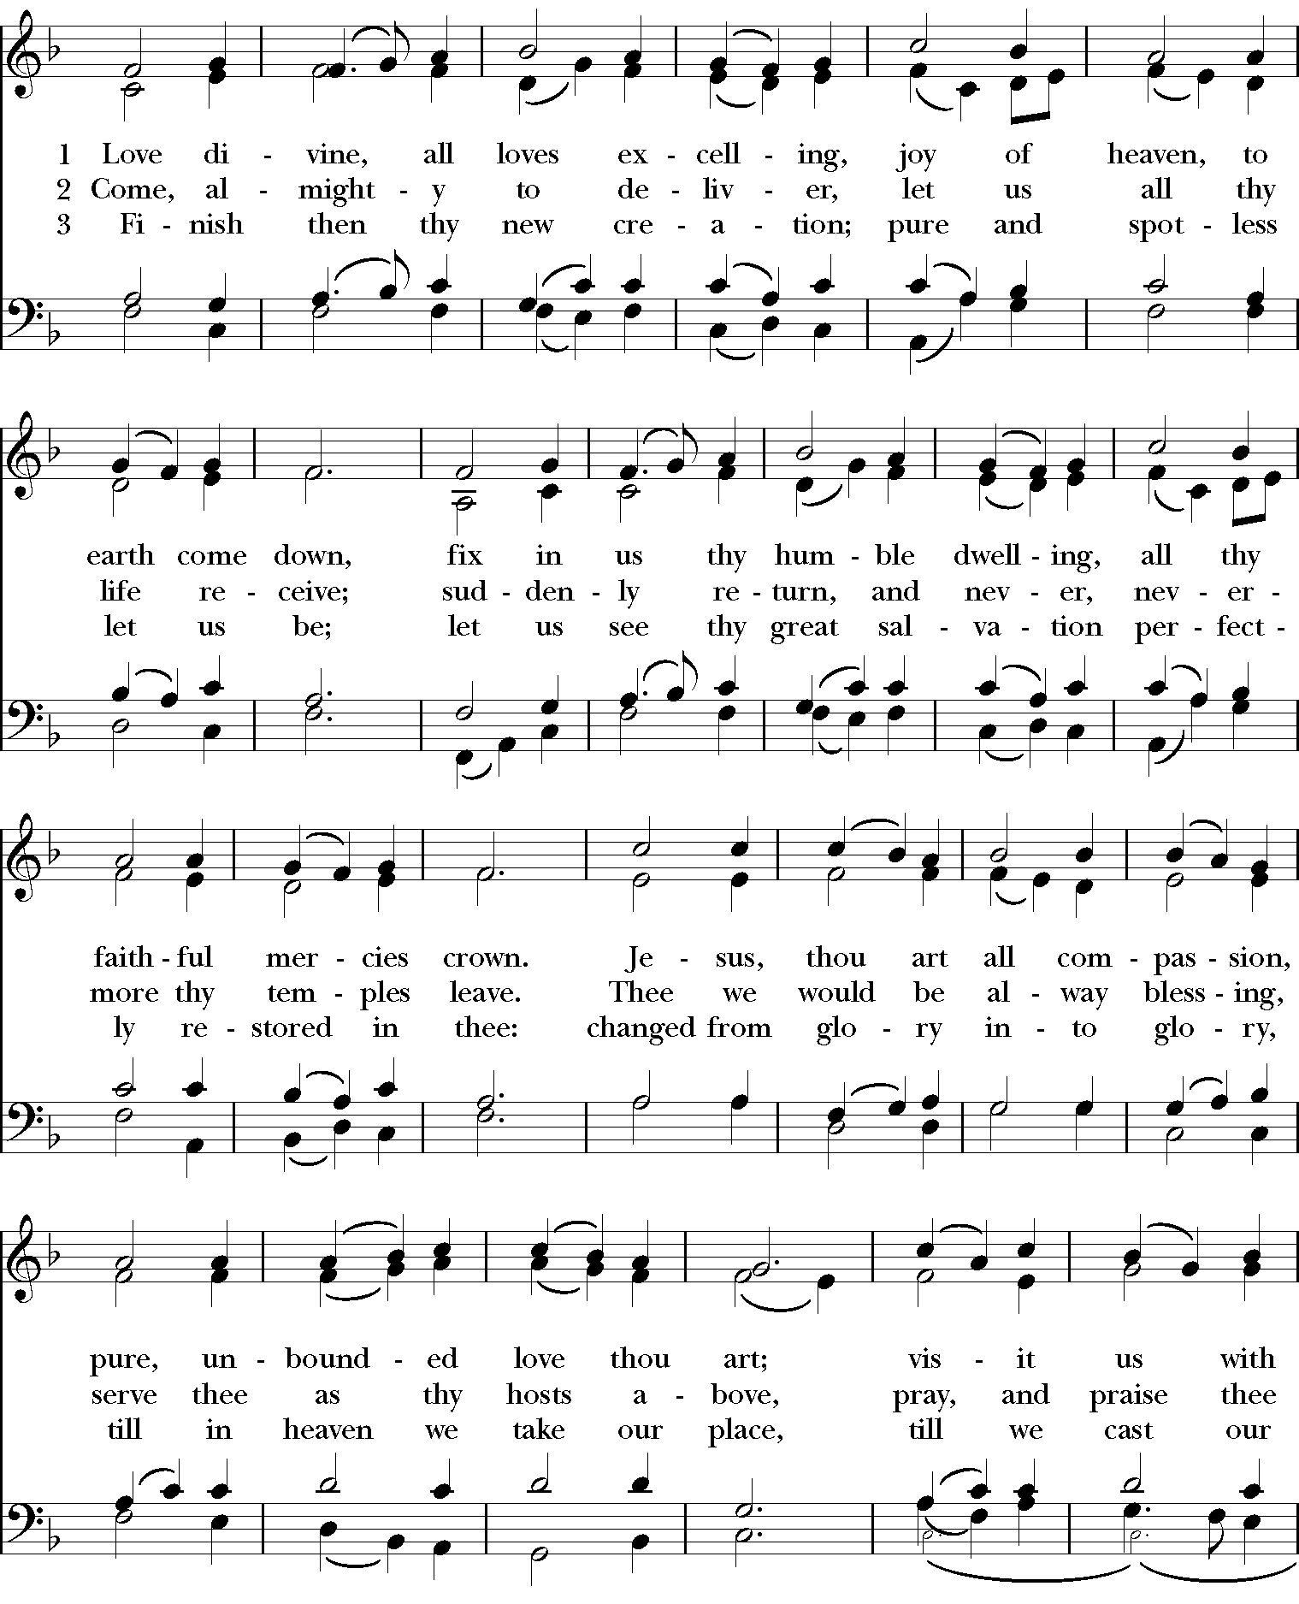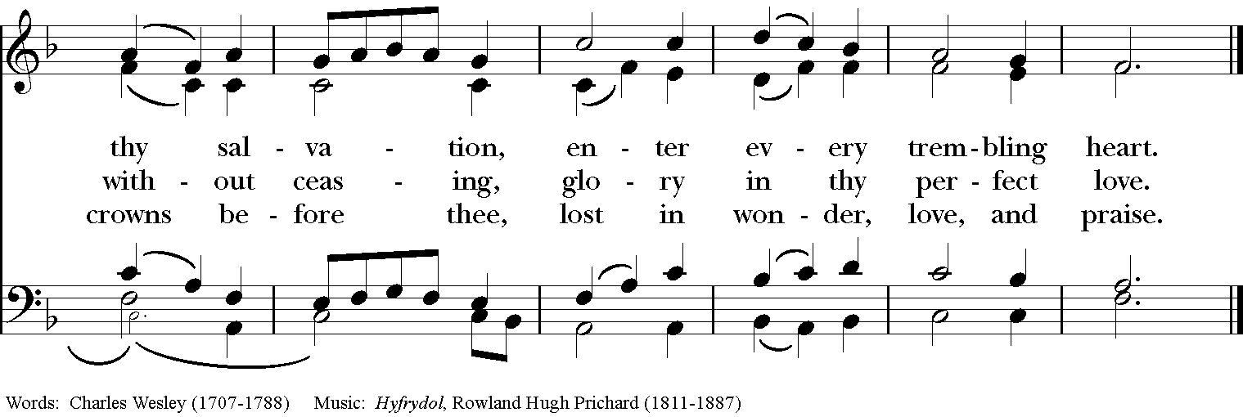
Priest: + Blessed be God, Father, Son and Holy Spirit.
All: And blessed be God’s Kingdom, now and forever. Amen.
Priest: Almighty God, to you all hearts are open, all desires known, and from you no secrets are hid: Cleanse the thoughts of our hearts by the inspiration of your Holy Spirit, that we may perfectly love you, and worthily magnify your holy
Name; through Christ our Lord. Amen. BCP, 355
Hymn of Praise: (Please remain standing to sing) Hymnal 1982, Hymn 421
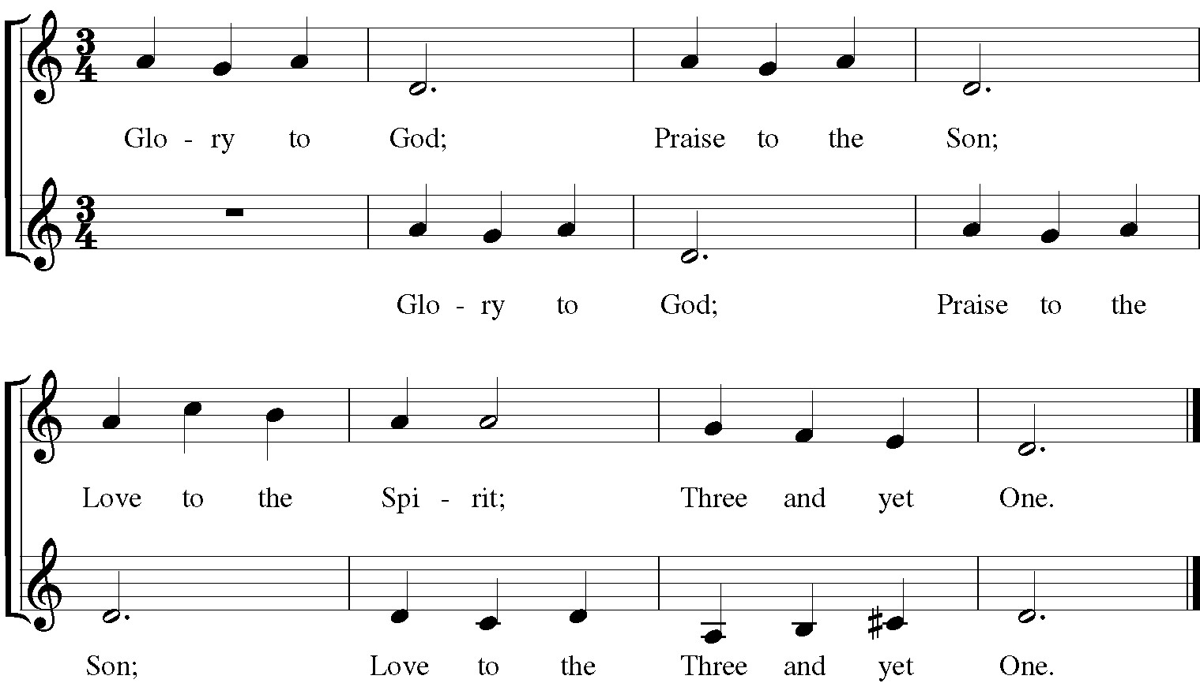

Collect of the Day
O God, you have taught us to keep all your commandments by loving you and our neighbor: Grant us the grace of your Holy Spirit, that we may be devoted to you with our whole heart, and united to one another with pure affection; through Jesus Christ our Lord, who lives and reigns with you and the Holy Spirit, one God, for ever and ever. Amen.
The Lesson (Ezekiel 1:1-5) Please be seated
The Lord said to me: O mortal, stand up on your feet, and I will speak with you... He said to me, Mortal, I am sending you to the people of Israel, to a nation of rebels who have rebelled against me; they and their ancestors have transgressed against me to this very day. The descendants are impudent and stubborn. I am sending you to them... Whether they hear or refuse to hear (for they are a rebellious house), they shall know that there has been a prophet among them. The Word of the Lord/ Thanks be to God

Psalm 123 Ad te levavi oculos meos
- To you I lift up my eyes, * to you enthroned in the heavens.
- As the eyes of servants look to the hand of their masters, * and the eyes of a maid to the hand of her mistress, 3 So our eyes look to the Lord our God, * until he show us his mercy.
4 Have mercy upon us, O Lord, have mercy, * for we have had more than enough of contempt, 5 Too much of the scorn of the indolent rich, * and of the derision of the proud.

Gospel Acclamation (Please stand and sing with the cantor)
Composed by K. Shanklin
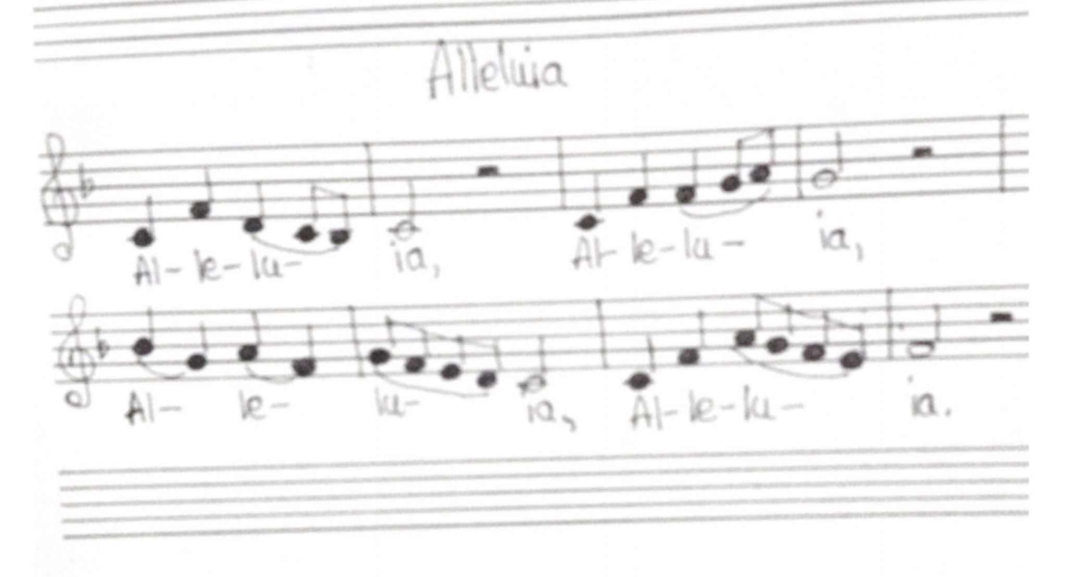
The Holy Gospel of our + Lord Jesus Christ according to Mark
All: Glory to you, Lord Christ
Jesus came to his hometown, and his disciples followed him. On the sabbath he began to teach in the synagogue, and many who heard him were astounded. They said, “Where did this man get all this? What is this wisdom that has been given to him? What deeds of power are being done by his hands! Is not this the carpenter, the son of Mary and brother of James and Joses and Judas and Simon, and are not his sisters here with us?” And they took offense at him. Then Jesus said to them, “Prophets are not without honor, except in their hometown, and among their own kin, and in their own house.” And he could do no deed of power there, except that he laid his hands on a few sick people and cured them. And he was amazed at their unbelief. Then he went about among the villages teaching. He called the twelve and began to send them out two by two, and gave them authority over the unclean spirits. He ordered them to take nothing for their journey except a staff; no bread, no bag, no money in their belts; but to wear sandals and not to put on two tunics. He said to them, “Wherever you enter a house, stay there until you leave the place. If any place will not welcome you and they refuse to hear you, as you leave, shake off the dust that is on your feet as a testimony against them.” So they went out and proclaimed that all should repent. They cast out many demons, and anointed with oil many who were sick and cured them. Mark 6:1-13
The Gospel of the Lord./ All: Praise to you, O Christ.

The Homily (Please be seated) Father Robert Laws
The Nicene Creed (Please stand) BCP, 358
We believe in one God, the Father, the Almighty, maker of heaven and earth, of all that is, seen and unseen.
We believe in one Lord, Jesus Christ, the only Son of God, eternally begotten of the Father, God from God, Light from Light, true God from true God, begotten, not made, of one Being with the Father. Through him all things were made. For us and for our salvation he came down from heaven: by the power of the Holy Spirit he became incarnate from the Virgin Mary, and was made man. For our sake he was crucified under Pontius Pilate; he suffered death and was buried. On the third day he rose again in accordance with the Scriptures; he ascended into heaven and is seated at the right hand of the Father. He will come again in glory to judge the living and the dead, and his kingdom will have no end.
We believe in the Holy Spirit, the Lord, the giver of life, who proceeds from the Father and the Son. With the Father and the Son he is worshiped and glorified. He has spoken through the Prophets. We believe in one holy catholic and apostolic Church. We acknowledge one baptism for the forgiveness of sins. We look for the resurrection of the dead, and the life of the world to come. Amen.

The Prayers of the People (Form II, BCP, page 385)
Please stand or kneel
I ask your prayers for God's people throughout the world; for William, our Bishop, for this gathering; and for all ministers and people. Pray for the Church.
Silence
I ask your prayers for peace; for goodwill among nations; and for the well-being of all people. Pray for justice and peace.
Silence
I ask your prayers for the poor, the sick, especially Jacob, Peggy, Mary, Elsie, Jeff, Gloribel, Denise, Linda, and Maryann . I ask your prayers for the hungry, the oppressed, and those in prison. Pray for those in any need or trouble.
Silence
I ask for your own intentions, offered silently or aloud.
Silence
I ask your prayers for all who seek God, or a deeper knowledge of him. Pray that they may find and be found by him.
Silence
I ask your prayers for the departed. Pray for those who have died.
Silence
Praise God for those in every generation in whom Christ has been honored, especially the Ever-Blessed Virgin Mary, St. Martin of Tours, and all the Saints.
Pray that we may have grace to glorify Christ in our own day.
Silence
Priest: Almighty and eternal God, ruler of all things in heaven and earth: Mercifully accept the prayers of your people, and strengthen us to do your will; through Jesus Christ our Lord. Amen.
Priest: Let us confess our sins against God and our neighbor. BCP, 360
All: Most merciful God, we confess that we have sinned against you in thought, word, and deed, by what we have done, and by what we have left undone. We have not loved you with our whole heart; we have not loved our neighbors as ourselves. We are truly sorry and we humbly repent. For the sake of your Son Jesus Christ, have mercy on us and forgive us; that we may delight in your will, and walk in your ways, to the glory of your Name. Amen.
Priest: Almighty God have mercy on you, forgive you all your sins through our Lord Jesus Christ, strengthen you in all goodness, and by the power of the Holy Spirit keep you in eternal life. Amen.

The Peace & Offertory Hymn WLP Hymn 778
Please stand to sing the offertory hymn. It is customary to bow to the Thurifer as he bows to you before and after the censing).

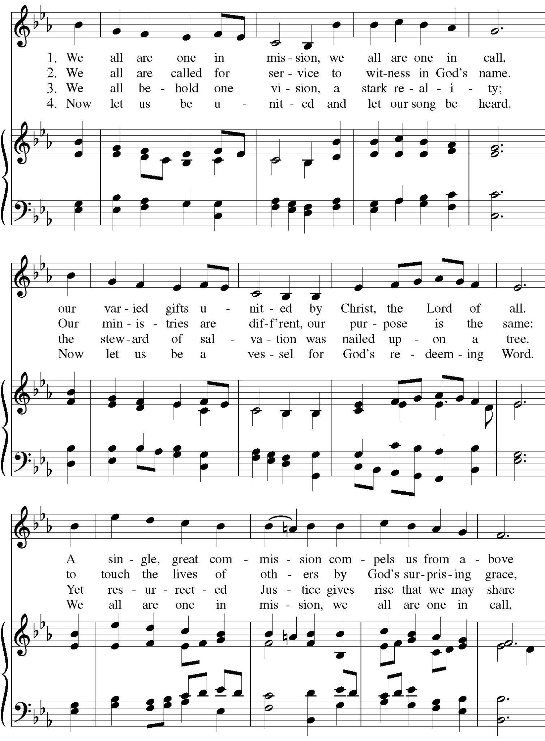

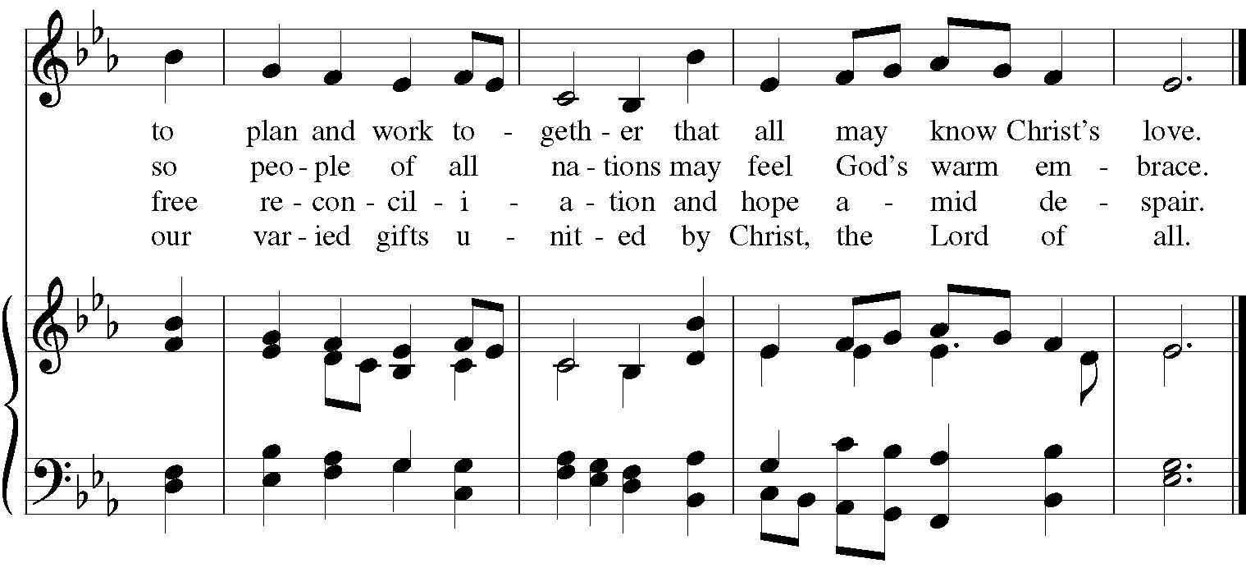

The Liturgy of the Altar BCP, 361
The Lord be with you. And also with you.
Lift up your hearts. We lift them to the Lord.
Let us give thanks to the Lord our God.
It is right to give our thanks and praise.
It is right, and a good and joyful thing, always and everywhere to give thanks to you, Father Almighty, Creator of heaven and earth through Jesus Christ our Lord; who on the first day of the week overcame death and the grave, and by his glorious resurrection opened to us the way of everlasting life. Therefore we praise you, joining our voices with Angels and Archangels and with all the company of heaven, who forever sing this hymn to proclaim the glory of your Name:
Holy, Holy, Holy Lord, God of power and might, heaven and earth are full of your glory. Hosanna in the highest.
Blessed is he + who comes in the name of the Lord. Hosanna in the highest.
Holy and gracious Father: In your infinite love you made us for yourself, and, when we had fallen into sin and become subject to evil and death, you, in your mercy, sent Jesus Christ, your only and eternal Son, to share our human nature, to live and die as one of us, to reconcile us to you, the God and Father of all. He stretched out his arms upon the cross, and offered himself, in obedience to your will, a perfect sacrifice for the whole world.
On the night he was handed over to suffering and death, our Lord Jesus Christ took bread; and when he had given thanks to you, he broke it, and gave it to his disciples, and said, "Take, eat: This is my Body, which is given for you. Do this for the remembrance of me.
After supper he took the cup of wine; and when he had given thanks, he gave it to them, and said, "Drink this, all of you: This is my Blood of the new Covenant, which is shed for you and for many for the forgiveness of sins. Whenever you drink it, do this for the remembrance of me."
Therefore we proclaim the mystery of faith:
Christ has died. Christ is risen. Christ will come again.
We celebrate the memorial of our redemption, O Father, in this sacrifice of praise and thanksgiving. Recalling his death, resurrection, and ascension, we offer you these gifts. Sanctify them by your Holy Spirit to be for your people the Body and Blood of your Son, the holy food and drink of new and unending life in him. Sanctify us also that we may faithfully receive this holy Sacrament, and serve you in unity, constancy, and peace; and at the last day bring us with The Ever Blessed Virgin Mary, St. Martin of Tours and all your saints into the joy of your eternal kingdom. All this we ask through your Son Jesus Christ: By him, and with him, and in him, in the unity of the Holy Spirit all honor and glory is yours, Almighty Father, now and forever. Amen.
And now, as our Savior Christ has taught us, we are bold to say,
Our Father, who art in heaven, hallowed be thy Name, thy kingdom come, thy will be done, on earth as it is in heaven. Give us this day our daily bread. And forgive us our trespasses, as we forgive those who trespass against us. And lead us not into temptation, but deliver us from evil. For thine is the kingdom, and the power, and the glory, for ever and ever. Amen.

The Fraction
Alleluia! Christ our Passover is sacrificed for us; Therefore let us keep the feast. Alleluia!
Behold the Lamb of God who takes away the sins of the world.
Happy are they who are called to the Supper of the Lamb.

Holy Communion
The priest will deliver communion to those seated on the socially distanced side first. Then, the ushers will guide the other side to receive at the altar rail. Please return to your pew via the side aisle.

Communion Hymn Hymn 671
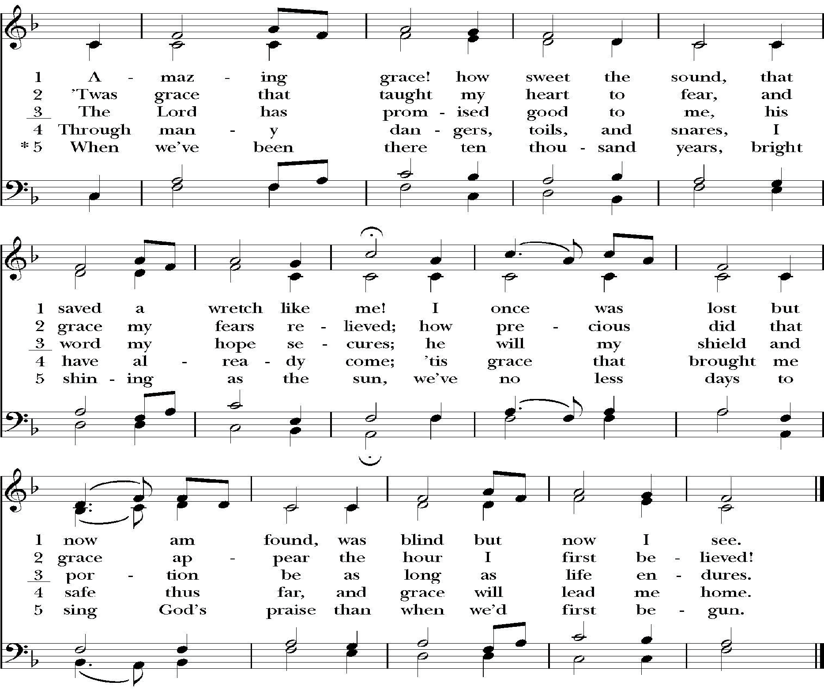

Post Communion Prayer (Please kneel or stand) BCP, 365
Eternal God, heavenly Father, you have graciously accepted us as living members of your Son our Savior Jesus Christ, and you have fed us with spiritual food in the Sacrament of his Body and Blood. Send us now into the world in peace, and grant us strength and courage to love and serve you with gladness and singleness of heart; through Christ our Lord. Amen.

Blessing
A Collect for Our Nation
Lord God Almighty, in whose Name the founders of this country won liberty for themselves and for us, and lit the torch of freedom for nations then unborn: Grant that we and all the people of this land may have grace to maintain our liberties in righteousness and peace; through Jesus Christ our Lord, who lives and reigns with you and the Holy Spirit, one God, for ever and ever. Amen.
Patriotic Medley (sung by all)
- National Anthem (Hymn 720, vs. 1)
- You’re a Grand Old Flag
You’re a grand old flag, you’re a high flying flag;
And forever in peace may you wave;
You’re the emblem of the land I love, The home of the free and the brave. Ev’ry heart beats true under red, white and blue, where there’s never a boast or brag;
But should auld acquaintance be forgot, Keep your eye on the grand old flag.
- My Country ’Tis of Thee (717, vs. 1 & 4)
- God Bless America
God bless America, land that I love. Stand beside her and guide her through the night with a light from above.
From the mountains to the prairies, to the oceans white with foam.
God bless America, my home sweet home.
God bless America, my home sweet home.
- This Land Is Your Land
This land is your land, this land is my land, from California, to the New York island
from the redwood forests, to the Gulf Stream waters, This land was made for you and me.
As I went walking that ribbon of highway, I saw above me, the endless skyway, I saw below me that golden valley, This land was made for you and me.
Vs. 1 again.
- America, America (719, vs. 1 & 3)
Dismissal
Please join us outdoors for light refreshments and fellowship following the Mass.

