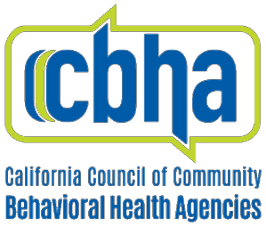

Member Town Hall

July 24, 2020 | Friday at 11:00AM
Join Zoom Meeting: Click here to join.

Agenda

I. Welcome, Roll Call, and Housekeeping

II. Announcements
  - N95 Masks Available from CCAPP
  - NCBH Opioid Epidemic Webinar 7/29/20
  - Immigrant Services Survey
  - CBHA Membership Renewal

III. Policy Updates
  - Main Street Lending Program now funding large employers
  - CBHA Presents to NCBH Association Executive Group
  - CBHA Workgroup on Equity Update
  - CBHA highlighted at State of Reform conference 8/13/20
  - Capitol Updates
  - California Access Coalition Webinar 8/10/20
- California Access Coalition Webinar 8/10/20

IV. Addressing Behavioral Health Staff Burnout During the Pandemic
  - Setting the Stage: The Impact of Burnout
      - Vitka Eisen, CBHA Board President and CEO HealthRight 360
  - Strategies for Addressing Burnout
      - Myeisha Peguero Gamino, Pacific Clinics
      - Christina Miller, Mental Health America Los Angeles
  - A Charitable Solution: Covid19counselingCA.org
      - Randall Hagar, Director of Government Affairs, California Psychiatric Association
- Special Presentation by CBHA and NextGen Policy

V. Member Discussion

VI. Closing Announcements
  - Upcoming CBHA Events
      - MHFA Summit
      - BHCalCon

