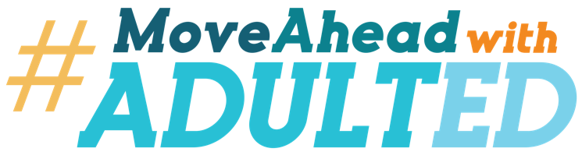
[Insert your logo here]

FOR IMMEDIATE RELEASE
[insert date here]
[insert contact information here]

[YOUR ORGANIZATION NAME] JOINS ‘MOVING AHEAD WITH ADULT ED’ CAMPAIGN TO GET ADULTS BACK TO SCHOOL AND WORK
Reskilling, Upskilling Will Help Move Adults Into Family-Sustaining Jobs
for Economic Recovery from Pandemic
[Insert city, state] – With reskilling and upskilling programs in place, adult education is an economic catalyst to help low-skilled adults and their communities recover from the financial impacts of the COVID-19 pandemic. Our programs provide numerous options for participation, including working from home or receiving in-person instruction.
[insert your organization’s name] joins more than 65,000 adult educators in “Moving Ahead with Adult Ed,” a new national campaign to enroll adult learners into programs that equip them with skills that lead to high school equivalency and jobs that pay a family-sustaining wage. Millions of Americans are out of work or underemployed and need to reskill or upskill to re-enter the workforce or pursue their education. The pandemic has exacerbated the need for services.
[insert your organization’s name] adult education programs currently are providing instruction [insert ways in which instruction is provided: e.g., online and in-person]. CDC guidelines and sanitation protocols are in place for in-person instruction to ensure a safe learning environment.
An international study indicated approximately 43 million working-age Americans lack the skills needed for many of the nation’s fastest-growing and highest-paying jobs. According to the U.S. Census, there are over 22 million adults in the U.S. without a high school diploma.
“Adult education provides on-ramps to better jobs and to community college,” said [insert name and title of local leader]. “With adult education, the infrastructure is in place to reskill and upskill Americans and not only get them back into the workforce but get them into better jobs than they had before the pandemic.”
Campaign partners Coalition on Adult Basic Education and the National Association of State Directors of Adult Education also estimate that for every dollar invested in adult education, a community receives $60 back in increased income, property taxes and savings on public assistance and legal-system expenses.
The #MovingAheadWithAdultEd campaign focuses on re-engaging the millions of Americans who are in need of additional skills to compete in the workforce to recover financially from the pandemic. In addition to providing industry skills training, adult education programs teach literacy, numeracy and digital literacy, as well as offer high school equivalency classes.
In [insert your state/region], [insert # for your region] people are enrolled in adult education programs, among them is [insert name of a learner who enrolled in adult education after losing their job due to the pandemic]
[Add copy to expand on the student’s situation, including information about their previous situation, how they found out about adult education, what their goal is now that they are enrolled and how they feel it is changing their life.]
###
[Insert organization’s About information]

