
SPEAKER BIOS
Shahira Knight, AManaging Principal, Policy & Government Relations
Deloitte
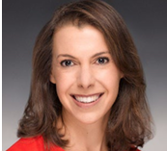
Carolyn Beaver has served as a director and member of the audit committee of MaxLinear, Inc., a fabless semiconductor company headquartered in Carlsbad, CA, since December 2018, and became chair of its audit committee in February 2021. She is also a member of the board of directors and chair of the audit committee of Sonendo, Inc., a dental technology company based in Laguna Hills, and a director and chair of the audit committee of MediciNova, Inc., a biopharmaceutical company based in La Jolla.

She previously held various positions at Sequenom Inc., a life sciences testing company, including Chief Financial Officer from 2014 to 2016 and Vice President and Chief Accounting Officer for the prior two years.

Prior to that, Carolyn was Corporate Vice President, Controller and Chief Accounting Officer of Beckman Coulter, Inc., a biomedical laboratory instrument and test company, for 7 years, Her first public company director position was Commerce National Bank, in Newport Beach, California from 2005 to its sale in 2013, where she chaired the audit committee and served on the bank’s asset/liability committee.

Carolyn served as an audit partner with KPMG LLP from 1987 to 2002. She is a CPA (inactive) and is involved in the community, serving on the board of directors of Working Wardrobes, Inc. and as chairman of the board of Changing Strides, both non-profit organizations.
Carolyn received a Bachelor of Science degree in Business Administration from California State Polytechnic University, Pomona.

Priya Cherian Huskins, Compensation Committee Chair
Realty Income Corporation

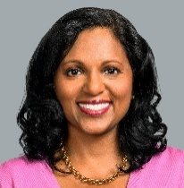
Priya Cherian Huskins is a partner at Woodruff Sawyer, a full-service insurance brokerage that services clients worldwide. She is a recognized expert in D&O liability risk and its mitigation. In addition to consulting on D&O insurance matters, she counsels clients on corporate governance, including ways to reduce their exposure to shareholder lawsuits and regulatory investigations.

Priya is a frequent speaker on D&O issues. She has appeared on CNBC and been quoted in publications including the Wall Street Journal, the New York Times and the Financial Times. She is also the editor of the D&O Notebook, a blog that analyzes issues as they arise in the areas of D&O liability, insurance, and corporate governance.

Priya serves on the board of directors of Realty Income Corporation (NYSE: O) and NMI Holdings, Inc. (Nasdaq: NMIH). She also serves on the board of the Long Term Stock Exchange and previously served as the Presiding Director of Woodruff Sawyer until its acquisition by Gallagher.

Priya is a member of the advisory board of the Stanford Rock Center for Corporate Governance and is an active participant in their programs such as Stanford’s Directors College. In 2024, Priya was named an NACD Directorship 100 honoree.

Prior to joining Woodruff Sawyer, Priya practiced corporate and securities law at Wilson Sonsini Goodrich & Rosati. Priya has worked with both public and private technology companies through all stages of their development, including IPOs and M&A transactions.

Priya was awarded her juris doctorate with honors from the Law School at the University of Chicago. She earned her undergraduate degree with high honors from Harvard University.

Douglas Pasquale, Nominating/Governance Committee Chair
Sunstone Hotel Investors

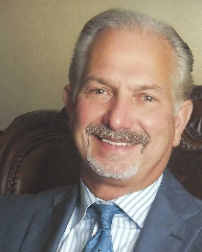
Doug Pasquale is Founder & CEO of Capstone Enterprises Corporation, a real estate, investment and consulting firm, since January 1, 2012. He served as Sunstone Hotel Investors, Inc.’s Interim CEO from September 2021 through March 2022 and as Executive Chairman from March 2022 to September 2022.

Doug served as Senior Advisor to Healthpeak (NYSE: PEAK) from June 2017 through December 2019. On the July 2011 sale of Nationwide Health Properties, Inc. (NYSE: NHP) to Ventas Inc. (NYSE: VTR), Doug served as Senior Advisor from July 2011 to December 2011. He also served on the Ventas Board of Directors from July 2011 to May 2017. Prior to Nationwide Health Properties, Inc.’s sale, Doug served as Chairman of the Board of NHP from May 2009 to July 2011, as President and CEO of NHP from April 2004 to July 2011, and as Executive Vice President and Chief Operating Officer of NHP from November 2003 to April 2004. Doug was a Director of NHP from November 2003 to July 2011. Doug served as Chairman and CEO at ARV Assisted Living, Inc., a leading owner and operator of assisted living facilities, from June 1998 to September 2003 and concurrently served as President and CEO of Atria Senior Living Group, Inc. from April 2003 to September 2003. Doug also served as President and CEO of Richfield Hospitality Services, Inc. and Regal Hotels International—North America, a hotel ownership and management company, from 1996 to 1998, and as its Chief Financial Officer from 1994 to 1996. Prior to 1994, he served in various capacities primarily in finance, real estate, investment banking and public accounting.

Doug has served on over a dozen public, private and philanthropic boards over the course of his career. He currently serves on 4 NYSE Boards and is a Director of: 154-year old Alexander and Baldwin, Inc. (NYSE: ALEX), a Honolulu - headquartered real estate and related business company, for which he serves as Lead Independent Director, Chairman of the Audit Committee and Nominating and Corporate Governance Committee; Terreno Realty Corporation (NYSE: TRNO), a leading industrial REIT with a focus in six coastal U.S. markets, for which he serves as Lead Independent Director and a member of the Audit, Compensation and Nominating and Corporate Governance Committees; Sunstone Hotel Investors, Inc., (SHO) a hotel ownership company, for which he serves as Chairman of the Board and Nominating and Corporate Governance Committee, and Dine Brands Global, Inc. (NYSE: DIN), which franchises Applebee’s, IHOP and Fuzzy’s Taco Shop restaurants, for which he serves as the Chairman of the Audit Committee.

Doug is a successful leader in the real estate industry with extensive experience and skills in leadership, management, finance, mergers and acquisitions and strategic planning. Doug received his B.S. degree in Accounting and his M.B.A. degree with highest honors from the University of Colorado and guest lectures at several universities.

Hoshi Printer, Board Chair
Lantronix, Inc.

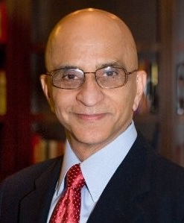
Hoshi Printer has been an experienced member of the Board of Directors for the last 15 years serving a diverse group of companies / organizations. He has served as Chairman of the Board, Chair of Audit Committees, and as member of Compensation and Nom/Gov Committees
Prior to that, for over 20 years he served as CFO of ten technology companies, three of which he took public. His experience spans several industries and company sizes.
He holds an MBA from Stanford, and an MS in engineering from Oklahoma State University.
He is a Vietnam Veteran and served as an officer.

