FOR IMMEDIATE RELEASE

CONTACT: Jackie Wible
Illinois Pork Producers Association
O: 217-529-3100 C: 812-564-8585
jackie@ilpork.com www.ilpork.com

Illinois Crowns Best Breaded Pork Tenderloin Sandwich

SPRINGFIELD, ILL. – During October Pork Month, the Illinois Pork Producers Association (IPPA) hosted the first-ever Breaded Pork Tenderloin Draft, a competition designed to spotlight hand-breaded pork tenderloin sandwiches served at restaurants across Illinois.

After multiple rounds of voting, Buford’s Pub in Sadorus, was named Best Pork Tenderloin Sandwich in Illinois, with River’s Edge in Dixon earning second place.

The Tenderloin Draft focused exclusively on true, hand-breaded pork tenderloins, not fritters. Nominated restaurants were required to operate year-round, maintain regular hours, and feature a hand-breaded pork tenderloin sandwich on their daily menu. Voting opened to the public in October 2025 during pork month, then IPPA members voted to narrow the list to a top 20, then to a top five. A panel then taste-tested the top five to determine first and second place

First Place: Buford’s Pub — 109 E Market St. Sadorus, IL

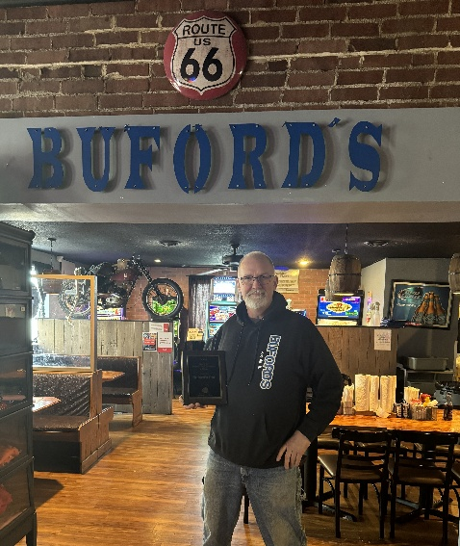
Buford’s Pub stood out among nominated restaurants statewide, capturing top honors for its oversized, hand-breaded pork tenderloin sandwich and its loyal following among pork tenderloin enthusiasts. “It’s always good to be rewarded for hard work. We make hundreds of tenderloins each week and to be nominated and awarded the best in Illinois is just unbelievable,” said Jeff Buckler, owner of Buford’s Pub. “There are hundreds of restaurants out there making delicious tenderloins. It’s still hard to fathom the following of this sandwich. People will travel hours for one and then to hear they loved ours brings tears to my eyes.”

“We are in Sadorus, about 10–15 minutes southwest of Champaign. Eight miles off I-57, four miles from Tolono. Sadorus is a small town of 350, but we draw people from all over the country now due to the Pursuing Pork Tenderloins Facebook group,” Buckler said.

Participation in the Tenderloin Draft and the attention generated through social media also drove new traffic to the restaurant.“We had quite a few folks come thru that told us they were here for the Illinois Pork Tenderloin Crawl. The Facebook traffic alone helps with overall sales and promotions,” Buckler said.
Buford’s Pub began as a unique community-driven concept and has grown steadily since opening, overcoming challenges including the COVID-19 pandemic. Today, the restaurant features hand-built tables, a large outdoor deck and bar, live entertainment, and a menu anchored by its signature giant pork tenderloin.
In the past year alone, Buford’s has sold nearly 10,000 pork tenderloins, prompting Buckler to expand production.

“In the past year with all the fame of our tenderloin, I decided to build a kitchen in Arthur, Illinois for the sole purpose of making pork tenderloins. I even went as far to make it a USDA-certified location,” Buckler said. “Which means we will be able to ship tenderloins all over the United States.”

Second Place: River’s Edge — 2303 W 1st St. Dixon, IL

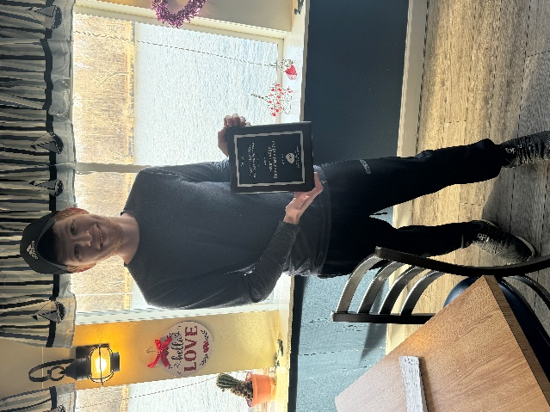
Taking second place, River’s Edge in Dixon earned strong support for its hand-breaded pork tenderloin sandwich and commitment to quality pork and classic preparation. The recognition highlights the depth of talent and variety found among Illinois restaurants serving this iconic sandwich.

Additional Top Five Finishers

Rounding out the Top Five in the Tenderloin Draft were:
• Old Mill - Greenville
• D’Arcy’s Pint – Springfield
• The Dirty Bird – Sycamore

Both first- and second-place winners received commemorative plaques, with Buford’s also awarded an outdoor banner recognizing its top finish. Under contest rules, the first-place winner cannot compete again for five years, but second-place and other top-five finishers are eligible to return in future competitions.

The Tenderloin Draft underscores the important connection between Illinois pork farmers, local restaurants, and consumers—celebrating the quality, craftsmanship, and community pride behind one of the state’s most beloved sandwiches.

“As a pork producer in Illinois, I really appreciate seeing pork highlighted on local restaurant menus, especially when it’s prepared well,” said Kent Blunier, IPPA Board Member. “We put great care into raising the animals. Events like this are a great example of how local restaurants and local farmers can support each other.”

-###-
The Illinois Pork Producers Association (IPPA) represents more than 800 pork producers throughout Illinois and the Illinois pork industry, which contributes more than $13.8 billion and more than 57,000 jobs to the state’s economy (related to pork production and processing). IPPA is an affiliate of the National Pork Producers Council and the National Pork Board.

