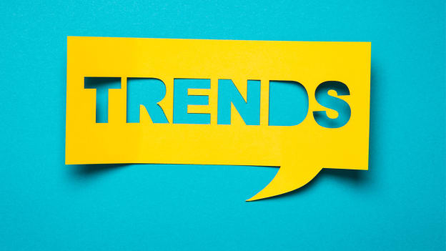
Remember 2019 travel? Just barely! A little reminder, hospitality trends we were told to be on the look out for, and some that we did experience; scaled up Ecotourism, Voluntourism, truly All-Inclusive Resorts, catering to Foodies and the Millennial Influencer (selfie). It hasn’t all been packed away but for the moment and the foreseeable travel future, trends are shifting. A few that we can expect as 2022 motors in:

Bleisure Travelers & Hotel Work Spaces
Bleisure travel is the combination of Business and Leisure travel. “Working remotely has today become commonplace for many employees and is forecasted to become more than just a passing trend. A shift accelerated by the global public health crisis, an unprecedented number of high-profile companies – with big tech companies like Twitter, Facebook, and Amazon leading the way – announced that they will adopt a hybrid or flexible approach to working remotely”. In 2021 alone, the percentage of workers around the world that are permanently working remotely doubled (2022 Top Hospitality Industry Trends, 2022)!
FUN FACT -
Global Workplace Analytics estimates that 56% of the U.S. workforce holds a job that is at least partially compatible with remote work, and that 25-30% of the workforce will be working at home for more than one day a week over the next two years - 90% of remote workers plan on working remotely for the rest of their career (Archer, 2021).

Digitalized Guest Experiences
“Apps are increasingly important in the way hoteliers manage the services they provide to their customers and can now control many aspects of the guest cycle and experience. Needless to say, the trend towards digital and contactless services has gained new momentum since 2020. Traditionally, customer-facing services are being given an overhaul thanks to the more widespread use of technology-assisted options, such as mobile check-in, contactless payments, voice control and biometrics” (Hospitality Industry Trends, 2022).
Guests who interact with their smartphones and laptops via facial recognition or a touch of a screen expect this same technology at the hotel of their choice. This may be costly to the property but the Brands are listening and digital check in is here.

Traveling Less & Staycations
The Staycation is back! Contrary to the belief that (the true) travelers are itching to get out there remains a reluctance to get moving. Along with company and federal restrictions the last two years have once again popularized the staycation. International travel’s on-again, off-again relationship, airline travel price increases along with mask and Covid testing prerequisites, both domestic and foreign travel has shrunk. Other reasons vacationers may be choosing their own neighborhoods can be attributed to concerns for the environment, budgets and the latest variant threat. Getting away but staying closer to home is pretty attractive. Tourism rich locations, great climates and attractions provided by Mother Nature provide the local vacationer the better option (Hospitality Industry Trends, 2022).
So, what can we do to prepare for these trends? A lot of what we’ve been doing. Make sure that we are receptive, have the right segments open to booking. Be sure to stay current with all Brand digital updates. Be mobile friendly. Capitalize on your environment and local attractions, provide maps, recommendations and be sure to get the word out. Promote your connection to the trend through social platforms, digital space, and traditional media formats. Remember the keys are flexibility, responsiveness and always exceptional service!

Hospitalityinsights.ehl.edu. 2022. 2022 Top Hospitality Industry Trends. [online] Available at: <https://hospitalityinsights.ehl.edu/hospitality-industry-trends> [Accessed 9 January 2022].\
Archer, S., 2021. 30+ Work From Home Statistics | Remote Work in 2022. [online] Your Best Digs. Available at: <https://www.yourbestdigs.com/work-from-home-statistics/> [Accessed 9 January 2022].

