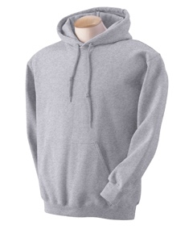
We Are St. Francis…
Let’s Get in the SFX Spirit!!!
New Spirit Wear options for purchase
NEW AUTHORIZED GYM UNIFORM SS SHIRT

- Pullover Hoody with SFX logo on left chest Youth & Adult Sizes $22.00
(Available in gray or maroon)

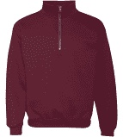
- ¼ zip Sweatshirt with SFX logo on left chest Youth & Adult Sizes $25.00
(Available in gray or maroon)

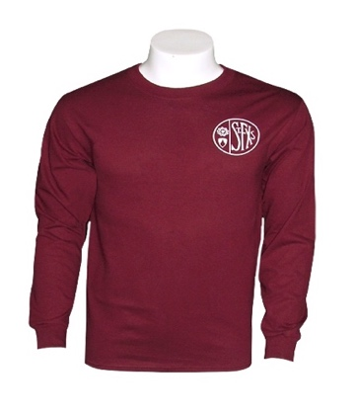
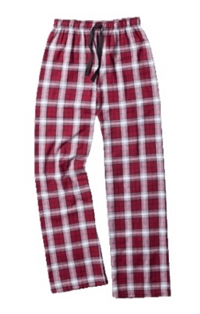
- Long Sleeve Shirt with SFX logo on left chest Youth & Adult Sizes $16.00
(Available in gray or maroon)

- Flannel Pajama Pant with SFX logo Youth & Adult Sizes $24.00

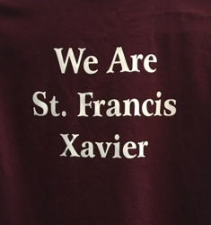
4. Short Sleeve Shirt with SFX logo on left chest and “We Are St. Francis Xavier” on the back Youth & Adult Sizes
$14.00 (Available in gray or maroon)
NEW ~ GRAY ONLY IS NOW AUTHORIZED FOR GYM UNIFORM
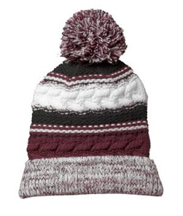

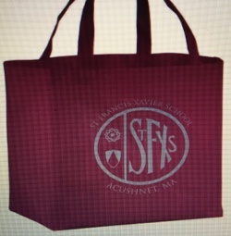
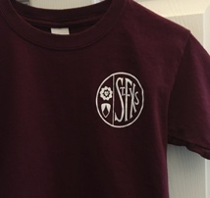
- Pom Pom Beanie with SFX logo - One Size $14.00

- SFX Pride Bag or Decal - One Size $5.00

Student / Family Name: _____________________________________________ Grade(s): ___________________ Total amount of check enclose (please make payable to SFX): $_________________________________________

ORDERS MUST BE SUBMITTED AND PAID IN FULL BY THURSDAY 12/5/19

Spirit Wear Item | Gray | Maroon | XS | SM | MED | LG | XL | Adult ( Note Size) | Qty | Price | Total
Pullover Hoody |  |  |  |  |  |  |  |  |  | $22.00
¼ Zip Sweatshirt |  |  |  |  |  |  |  |  |  | $25.00
Long Sleeve Shirt |  |  |  |  |  |  |  |  |  | $16.00
Short Sleeve Shirt |  |  |  |  |  |  |  |  |  | $14.00
Flannel Pajamas |  |  |  |  |  |  |  |  |  | $24.00
Pom Pom Beanie |  |  |  |  |  |  |  | 1 Size Only |  | $14.00
SFX Bag |  |  |  |  |  |  |  |  |  | $5.00
SFX Decal |  |  |  |  |  |  |  |  |  | $5.00
Notes:

