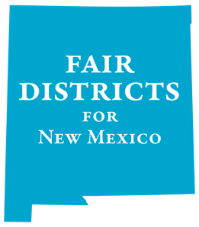

*New partners being accepted. Please contact us: fairdistricts@lwvnm.org

Statewide Partners
- Adelante Progressive Caucus
- American Association of University Women (AAUW), New Mexico
- American Civil Liberties Union (ACLU) of New Mexico
- Central New Mexico Democrats
- Common Cause New Mexico
- Indivisible Corrales
- Indivisible Las Cruces
- Indivisible Nob Hill
- Indivisible Santa Fe
- League of Women Voters of New Mexico
- National Association for the Advancement of Colored People (NAACP) Doña Ana County
- Native American Democratic Caucus of New Mexico
- Native American Voter Alliance (NAVA) Education Project
- New Mexico Democratic Black Caucus
- New Mexico Ethics Watch
- New Mexico First
- New Mexico Open Elections
- Progressive Democrats of America (PDA), Central New Mexico
- RepresentUs New Mexico
- Retake Our Democracy
- Save Our Western Way of Life
- Vecinos United

National Partners
- The Brennan Center for Justice
- Election Reformers Network
- Princeton Gerrymandering Project

