**Ambulatory APP wRVU Tip Sheet**

The Office of Advanced Practice Providers is here to support and advocate for you. We would like to explain why work relative value units (wRVU) are important to APP practice. wRVU measure billable work and denote direct financial contribution to UCSF Health.

# Ambulatory Billable Work

1. Independent APP visits (in person, telehealth, on demand)
2. Shared visits with physician (in person, telehealth, on demand)
3. Independent procedures performed by APP
4. Serving as the sole first assistant in the operating room
5. Medical Advice Messaging greater than 5 minutes
6. Telephone encounters greater than 5 minutes

**How to find your wRVU:** Establish monthly or quarterly meetings with your manager to review wRVU and time spent performing billable vs. non-billable work. The meetings provide an opportunity to influence your practice.

# 2023 wRVU Attribution Per Ambulatory Visit Type

|  |  |  |
| --- | --- | --- |
| **Ambulatory Visit Type** | **wRVU** | **Time Spent** |
| 99202: Level 2 New (video or in-person) | 0.93 | 15-29 minutes* |
| 99203: Level 3 New (video or in-person) | 1.60 | 30-44 minutes* |
| 99204: Level 4 New (video or in-person) | 2.60 | 45-59 minutes* |
| 99205: Level 5 New (video or in-person) | 3.50 | 60-75 minutes* |
| 99211: Level 1 f/u (video or in-person)A minimal problem that may not require the presence of the physician or other qualified health care professional, but the service is provided under the physician’s or other qualified health care professional’s supervision. | 0.18 | For 99211, the face-to-face services may be performed by clinical staff. |
| 99212: Level 2 f/u (video or in-person) | 0.70 | 10-19 minutes* |
| 99213: Level 3 f/u (video or in-person) | 1.30 | 20-29 minutes* |
| 99214: Level 4 f/u (video or in-person) | 1.92 | 30-39 minutes* |
| 99215: Level 5 f/u (video or in-person) | 2.80 | 40-54 minutes* |
| 99441: Telephone | 0.70 | 5-10 minutes |
| 99442: Telephone | 1.30 | 11-20 minutes |
| 99443: Telephone | 1.92 | 21-30 minutes |
| 99421: Medical Advice Message | 0.25 | 5-10 minutes |
| 99422: Medical Advice Message | 0.50 | 11-20 minutes |
| 99423: Medical Advice Message | 0.80 | 21-30 minutes |
| G2212: Prolonged services day of visit | 0.61 | Each 15 minutes |

# *Bill based on time spent if it results in a higher level of service than billing based on medical decision making

# *If billing based on time spent, document using .TIMESPENT and include the full time spent on the care of the patient on the date of service because APeX will automatically add G2212 for each additional 15 minutes above the max of Level 5 for new or f/u patients

# General Tips:

1. One way to improve your wRVU is to make sure you are performing billable work as outlined in 1-6 above.
2. Document using **.APPNOTE** for all notes including independent, shared, and procedure notes to ensure wRVU are appropriately allocated.
3. Procedure billing can never be shared. If you are performing the procedure, you are responsible for documenting the procedure and level of service.
4. Close all encounters within **5 days**.
5. The available consulting physician’s name entered when logging into APeX should be someone available at the time you see the patient.
   * 1. For clinic visits, the physician need not be physically present but must be reachable by phone or electronic means.
     2. For procedures, you must follow the outline of the standardized procedure (SP) for the procedure you are performing regarding physician supervision. Most SPs require only indirect supervision, but a few require the physician to be on site and immediately available (within five minutes) in case of an unexpected outcome during the procedure.

# APeX Tip Sheets:

1. [Ambulatory APP Shared-Independent Visit Note](https://myapex.ucsf.edu/sites/myapex.ucsf.edu/files/2023-01/Ambulatory%20APP%20Shared-Independent%20Visit%20Note.pdf)
2. [Inpatient APP Shared-Independent Visit Note Documentation](https://myapex.ucsf.edu/sites/myapex.ucsf.edu/files/2023-01/Inpatient%20APP%20Shared-Independent%20Visit%20Note%20Documentation.pdf)

# Billing Tips:

1. You may bill encounters based on medical decision making (MDM) or time. Use the approach which results in a higher level of service code to ensure the scope of your work is fully captured.

The level of service can be entered in the wrap up tab

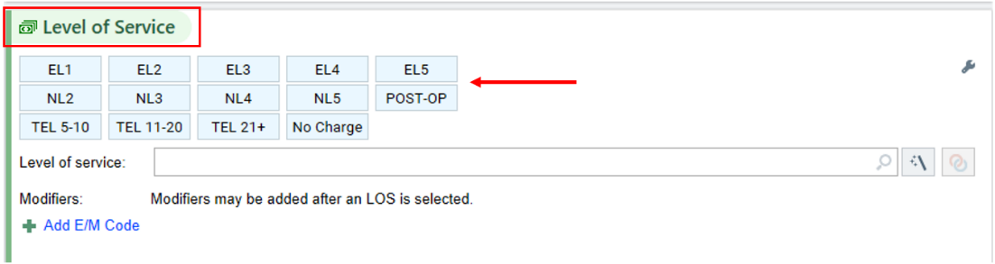

1. **MDM billing** is based on three categories: severity of problems addressed (diagnoses), complexity of data reviewed (history, labs, imaging), and risk of planned treatment (prescription medication, surgery). The level of service is determined by the best two out of three from these categories. Clicking on the wand icon in the level of service section of the wrap up tab opens the level of service calculator which provides a rubric to guide you.

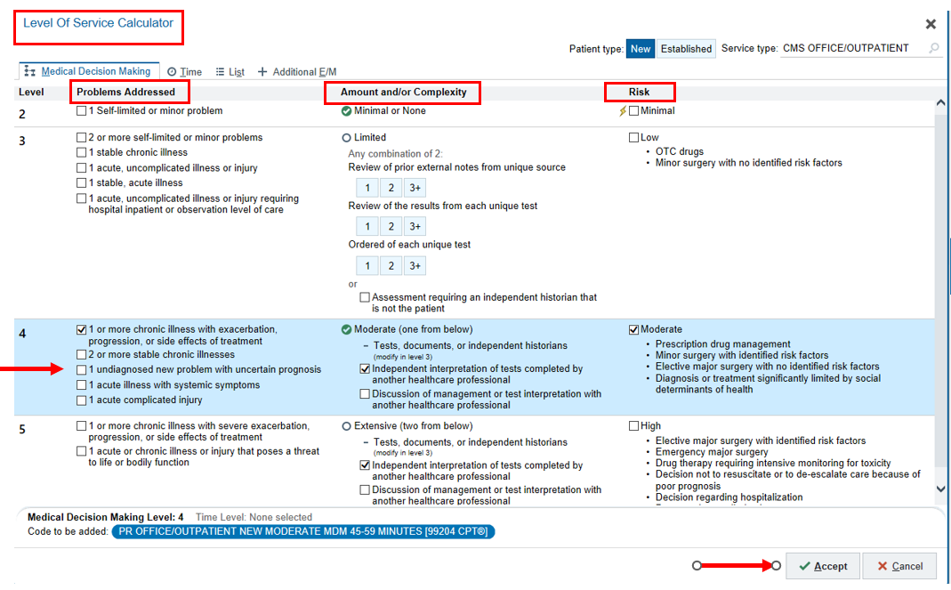

* 1. Things to keep in mind when billing for medical decision making:
     1. For problems addressed “threat to bodily function” can include conditions associated with common symptoms such as dyspnea, cognitive changes, disequilibrium, dizziness, ambulatory limitations, etc.
     2. For data complexity be sure to clearly document your independent interpretation of radiology images, EKGs, or any other testing in which you review the raw data (this excludes labs like CBC, BMP, etc.). Additionally, any form of communication with another provider counts in this category such as cc’ing your note to the PCP.
     3. For risk of treatment, prescribing a medication, managing a drug that requires monitoring at least every three months, or discussing a surgery counts towards your level of service. Be sure to clearly document in your note any risks or complications for the procedures or surgeries discussed.
     4. A word of caution: APeX has functionality to “auto-fill” the MDM sections in the level of service calculator. Do not rely on the auto-populated selections as they are often inaccurate. Use your own judgement.
     5. The documentation in the body of your note needs to support the selected level of service. An *optional* tool to aid in supportive documentation is .MDM. This is a SmartBlock with speed buttons that automatically populate statements in the body of your note to detail the complexity of your medical decision making.

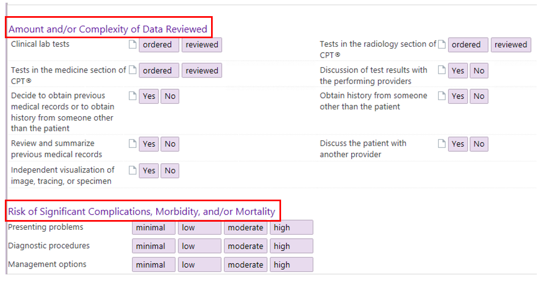

1. If you are **billing based on time**, then all time spent on patient care for the date of service is billable and should be included in your total visit time. Patient care time includes reviewing patient's records and tests, obtaining history, placing orders, communicating with other healthcare professionals, counseling the patient, family, or caregiver, care coordination for the diagnoses, and all visit documentation.
   1. Always use **.TIMESPENT** in the body of your note when billing by time.
   2. Using the wand in the level of service section brings you to a window that shows the amount of time you have spent in the patient’s chart for the current encounter.

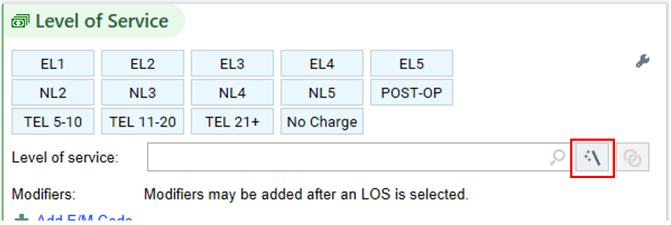

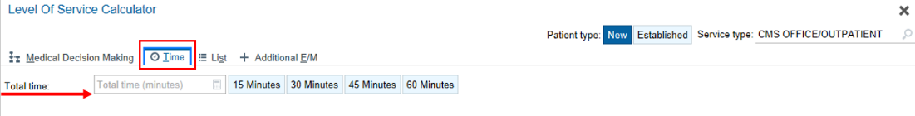

* 1. In the level of service section of the wrap up tab enter the amount of time you spent in the encounter under ‘Calculate LOS based on time’. This will automatically select the appropriate level of service evaluation and management code above.

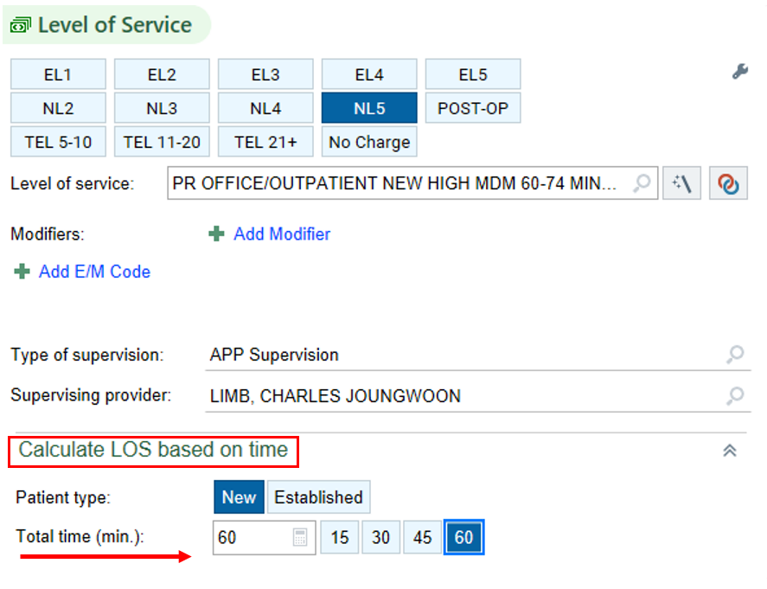

* + 1. Alternatively, you may also enter the patient care time in the ‘Total Time’ box in the level of service calculator
  1. Be sure to enter all the time that you spent on patient care. This may result in prolonged services codes which will automatically populate when you enter your total time in the level of service section.

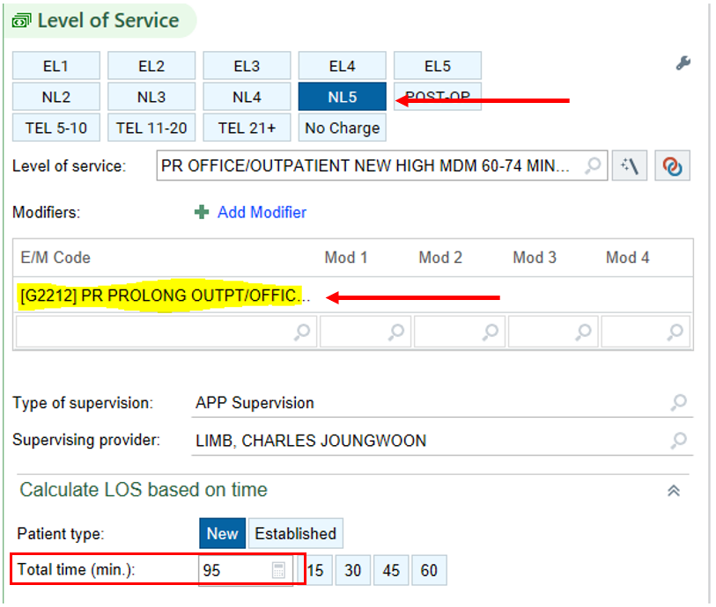

1. **Procedure Documentation / Billing:**

When performing procedures, document in the body of the note and include risks, benefits, alternatives, and consent. Enter the CPT code for the procedure performed in the charge capture section of the wrap up tab (Image 1). If you are providing evaluation and management services on the same day, then also add the appropriate level of care and modifier 25. If you do not know the CPT code for the procedure, then enter PROC1 into charge capture

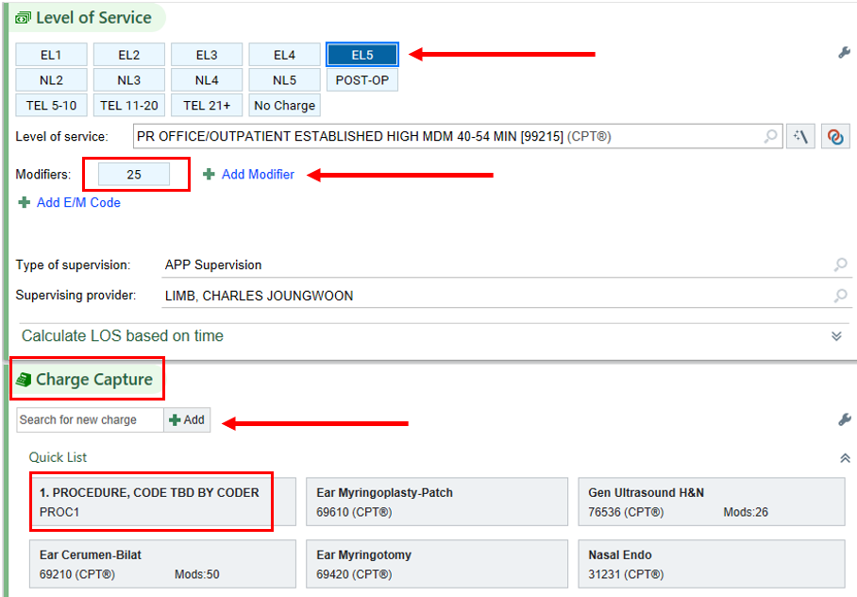

# If you have any questions, please email [providercoding@ucsf.edu](mailto:providercoding@ucsf.edu) or attend provider coding office hours on Zoom.

