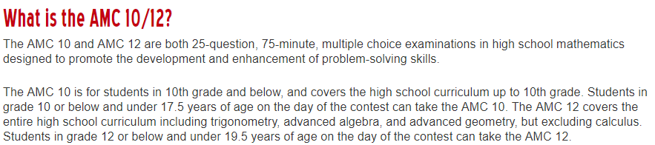

Test A (February 7, during 5th period, you will be excused from class, see your teacher about making up missed work)
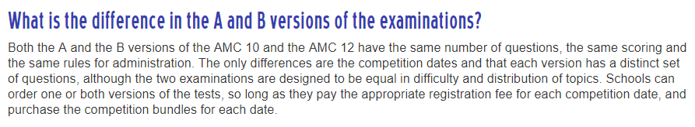
Test B (February 13, Wednesday after school, start at 2pm)

$10 paid to the office for BOTH contests
Deadline to Pay is Monday January 21 by 3pm
Email Regen Lorden with questions or links to practice problems!
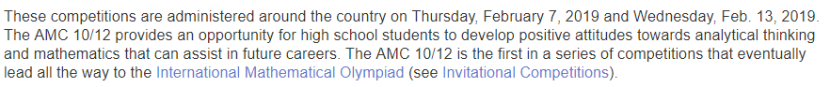
Why would sign up for something like this?

